Helwan University

Faculty of Commerce & Business Administration

Business Information Systems (BIS)



BIS Graduation Project

Project Number 92

|  |
| --- |
| BTCO  Bridge To Cross Over |

Project number (92)

Prepared By

|  |  |  |
| --- | --- | --- |
| 1 | Farah Ahmed Mahmoud Mohamed | 1920184 |
| 2 | Zeina Mohamed Hassan El-Sherief | 1920202 |
| 3 | Amr Mohamed Abbass | 1920212 |
| 4 | Farah Ahmed Mohamed Sayed | 1920214 |
| 5 | Farha Mohamed Goda | 1920203 |

Supervisors

IT Part Business Part

Dr:…………….. Dr:……………

## **ACKNOWLEDGMENT**

First, we put a lot of effort into this project. Nevertheless, without your help and support, this would not have been possible.

We would like to sincerely thank Dr. Mohamed Roshdy and Dr. Mervat El Saman for their excellent leadership on this project. And we sincerely appreciate all of your efforts in directing and supporting us.

We would want to express our gratitude to Helwan University, the faculty of commerce and business administration, and the BIS department for helping us advance and for igniting our interest in learning new things.

# Abstract

In today's modern world, technology has become an integral part of all businesses and organizations. From small startups to large multinational corporations, technology is used to streamline operations, enhance productivity, and improve customer experiences.

Using innovative technology we are helping students who are about to graduate to find illiterate people to teach them how to write and read, so that they can finish their graduation requirements efficiently. All they have to do is open our website and do very simple steps and we will connect them with an illiterate person who is wiling to learn. We have different unique services to make it easier for students to teach. By doing this we will help more students and help live in a better world where illiteracy exists in a very low rate and we will be participating in Egypt vision 2023.

# Table of content

|  |
| --- |
| Chapter ONE:  INTRODUCTION  1.1 Introduction  1.2 Problem statement  1.3 Project objectives  1.4 Existing Systems & problems  1.5 Project features  1.6 Project users  1.7 Project software and hardware requirements  1.7.1 Hardware requirements  1.7.2 Software requirements  1.8 Languages and Tools  1.9 Gantt chart |
| Chapter TWO:  BUISINESS PLAN  2.1 Executive Summary  2.2 Startup capital  2.3 Source of Funding  2.4 Owners  2.5 Business Idea and Market  2.5.1 Business Idea  2.5.2 Market research  2.5.2.1 Geographic Segmentation  2.5.2.2 Market Segmentation  2.5.2.3 Market Size  2.5.2.4 Market Share  2.6 S.W.O. T analysis  2.7 Survey  2.8 Marketing plan  2.9 Marketing Mix  2.9.1 Product  2.9.2 Price  2.9.3 Place  2.9.4 Promotion 2.10 legal form  2.11 organization staff  2.12 financial plan  2.12.1 start-up capital  2.12.2 market budget  2.12.3 source of funding  2.12.4 Expected revenues |
| 2.12.5 Expected Expenses  2.12.6 Expected Profit Margin  2.12.7 Cash Flow Statement  2.12.8 Opening Balance Sheet |
| Chapter THREE:  System Analysis    3.1 Introduction  3.2 Functional Requirements  3.3 Non-Functional Requirements  3.4 UML Use Case Diagrams  3.5 UML Sequence Diagrams |
| Chapter FOUR:  System Design  4.1 UML Activity Diagram  4.2 Database Structure (ERD)  4.3 Database Schema (Mapping) |

|  |  |
| --- | --- |
| Table of tables: | |
| Table number: | Table description: |
| Table (1.1)  Table (1.2) | Start-up capital |
| Source of capital |
|  |  |
| Table (3.1) | S.W.O.T analysis |
| Table (4.1) | Product |
| Table (4.2) | Price |
| Table (5.1) | Organization and Staff |
| Table (6.1) | Start-up Capital |
| Table (6.2) | Marketing Budget |
| Table (6.3) | Source of funding |
| Table (7.1) | Expected Revenues |
| Table (8.1)  Table (9.1) | Expected Expenses  Expected Profit Margin |
| Table (10.1) | Cash Flow Statement |
| Table (111) | Open balance sheet |

|  |  |
| --- | --- |
| Table of figures: | |
| Figure number | Figure description: |
|  |  |
| Gant chart |
|  |  |
| Figure (1.4) | Form question |
| figure(1.7) | Form question |
| figure(1.8) | Form question |
| figure (1.9) | Form question |

Chapter ONE

# INTRODUCTION

1.1 Introduction:

Education is essential for the improvement of one’s life and one’s community. It is necessary for the development of all life aspects. However, many developing countries struggle with having a lot of illiterate people. Among those countries is Egypt. Egypt is one of the countries that has the highest illiteracy rates, and it is suffering from widespread illiteracy. According to CAPMAS Egypt has 17.2 million illiterate people. Since Egypt is a developing country, many people struggle with finances. Thus, many people are deprived of the privilege of going to school and seeking education. Therefore, the State has undertaken a project to eradicate illiteracy and achieve the zero percent of illiteracy goal in Egypt. One of the principles of achieving this goal is obligating university students to teach up to 4 illiterate people. However, many students face the challenge of finding those people, especially that university students always have a busy schedule. Thus, the goal of this business is to provide students with a facilitated way to connect with illiterate people. That is through presenting all the data and information of the people who are seeking to become literate.

❖ Our website includes 3 categories:

1-Students (customers): students face difficulty in finding data of illiterate people. They will open our website and find all the data on the website and we will connect them with the nearest person to them.

2-Data of illiterate people: the data of the illiterate person who is willing to learn will be available on the website.

3-Admin: the person who will insert data of illiterate people on the website and manage the website.

4-volunteer: Some people will volunteer to help us collect data of the illiterate people. Such as: student activities as they do a lot of things to help the society.

Egypt is 7th Arabian, 23rd African, 32nd worldwide in uneducated people

Egypt

Educated

Uneducated

0

20

40

60

80

100

120

0

's - 20's

20

's - 60's

's

-

60

Chart Title

Uneducated

Educated

Figure 1.1

1.2 Problem Statement:

Many people grew up without having access to any education. Since Egypt is a developing country, it suffers from having a high number of illiterate people. However, Egypt is trying to eradicate illiteracy through providing illiterate people with an opportunity to learn how to read and write through obligating students to teach them. However, many students face a challenge in trying to find illiterate people who are really willing to learn because most of them are in rural areas. Moreover, it is really hard to access information about those people. Here comes the role of our business and it is to connect people who are really seeking to learn how to read and write to students so they could help them and at the same times fulfil the requirements of their graduation.

1.3 Project Objectives :

Our web application facilitates linking between students and illiterate people.

We can formulate the objectives as:

1-for the students:

1. Giving the students the opportunity to find more than one illiterate person in no time with no effort.
2. Providing them the service with the most affordable price.
3. Facilitating the student’s graduation process as possible as we can.

2-For the illiterate people:

1. As for our vision to provide them with training and job opportunities that can help them.
2. Teaching them without any cost (for free).
3. Improving their income and living.

3-For the society:

* + - 1. Decreasing number of illiterate people by participating and helping in Egypt vision 2023
      2. Increasing man power.
      3. By teaching more people and eradicating illiteracy, unemployment rate will decrease.
  1. Existing Systems & problems

Our only competitor is "El-Abasya office", students go to this office to try to find an illiterate person to teach. which consumes energy, transportation costs and sometimes they don't find anyone to teach. As for our website the student won't have to go anywhere and we also have a package that connects that student with an illiterate person and also a discount in the nearest co-working space to the student so it will be easier for the student to teach in.

* 1. Project features:
     + - * Students profile
         * Volunteers profile • Requests
         * Choosing suitable • Online payment

1.6 Project Users:

* + - * + Students
        + Volunteers
        + Admin

1.7 Project Requirements:

The configuration that a system must have in order for a piece of hardware or software to function properly is known as the system requirements.

Installation or performance issues may arise if these conditions are not met.

1.7.1 Hardware requirements:

-Desktop computer (Pentium 4 ,2gb ram, 1gb VGA card)

- Mobile IOS or Android

-Internet Connection (ADSL at least 1MB)

Hardware requirements for implementing:

* + - * + Server
        + PC
        + Internet Access

Hardware requirements for accessing:

* + - * + PC

1.7.2 Software requirements:

Using old browser versions may prevent you accessing our website and some site features may not function as expected. Note: browser supported on desktop maybe different from those supported on mobile. So, it’s preferred to use updated version of the browser to make features function as it is as well as stable internet connection to ensure that the orders are sent. On both mobile and desktop, “Google chrome, Microsoft edge, Firefox” are supported.

Software requirements for implementing:

* + - * + Domain • Web browser

Software requirements for accessing:

* + - * + Web browser

1.8 Languages and Tools

LANGUAGES

* + - * HTML:

HTML, or Hypertext Markup Language, is a markup language for the web that defines the structure of web pages.

* + - * CSS:

Cascading Style Sheets (CSS) is a stylesheet language used to describe the presentation of a document written in HTML or XML (including XML dialects such as SVG, MathML or XHTML). CSS describes how elements should be rendered on screen, on paper, in speech, or on other media.

* + - * Java script:

JavaScript is a programming language commonly used in web development. It was originally developed by Netscape as a means to add dynamic and interactive elements to websites.

* + - * PHP:

PHP is an open-source server-side scripting language that many devs use for web development. It is also a general-purpose language that you can use to make lots of projects, including Graphical User Interfaces (GUIs).

* + - * SQL:

Structured Query Language (SQL) is a standardized programming language that is used to manage relational databases and perform various operations on the data in them.

Tools: • VS Code:

The Visual Studio IDE is a creative launching pad that you can use to edit, debug, and build code, and then publish an app. Over and above the standard editor and debugger that most IDEs provide, Visual Studio includes compilers, code completion tools, graphical designers, and many more features to enhance the software development process.

* + - * Bootstrap (front-end framework): bootstrap is a free and open-source CSS framework directed at responsive, mobile-first front-end web development.

Gantt Chart:

Figure1.2

g

1.9

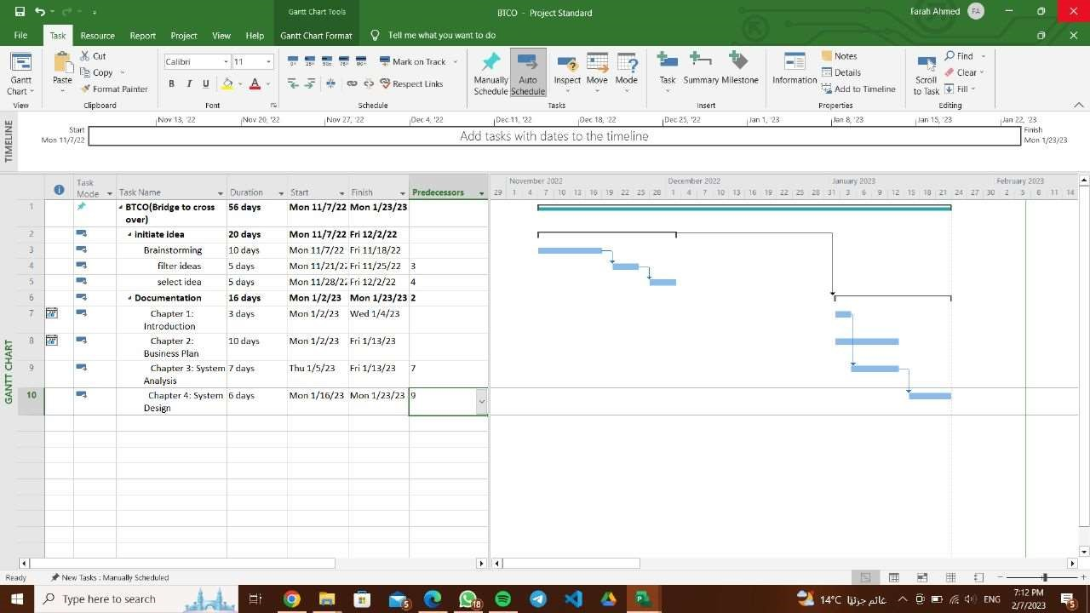

Chapter TWO

BUSINESS PLAN

Business Plan:

A business plan is an essential written document that provides a description and overview of your company’s future. All businesses should have a business plan. The plan should explain your business strategy and your key goals to get from where you are now to where you want to be in the future.

2.1 Executive summary:

* + - Name: BTCO (Bridge to cross over)
    - Legal form: General partnership
    - Number: 01198653215
    - Email: btcoforlearning@gmail.com
    - Type of business: service provider
    - Service description: BTCO is a service for Alsun, Education and Arts faculties students that helps them to find more than one illiterate person to educate in the simplest way in no time with minimum effort.
    - Vision:

To help in eliminating illiteracy, be trustworthy within the range of our business and try to provide the people who the students educate with job opportunities.

* + - Mission:

Targeting Alsun and Education students to help them solve their problem in finding people to teach how to read and write. Additionally, cooperating with co-working spaces to provide the students and people seeking to become literate with a comfortable environment to learn and teach in.

2.2.3 Startup Capital and Source of Capital:

|  |  |
| --- | --- |
| Start-up capital | |
| Investment | EGP 500,000 |
| Working Capital | EGP 622,400 |
| Total | EGP 1,122,400 |

**Table(1.1)**

|  |  |
| --- | --- |
| Sources of capital: |  |
| Partners | EGP 375,000 |
| Bank Loan | EGP 125,000 |

**Table (1.2)**

2.4 Owners:

|  |  |  |  |
| --- | --- | --- | --- |
| Name | Address | Function | Qualification |
| Farah Zaki | Maadi | CEO | graduate from Business Information System  (BIS), Helwan University |
| Zeina  Mohamed | Maadi | Public  Relations | graduate from Business Information System  (BIS), Helwan University  2 Years’ Experience in PR |
| Farah  Ahmed | Masr  El-  Gdeeda | Accountant | graduate from Business Information System  (BIS), Helwan University  2 Years’ Experience in Accountant |
| Amr  Mohamed | Nasr city | Web  Developer | graduate from Business Information System  (BIS), Helwan University |
| Farha  Mohamed | Shobra | Marketer | graduate from Business Information System  (BIS), Helwan University |

**Table(2.1)**

2.5 Business Idea and Market

2.5.1 Business Idea:

Using simple elegant technology. We provide Alsun, Education and Arts students with a website that’s very easy to use, the website contains data of illiterate people so that they can find them easily and educate them as its one of their requirements to graduate.

The main problem we solve is the difficulty the students face in finding illiterate people as they are in different places and not easy to find. The government added these requirements for Alsun, Education and Arts universities so that they can help in eradicating illiteracy. Illiteracy in Egypt is a threating problem as Illiteracy affects an individual in all aspects of their life. An illiterate individual cannot read and write, and thus cannot join the workforce or may work as unskilled labor, lack awareness to make an informed decision which affects them and their community. Further, children of illiterate parents do not receive the same education as children of educated parents. The percentage of illiteracy in developing countries as Egypt is pretty high because of so many problems as poverty many people will leave their education so that they can support their families and start working immediately, Another reason is the family pressure on women specifically from husbands, most of the husbands do not want their wife’s to learn, specially the illiterate husbands. In the rural areas it is nearly impossible to convince the husband to attach his wife to a learning system. The husband is convinced that his wife has no need to learn.

She only needs to serve her house, so what is the need of learning.

Our website solves this problem by facilitating the connection between the student and the illiterate person, so that the student can graduate with finishing all the graduation requirements, the illiterate person will learn for free so it’s a win win situation for both of them. We collect the data of illiterate people from charities, Campaigns we will do by ourselves and people who will volunteer to collect the data with us.

We are a b2c company where our target customer is the students, as it’s difficult for them to find illiterate people that they can teach.

What makes our service unique is that we connect students with the nearest person to their location who is willing to learn in no time. We also have a premium package that connects the student with an illiterate person providing them with a co-working space near to them so that they can meet in. Also one of our best features is that we will help the person that has been taught find a suitable job so this will improve his quality life and help improve all the society.

Because of our unique service, we have a small group of competitors, having small group of competitors will help us increase our market share. What makes us better than our competitors are that everything can be done from our website which saves students time, energy and any transportation cost.

Our main goal in pricing our service is to make it suitable for a student because students still don’t have their own income. we also have discount for large number of students and big discounts for university collaborations.

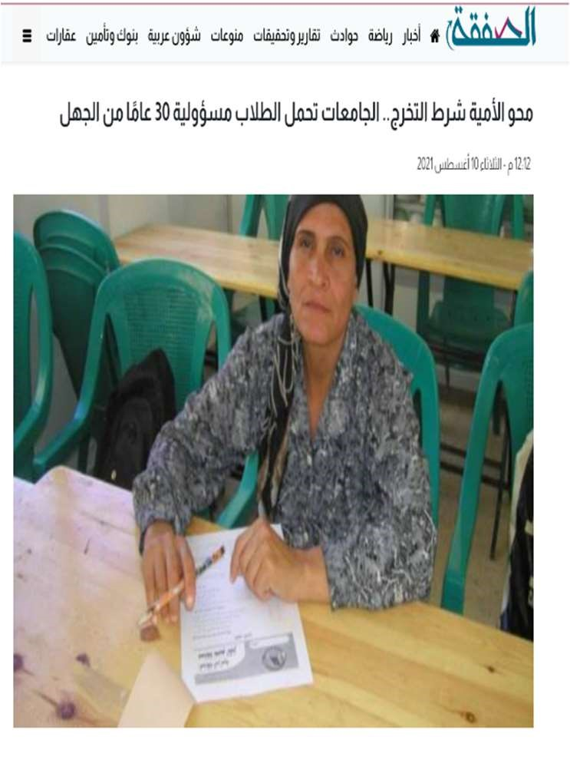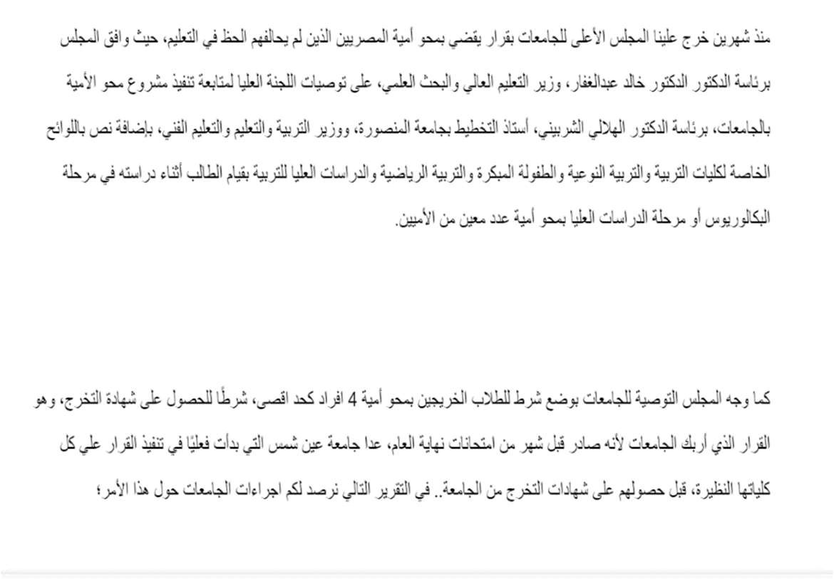

Figure(1.3)

2.5.2 Market research:

Market research is an organized effort to gather information about target markets and customers: know about them, starting with who they are. It is an important component of business strategy and a major factor in maintaining competitiveness. Market research helps to identify and analyze the needs of the market, the market size and the competition. Market research, also known as "marketing research," is the process of determining the viability of a new service or product through research conducted directly with potential customers. Market research allows a company to discover the target market and get opinions and other feedback from consumers about their interest in the product or service. This type of research can be conducted in-house, by the company itself, or by a third-party company that specializes in market research. It can be done through surveys, product testing, and focus groups. Test subjects are usually compensated with product samples or paid a small stipend for their time. Market research is a critical component in the research and development (R&D) of a new product or service.

2.5.2.1 Geographic segmentation:

As at our beginning will only focus on Cairo’s Alsun and Education faculties (Helwan, Cairo, Ain Shams)

So that most of the student’s location will be

* Helwan: Maadi, Helwan, 15th of May, Cairo: Dokki, Manial, Zamalek, Maadi,
* Ain shams: Helmayat El Zaytoun, El zahraa, El Helmya, Helioplis, Gessr el Suez.

2.5.2.2 Market Segmentation:

Stronger brand image. Marketing segment forces management to consider how it wants to be perceived by a specific group of people. Once the market segment is identified, management must then consider what message to craft. Because this message is directed at a target audience, a company's branding and messaging is more likely to be very intentional. This may also have an indirect effect of causing better customer experiences with the company.

Better targeted digital advertising. Marketing segmentation enables a company to perform better targeted advertising strategies. This includes marketing plans that direct effort towards specific ages, locations, or habits via social media.

➢ Based on Demographically:

We will target both genders (males and females) senior students age range in their twenties between 20 and 21. Not all students have fixed income even if some of them already have their work so we should provide the most affordable price.

2.5.2.3 Market size:

Market size is simply the number of people who could potentially become your customers.

As we find we are competing in an unsaturated market as our obvious competitor is “EL Abassya office” and we’ll collaborate with it to provide us with the data of the illiterate people.

Also, we are totally aware of customer needs and providing the best price with no effort and features to facilitate the process on the contrast “EL Abassya office” that only provides the data and the students should go their every time he/she needs to educate an illiterate person.

Penetration Rate = (Number of Customers ÷ Target Market Size) ×

100

= (2500 ÷ 10000) *100

=25%

2.5.2.4 Total market share:

Market share–also known as revenue market share or market share by revenue–is the portion of an industry that is controlled by a single company.

The total market is alsun and education faculties all over Egypt but we only focus on Cairo.

2.6 SWOT Analysis:

|  |  |
| --- | --- |
| Strength   * Instant connection between the 2 parties. * Affordable price for students * Free service for the uneducated people * Collaboration by many charities and El-Abasia office * Ensuring safety of students as we check the data and their willingness   to learn | Weakness   * Small market share * Small profit * Lack of experience * Difficulty obtaining capital and finance * Not enough data about the uneducated people |
| Opportunities   * Offering useful features * Attracting students by different offers * Very few competitors * Innovative idea * Can be expanded to other regions * We can use new technologies as we can make a mobile applications * High demand from students * Improves the society • Offering trainings. | Threats   * Limited for specific time. * Low income * Quite changeable prices. * Lack of awareness * Resistance from illiterate people * Hard to reach the uneducated people |

**Table(3.1)**

2.7 Survey:

We sent this form to the students through social media channel and we got 121 responses.

As those responses helped us in:

1-Determining whether this service is beneficial or not for the students

2-Reaching the customer satisfaction by achieving the most affordable price.

3-Knowing their reaction on our packages.

Figure 1.4

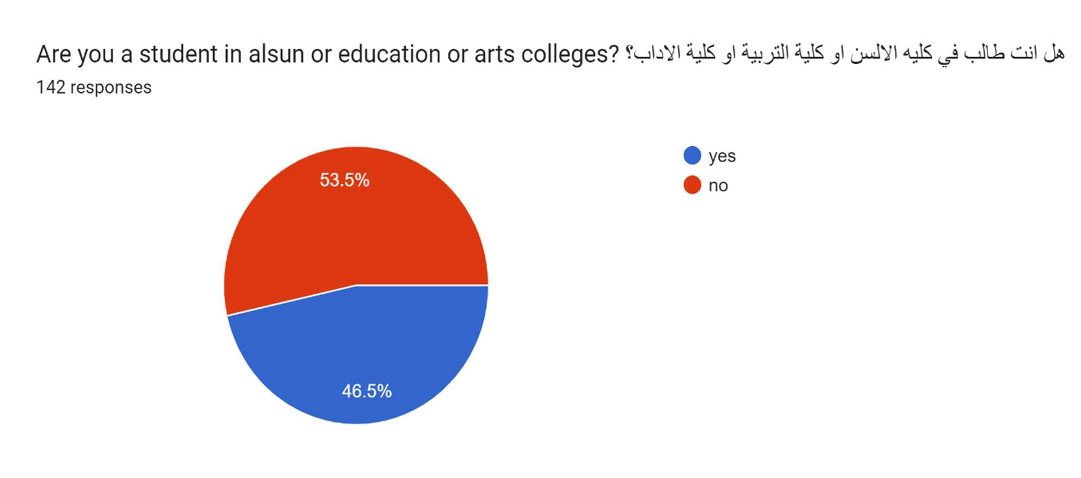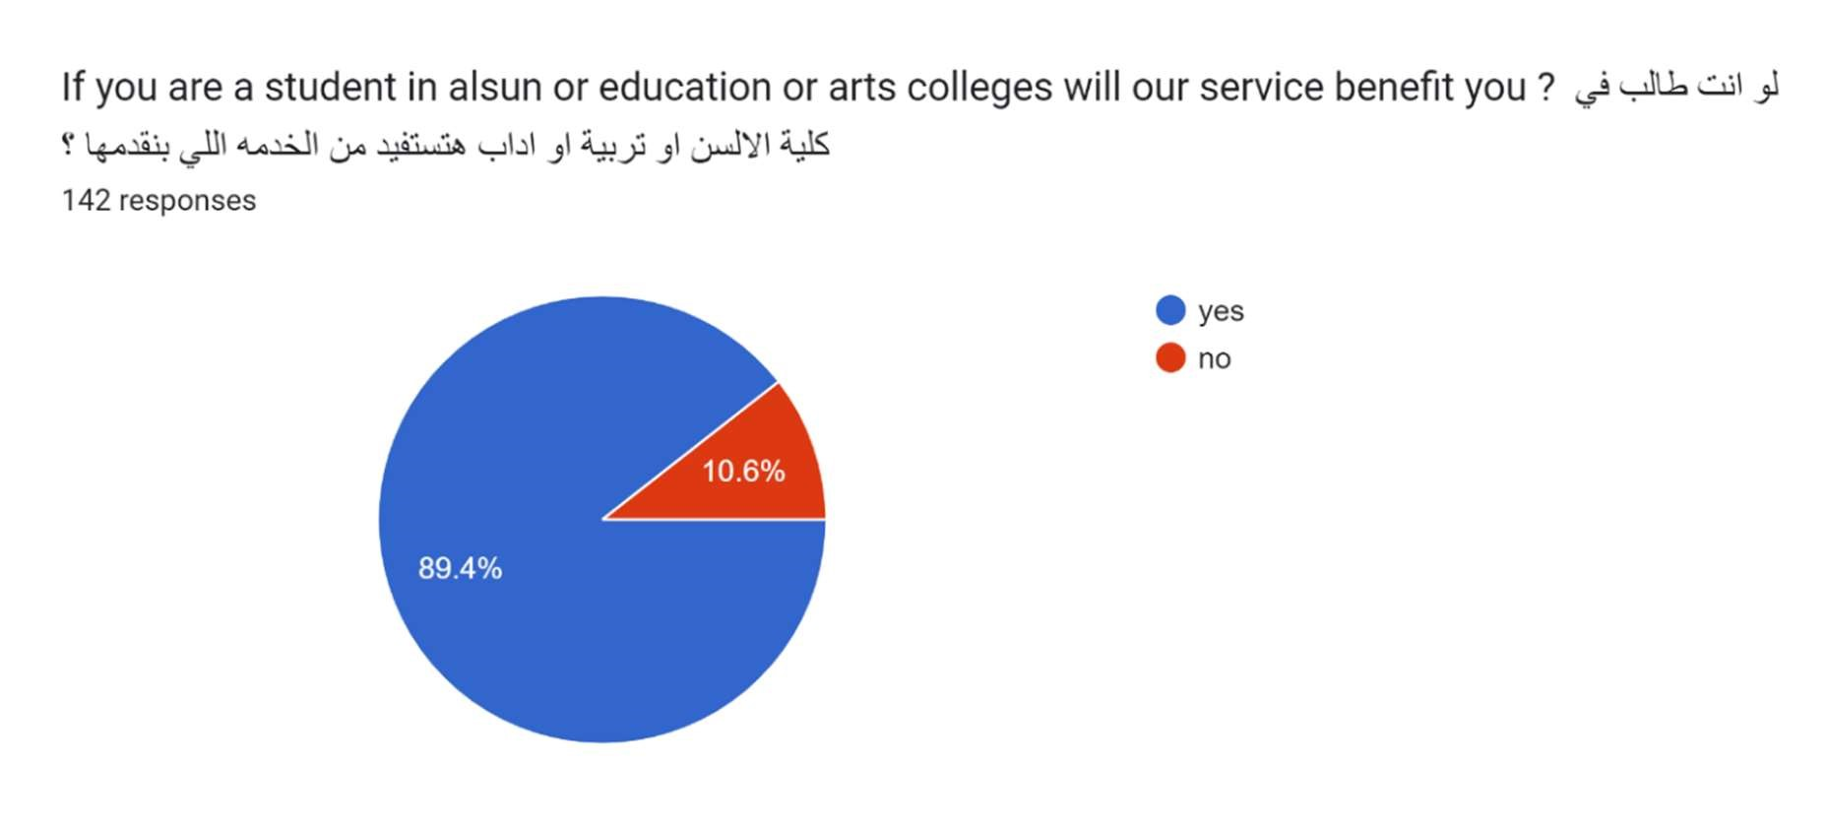

Figure 1.5

Figure 1.6

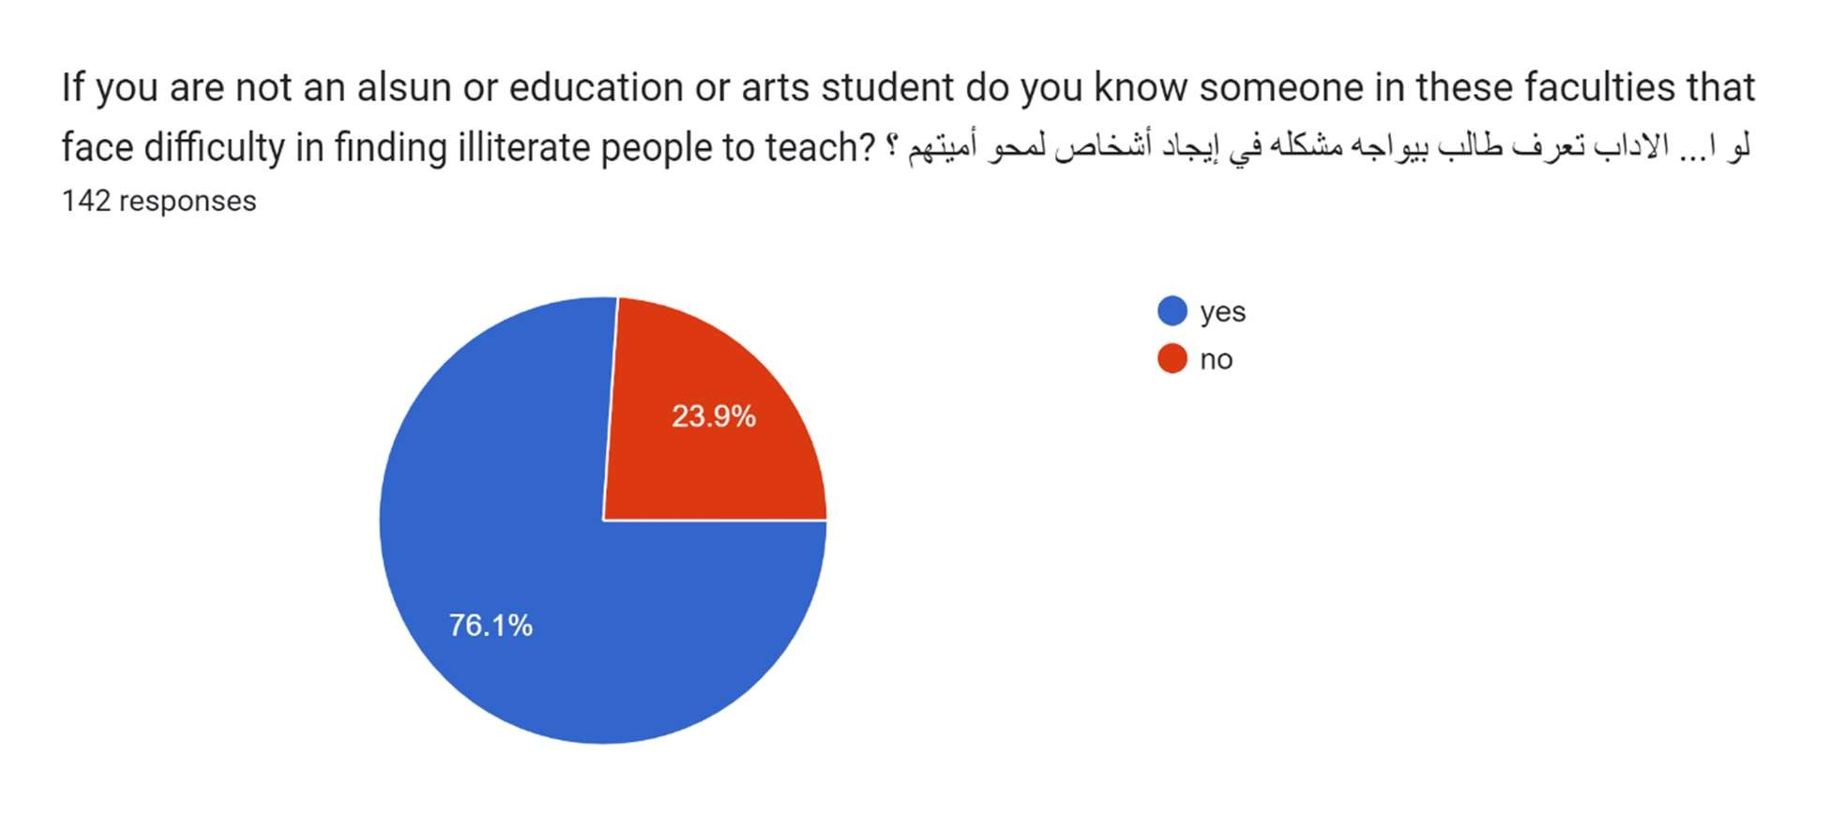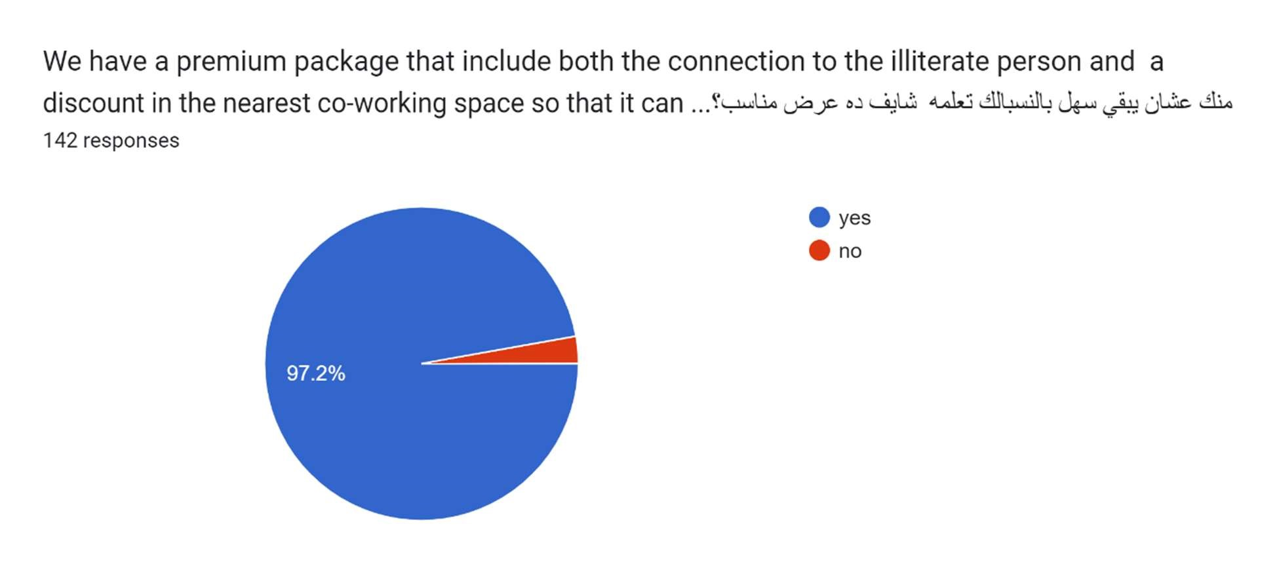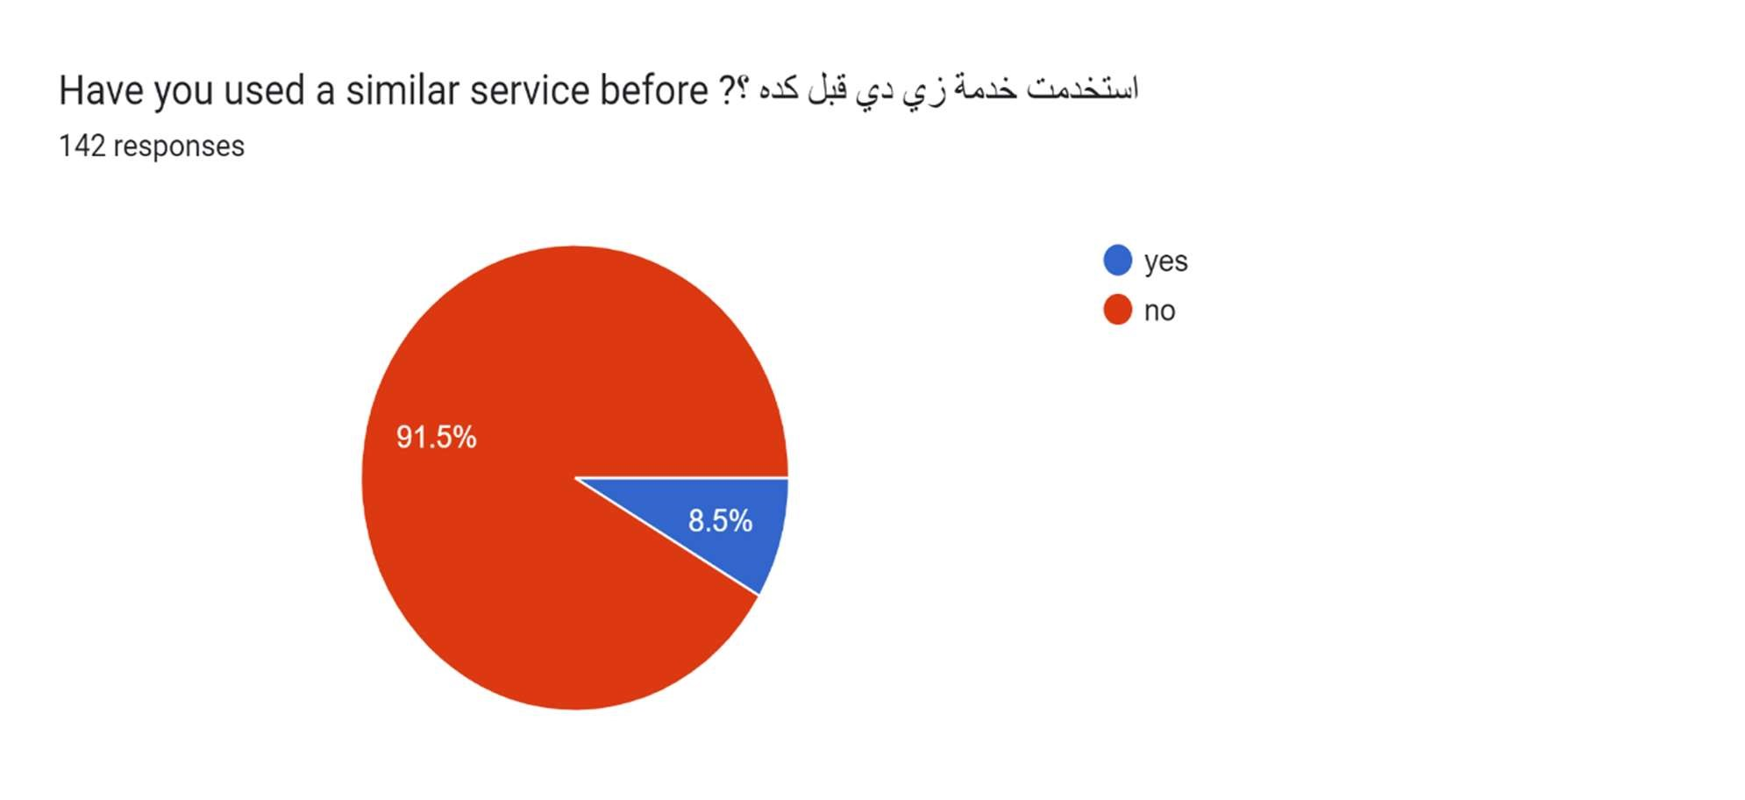

Figure 1.7 and 1.8

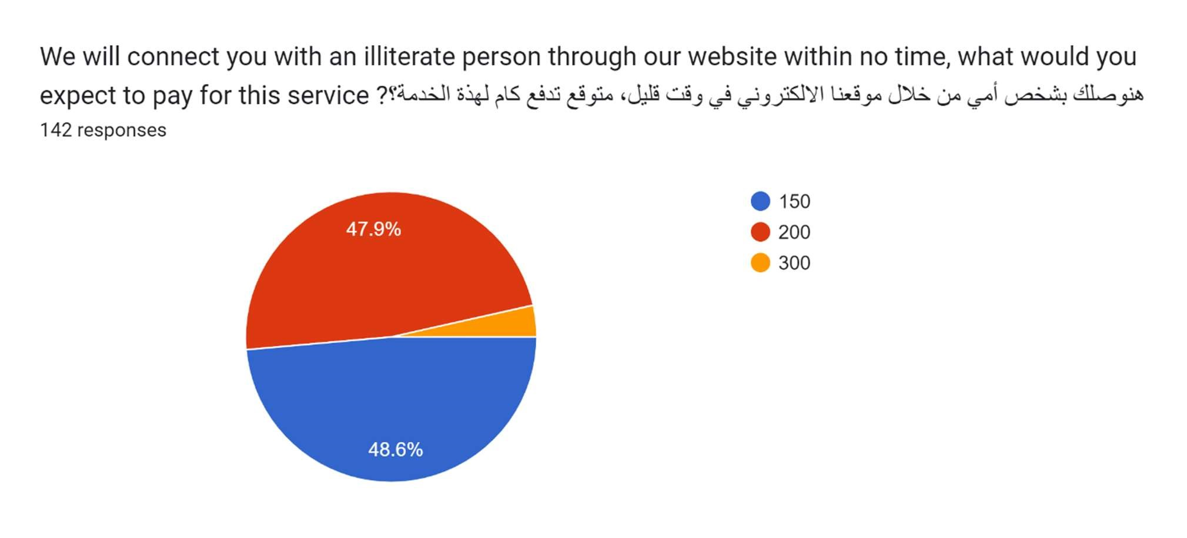

Figure 1.9

2.8 Marketing Plan

A marketing plan is a strategic roadmap that businesses use to organize, execute, and track their marketing strategy over a given period. Marketing plans can include different marketing strategies for various marketing teams across the company, all working toward the same business goals.

2.9 Marketing mix

A business’s marketing mix refers to the methods, strategies and tools used to reach out to potential customers and drive sales. A good marketing mix contains a range of key strategies that allow business owners to target a specific market and develop a brand image that engages customers. In a marketing plan, or the specific steps a business takes to advertise, the marketing mix identifies all of the elements that influence an ideal target market and how they work together to increase reach.

2.9.1 Product

We offer services for the students of Alsun and education universities, to solve their problem in the difficulty of finding an illiterate person that they can teach for their graduation requirements. We are the bridge that connects between the student and the illiterate person. Our best feature is that we connect the student with the nearest illiterate person from where the student live.

|  |  |  |  |
| --- | --- | --- | --- |
| Service | 1 | 2 | 3 |
| Name | Basic | Premium | Standard |
| Specification | We connect the student with the illiterate person. | We connect the student with the illiterate person  proving them with a suitable co-  working space they can work in. | We connect the student with 4  illiterate people in a package with a discount. |
| After the sale | We provide students with guidance before they start teaching, we are always here for any questions and we take feedback from both the student and the illiterate person. | | |

Table(4.1)

2.9.2 Price

We are setting the price based on cost-plus pricing.

Cost-plus pricing, also called markup pricing, is the practice by a company of determining the cost of the product to the company and then adding a percentage on top of that price to determine the selling price to the customer.

Cost-plus pricing is a very simple cost-based pricing strategy for setting the prices of goods and services. With cost-plus pricing you first add the direct material cost, the direct labor cost, and overhead to determine what it costs the company to offer the product or service. A markup percentage is added to the total cost to determine the selling price. This markup percentage is profit. Thus, you need to start out with a solid and accurate understanding of all the business costs and where those costs are coming from. Table(4.2)

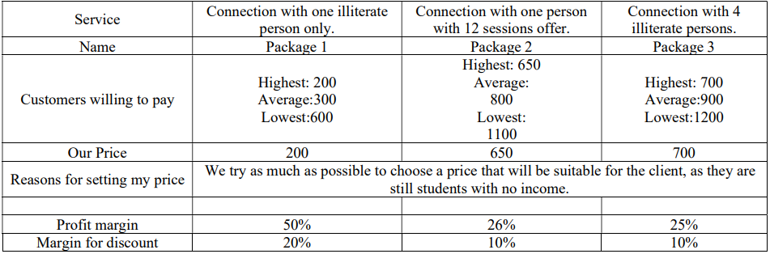

* If we made a collaboration with a large number of university students, we will provide them with a discount.

*Speaking of package 2 pricing method, we made a collaboration with co-working spaces providing them with many students and sessions, in contrast they will offer us a discount on each hour per session.

2.9.3 Place

A business’s online presence, regardless of industry, can have a massive impact on its success. Having a strong online presence, particularly a website, can be make or break for generating more revenue. One of the most intriguing reasons to have a website for your business is because it can increase your chances of getting leads. Once people find you online, become interested in your product or service and want to know more, they’ll know how to contact you thanks to the information on your website

Location of our business: The main place for us is our website. But we plan on having our office when we expand that will be specially for collecting the data of the illiterate people.

2.9.4 Promotion

Promotions refer to the entire set of activities, which communicate the product, brand or service to the user. The idea is to make people aware, attract and induce to buy the product, in preference over others.

Our promotions mainly focus on making advertisements on college campus through

• Sponsoring student activities

* Collaboration with student activities as:

* + Cairo university: SCCI, MSP.
  + Helwan university: IEEE.
  + Ain Shams university: AIEB.

We will also advertise/communicate with college students through digital marketing. Most college students grow with tech and internet. And we will do this through:

* + Facebook
  + YouTube

Also, there will be public relations employees who will go to the headquarters of universities to offer them our service.

2.10 Legal form:

The legal form of our project is General partnership.

As it is a business arrangement by which two or more individuals agree to share responsibilities, assets, profits, and financial and legal liabilities of a jointlyowned business. In a general partnership, partners agree to be personally responsible for potentially unlimited liability. Liabilities are not capped as they would be in, say, a partnership formed as a limited liability partnership or a limited liability company (LLC). Partners are responsible for the debts, and the seizure of an owner's assets is a possibility. Furthermore, any partner may be sued for the business's debts. Since a general partnership is a pass-through entity where income flows straight to the owners, each partner reports their share of partnership profits or losses on their personal tax returns. The partnership itself is not taxed.

Advantages:

1. Duty of Loyalty: Partners must not pursue personal activities that can harm the partnership. They must place the partnership’s best interests above personal interests. And they must forego all conflicts of interest that may exist with the partnership due to those personal interests
2. Compensation: Rather than a salary, partners receive distributions from the partnership’s profits. These distributions should be in accord with the allocation of profits detailed in the partnership agreement. If the partnership has no agreement, profits should be equally distributed according to RUPA (mentioned above). Money that the partnership does not distribute to partners can be used for other purposes (e.g., reinvested in the business).

Disadvantages:

1. Personal assets are at-risk within a general partnership: Unlike other business structures, a general partnership does not act as an independent entity. That means the financial protections which partners have in a corporation structure are not found within this structure. A general partnership is more like a sole proprietorship instead. If there is an issue which affects the finances of the organization, then each partner faces a potential personal liability for costs that may be incurred
2. General partners are deemed to be agents: Every general partner that is part of the organization is deemed to be an agent of the partnership relationship. That

26 | P a g e

means if one general partner is representing the company or carrying along with partnership business, then every other partner can be held out as partners when dealing with a third party. That also means that every partner in the structure is liable for the debts that are incurred by the other partners in the course of doing business.

1. It can be difficult to raise money in a general partnership: Because each person within a general partnership has personal taxation liabilities, along with general debt liabilities, that fall somewhat outside of their direct control, investors are not a big fan of this type of business. That can make it difficult to find enough money to continue growing outside of the personal networks of the general partners. For that reason, many general partnerships tend to stay as a small business or eventually restructures itself into a corporation or LLC.

2.11 Organization and Staff:

|  |  |  |  |
| --- | --- | --- | --- |
| Name | Function | Job Description | Salary per  month |
| Farah Zaki | CEO | Manages and directs the company. | 3,000 |
| Zeina  Mohamed | PR | Coordinating all public relations activities | 3,000 |
| Farah  Ahmed | Accountant | make critical financial decisions by collecting, tracking, and correcting the company's finances. | 3,000 |
| Amr  Mohamed | Web  Developer | makes and maintains websites | 3,000 |
| Farha  Mohamed | Marketer | responsible for creating advertising  campaigns, pricing strategies and targeting the demographic data of their target audience | 3,000 |

27 | P a g e

Table(5.1)

**2.12.1 Startup capital:**

Table(6.1)

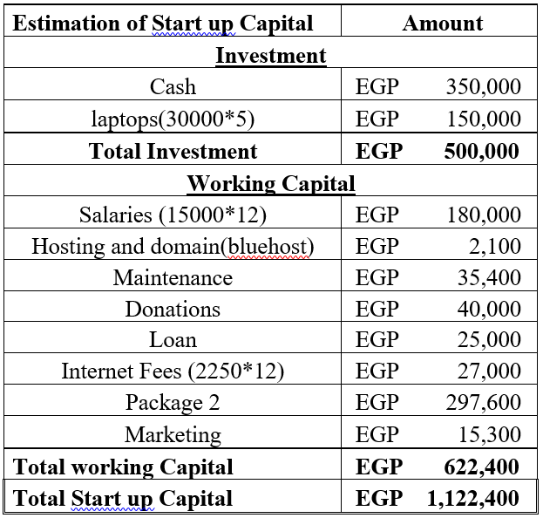

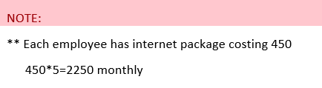

**2.12.2 Marketing Budget:**

The total market budgeting is 15,300

Table(6.2)





**2.12.3 source of funding**

Table(6.3)





**Loan**

*we have taken a family loan of 125,000 and we will repay it over the course of five years



**2.12.4 Expected Revenues**

*our penetration rate is 25% so we are targeting 2,500 of the total market share

****\*As our customers are students, so on July, August and September are the final holidays so we have no profit at these three months. As our service is very specific to students during their college days. Table(7.1)

**2.12.5 Expected Expenses**

Table(8.1)



**2.12.6 Expected profit Margin**

Table(9.1)

**2.12.7 Cash Flow Statement:**

Table(10.1)



**2.12.8 Opening Balance Sheet:**

Table(11.1)



Chapter THREE

# System Analysis

|  |  |
| --- | --- |
| **UML Use Case** | |
| **User Use Case** | **Figure 1.1** |
| **Admin Use Case** | **Figure 1.2** |
| **UML Sequence** | |
| **Register Sequence** | **Figure 2.1** |
| **Login Sequence** | **Figure 2.2** |
| **Logout Sequence** | **Figure 2.3** |
| **Forget Password Sequence** | **Figure 2.4** |
| **Service & Payment Sequence** | **Figure 2.5** |
| **Contact Us Sequence** | **Figure 2.6** |
| **Add Illiterates Sequence** | **Figure 2.7** |
| **Database Sequence** | **Figure 2.8** |
| **UML Activity** | |
| **Register Activity** | **Figure 3.1** |
| **Login Activity** | **Figure 3.2** |
| **Forget Password Activity** | **Figure 3.3** |
| **Logout Activity** | **Figure 3.4** |
| **Service & Payment Activity** | **Figure 3.5** |
| **Contact Us Activity** | **Figure 3.6** |
| **Add Illiterates Activity** | **Figure 3.7** |
| **Database Activity** | **Figure 3.8** |
| **Database** | |
| **ERD** | **Figure 4** |
| **Database Schema** | |
| **Mapping** | **Figure 5** |
| **Site map** | |
| **Site map** | **Figure 6** |

3.1INTRODUCTION

Education is not a skill to earn, its mandatory for life and live. Due to the difficulty of life and commitments, some people face a problem in the difficulty of education and tend to leave it and go to work to earn money and help the family in living. But life always gives you another chance, and this opportunity is represented in the students who must eradicate the illiteracy of some uneducated people. And here lies our role in linking these students with uneducated people without being subjected to financial exploitation.

**Functional requirements (User):**

* Register
* Login
* Forget password
* Logout
* Choose package
* Make Payment
* Add Illiterates
* Contact Us

**Functional requirements (admin):**

* Register
* Sign in
* Update database

**Non-functional requirements:**

* Performance: serving 500 client per hour with 5 seconds response
* Scalability: serving 500 clients while maintain optimal performance
* Portability: website runs on any web browsers that support HTML5
* Reliability: The system must perform without failure in 90 percent of use cases during a month
* Maintainability: The mean time to restore the system (MTTRS) following a system failure must not be greater than 10 minutes
* Availability: The web dashboard must be available to user’s 97 percent of the time every month
* Security: all data is encrypted to increase safety of user’s data also no one can access user’s data except user or admin
* Usability: system interface is user friendly supporting 2 languages (Arabic & English) to be easily to use with failure 5%

**UML Use Case:**

Use case diagram is a way to summarize details of a system and the users within that system. It is generally shown as a graphic depiction of interactions among different elements in a system. Use case diagrams will specify the events in a system and how those events flow, however, use case diagram does not describe how those events are implemented

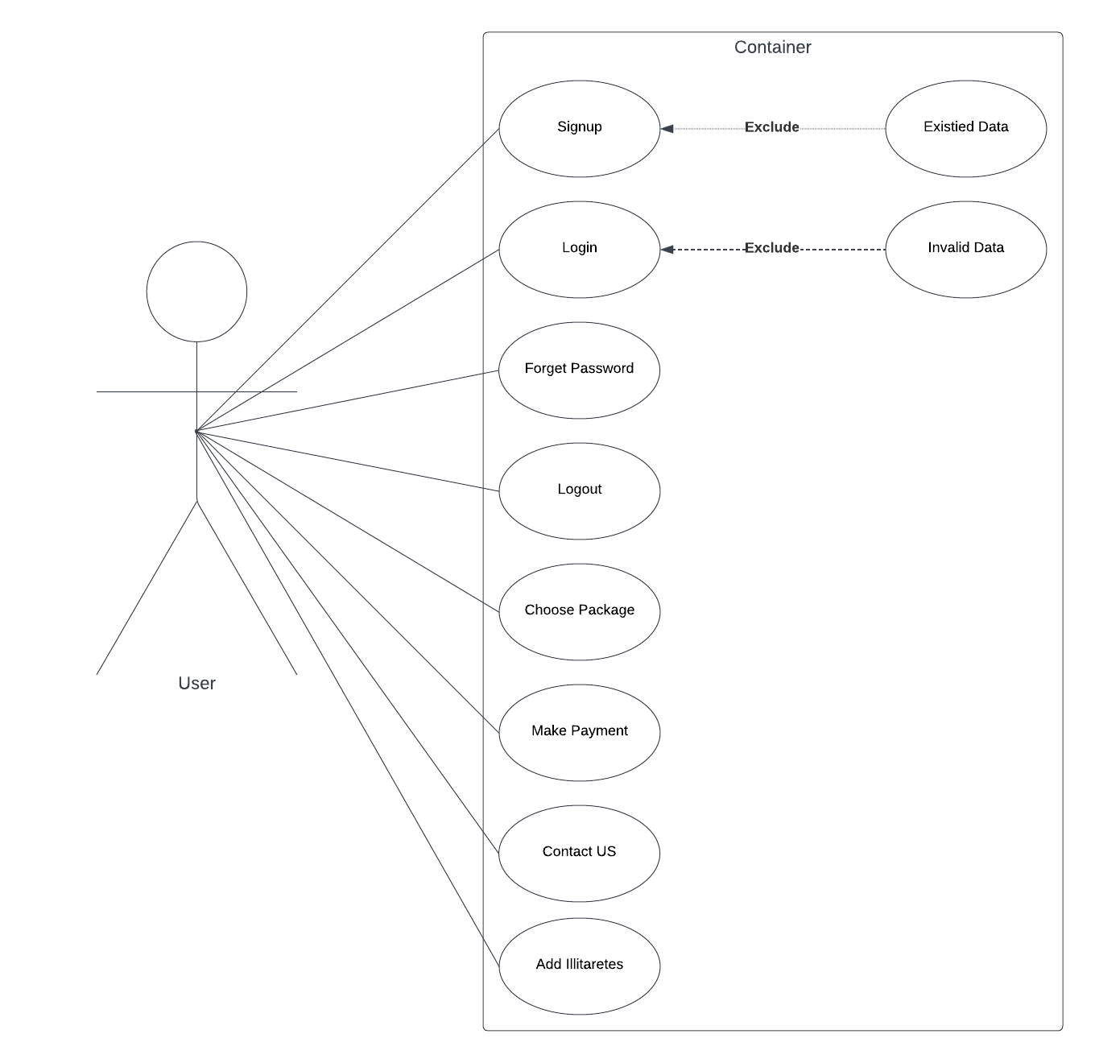**User use case:**

Figure describes what is the events that user will use

Figure 1.1

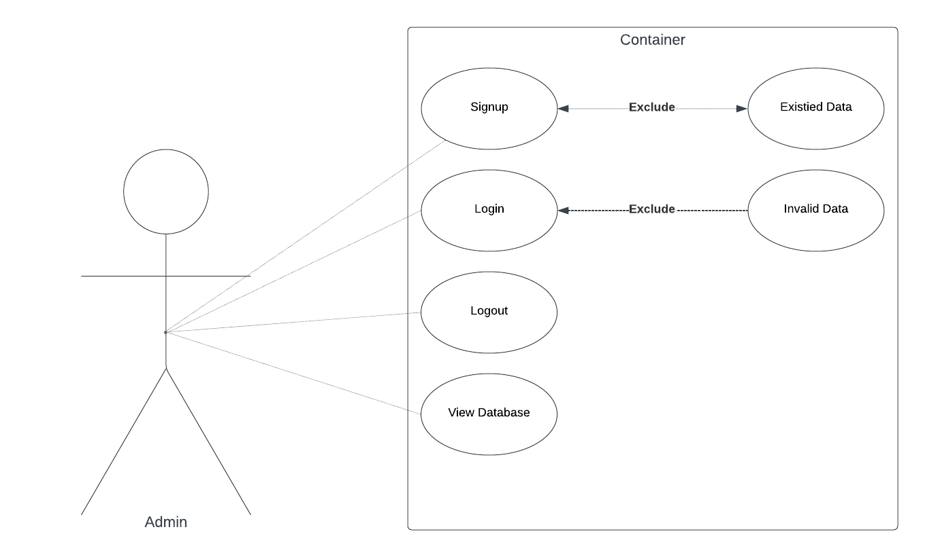**Admin Use Case:**

Figure 1.2

Figure describes what is the events that admin will use

**UML Sequence:**

UML Sequence Diagrams are interaction diagrams that detail how operations are carried out. They capture the interaction between objects in the context of a collaboration. Sequence Diagrams are time focus and they show the order of the interaction visually by using the vertical axis of the diagram to represent time what messages are sent and when.

**Register Sequence:**

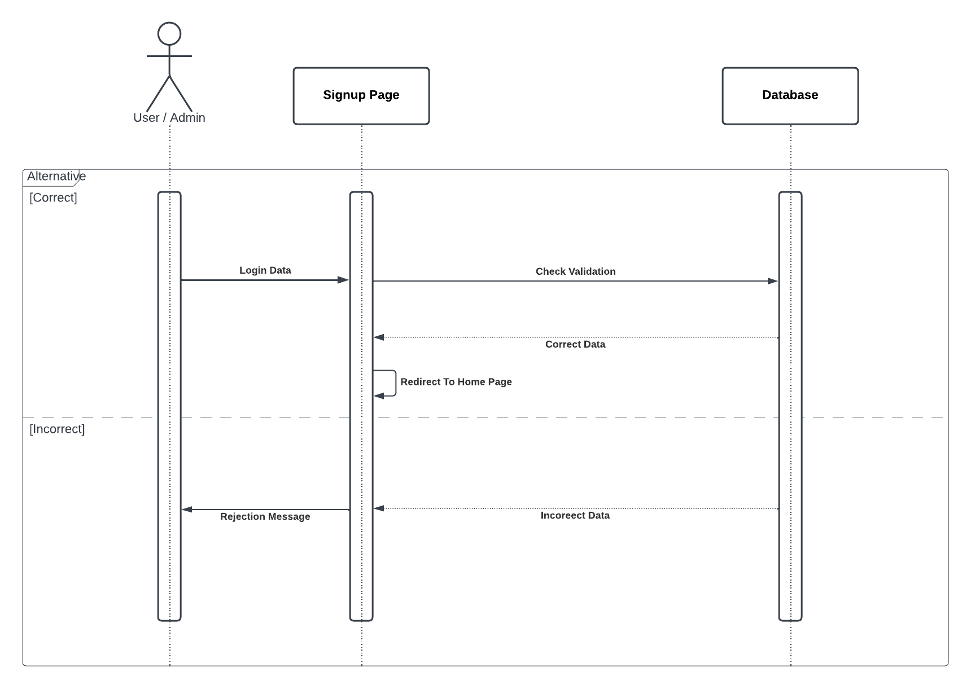

Figure 2.1

Figure describes how register operation done in system

**Login Sequence:**

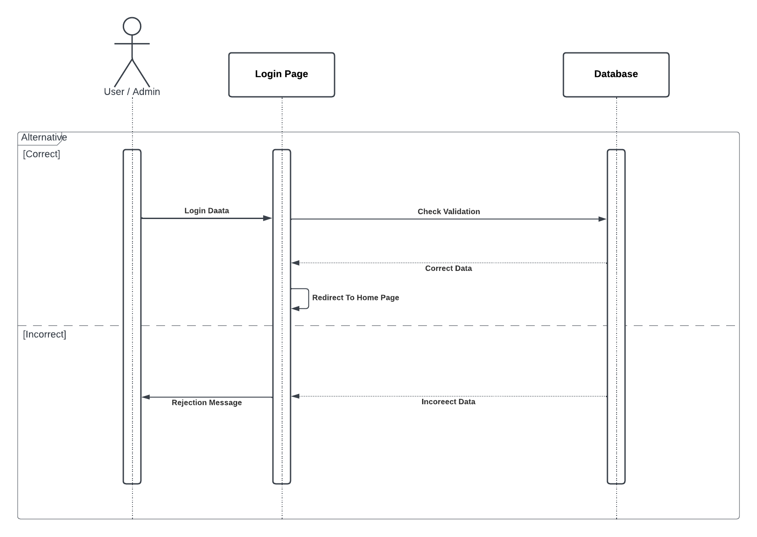

Figure describes how Login operation done in system

Figure 2.2

**Logout Sequence:**

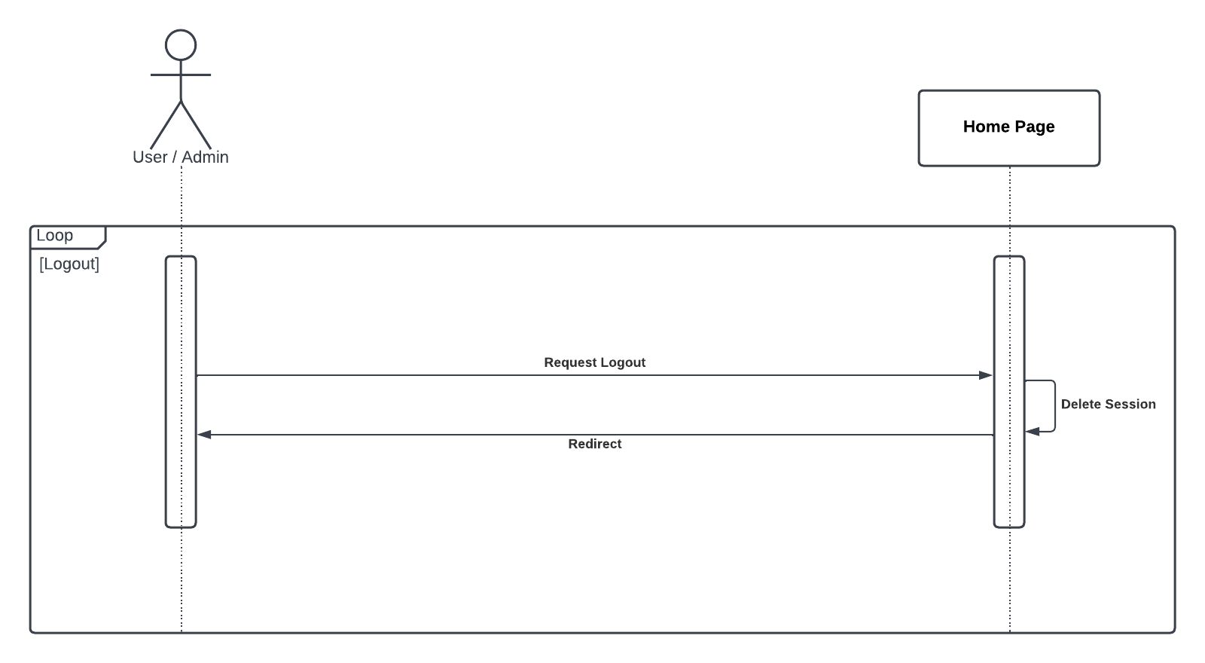

Figure 2.3

**Forget Password Sequence:**

Figure describes how logout operation done in system

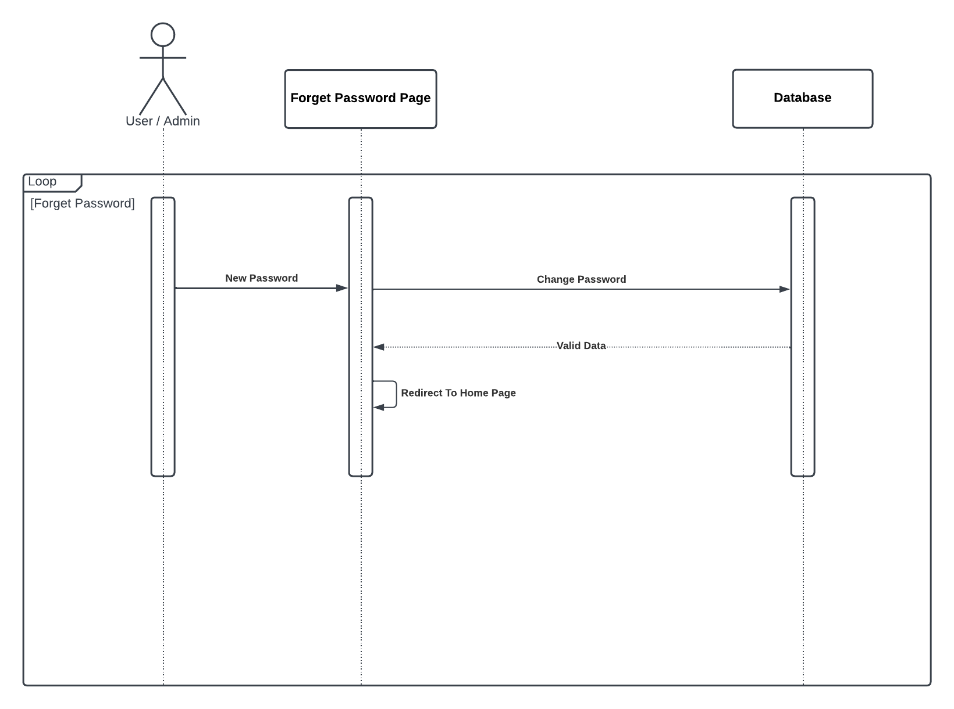

Figure 2.4

Figure describes how forget password operation done in system

**Service & Payment Sequence:**

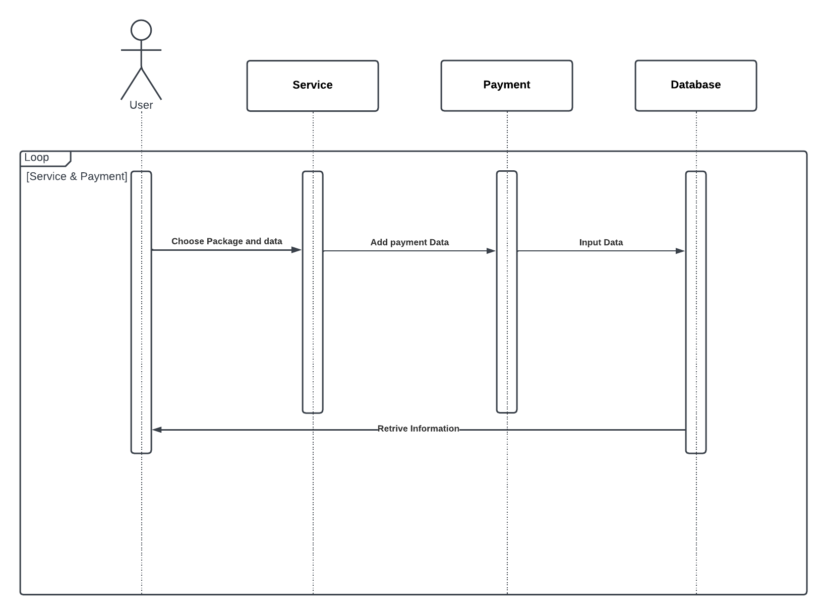

Figure 2.5

Figure describes how Service & Payment operation done in system

**Contact Us Sequence:**

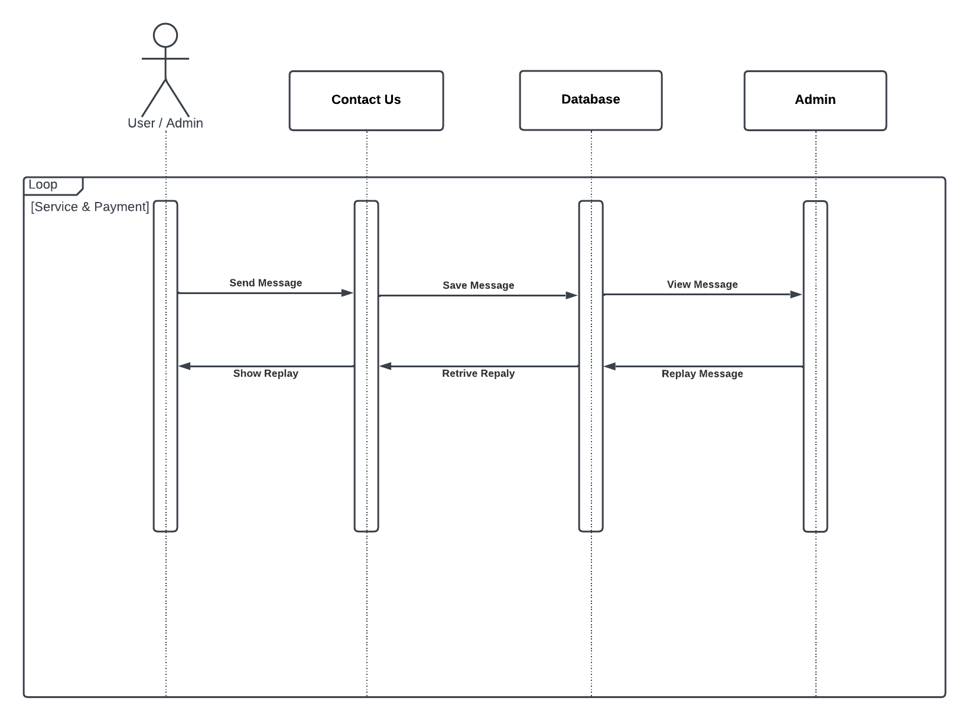

Figure describes how Contact Us operation done in system

Figure 2.6

**Add Illiterates Sequence:**

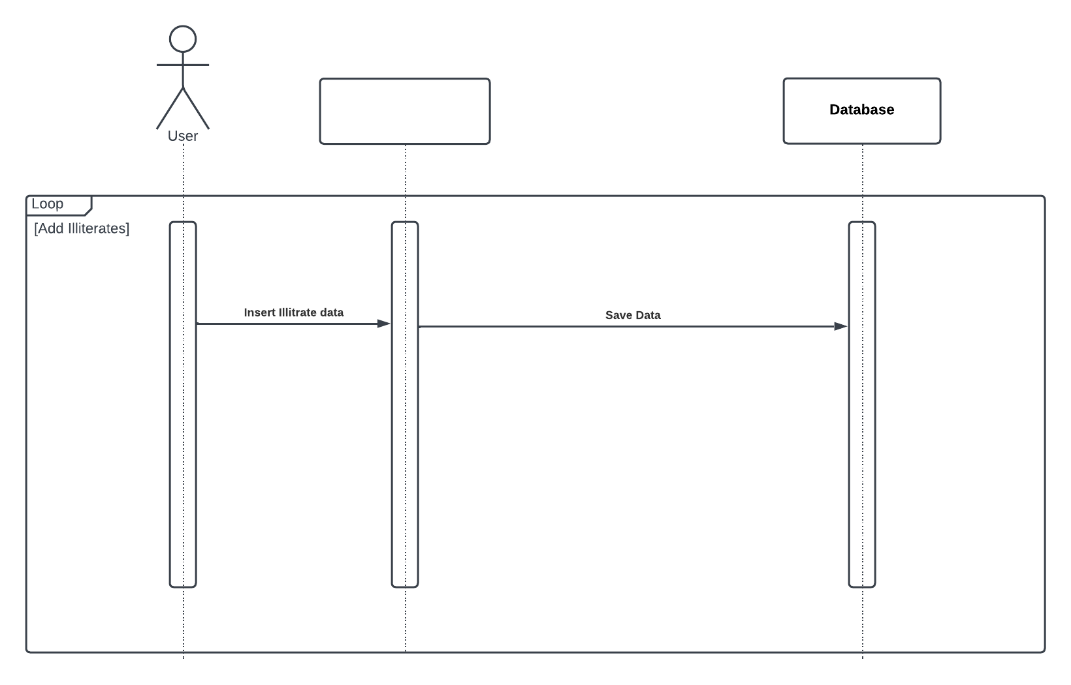

**Home**

Figure 2.7

Figure describes how Add Illiterates operation done in system

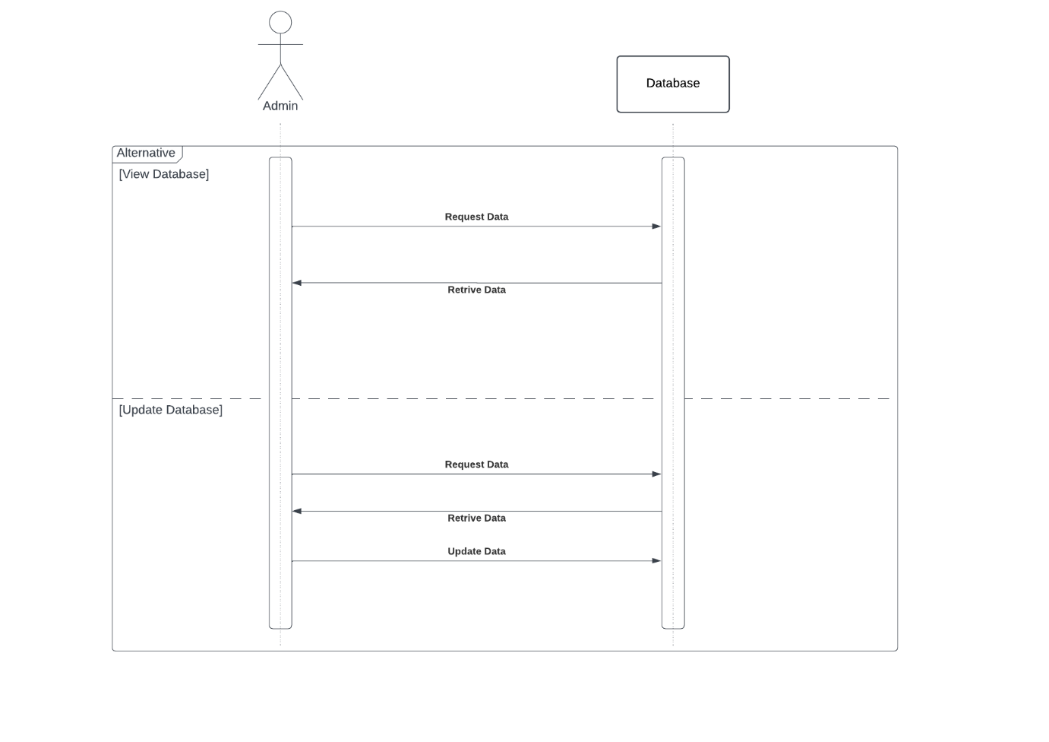**Database Sequence:**

Figure describes how Database operation done in system

Figure 2.8

Chapter Four

# System design

**UML Activity:**

Activity diagram is another important behavioral diagram in UML diagram to describe dynamic aspects of the system. Activity diagram is essentially an advanced version of flow chart

**Register Activity:**

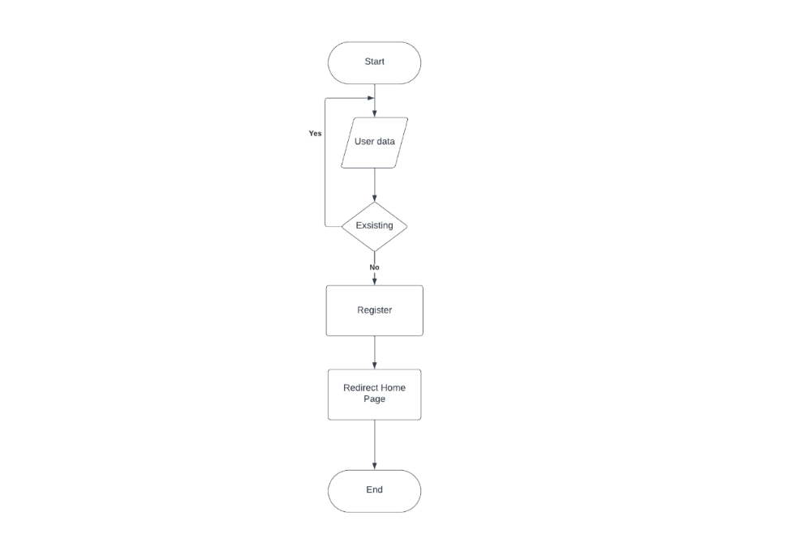

Figure 3.1

Figure describe dynamic aspects of Register

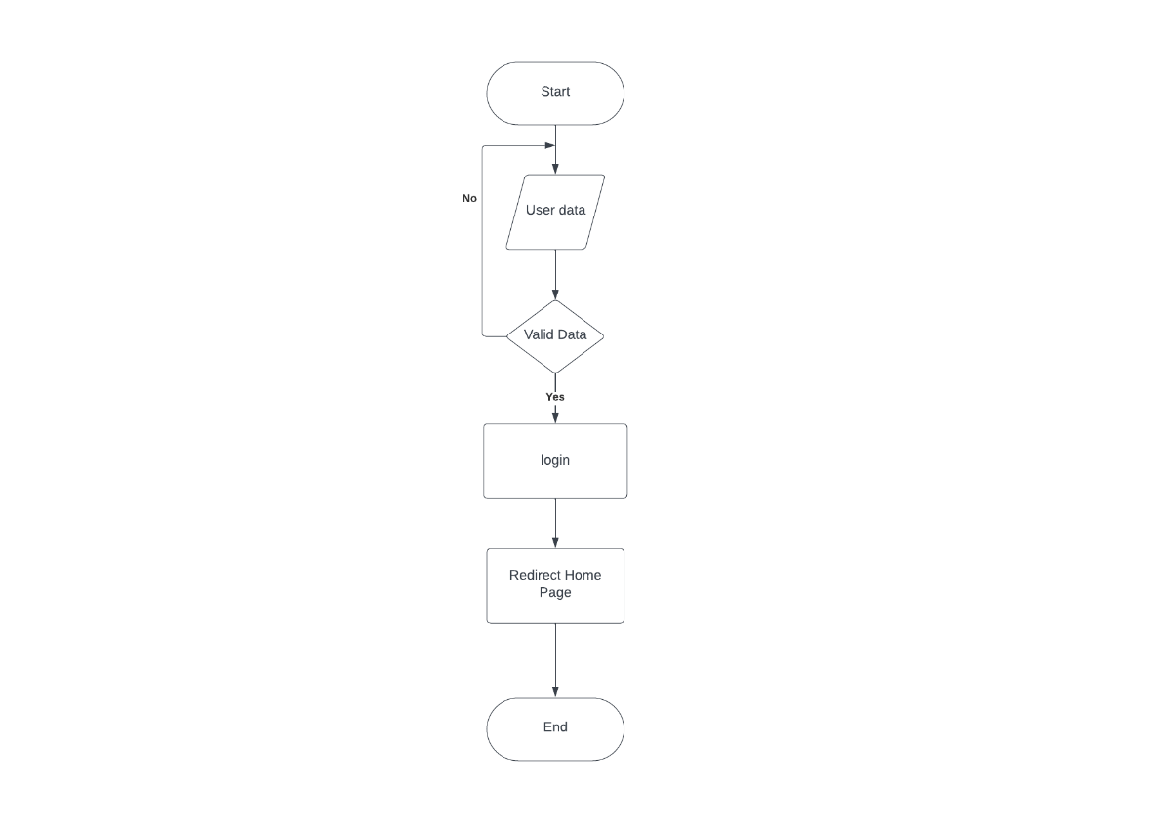

**Login Activity:**

Figure describe dynamic aspects of Login

Figure 3.2

**Forget Password Activity:**

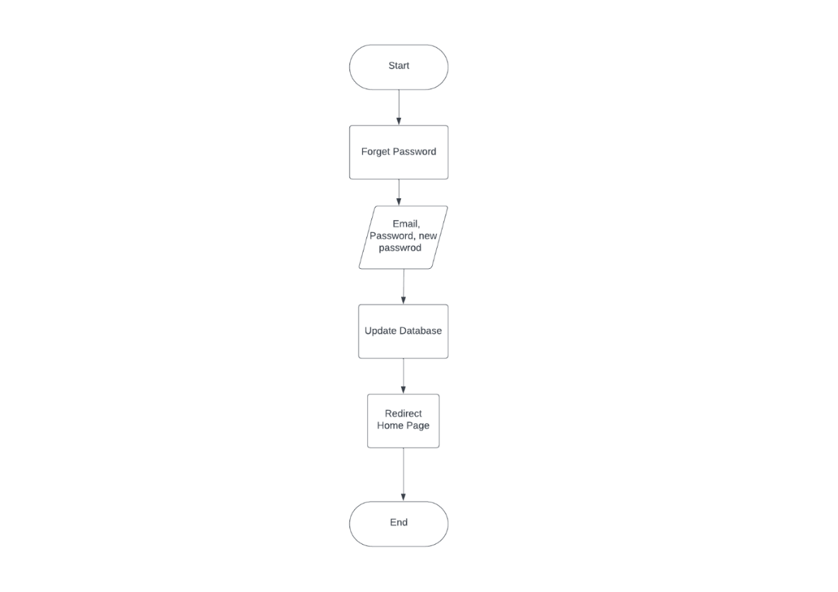

Figure 3.3

Figure describe dynamic aspects of Forget Password

**Logout Activity:**

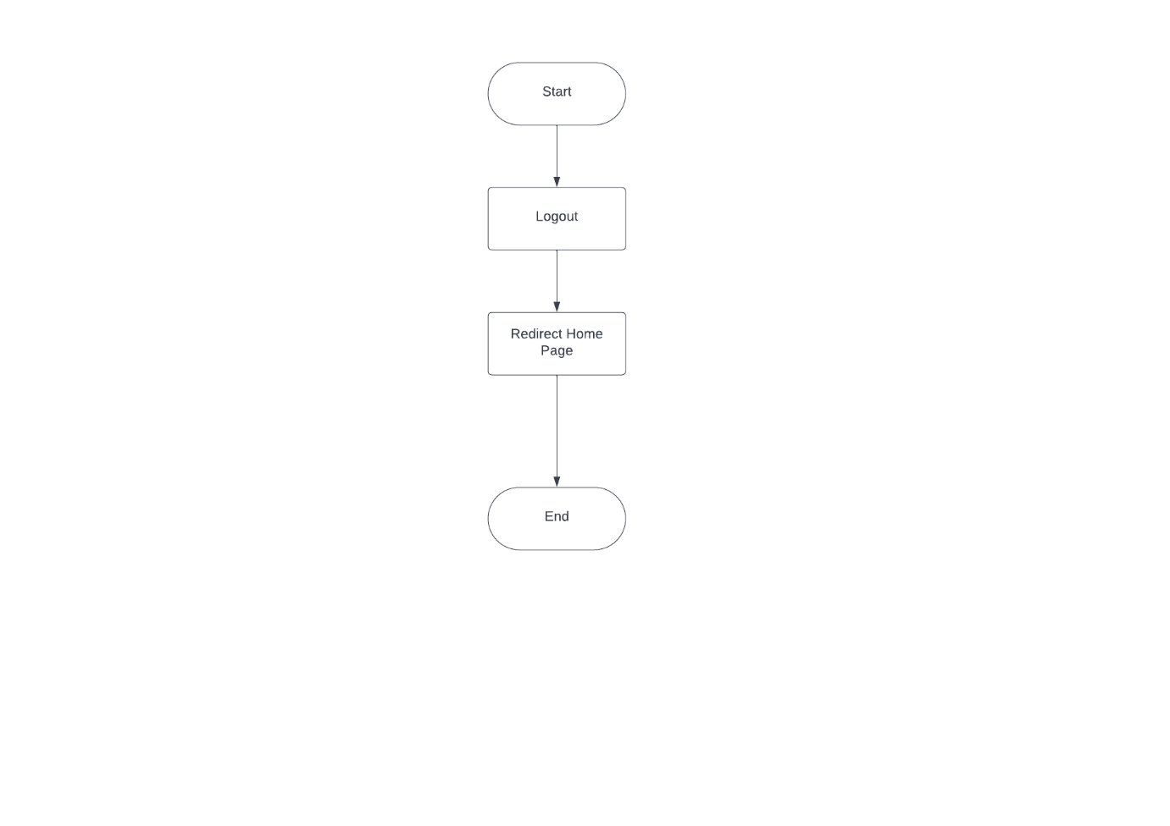

Figure 3.4

Figure describe dynamic aspects of Logout

Figure 3.4

**Service & Payment Activity:**

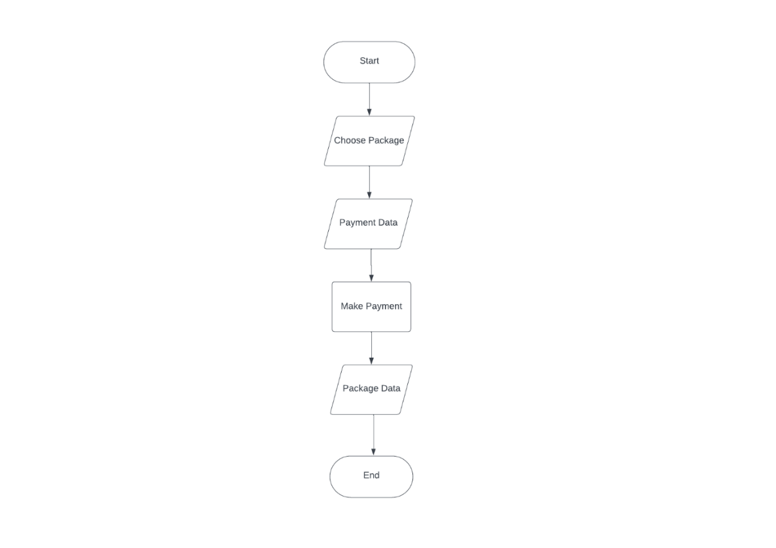

Figure 3.5

Figure describe dynamic aspects of Service & Payment

**Contact Us Activity:**

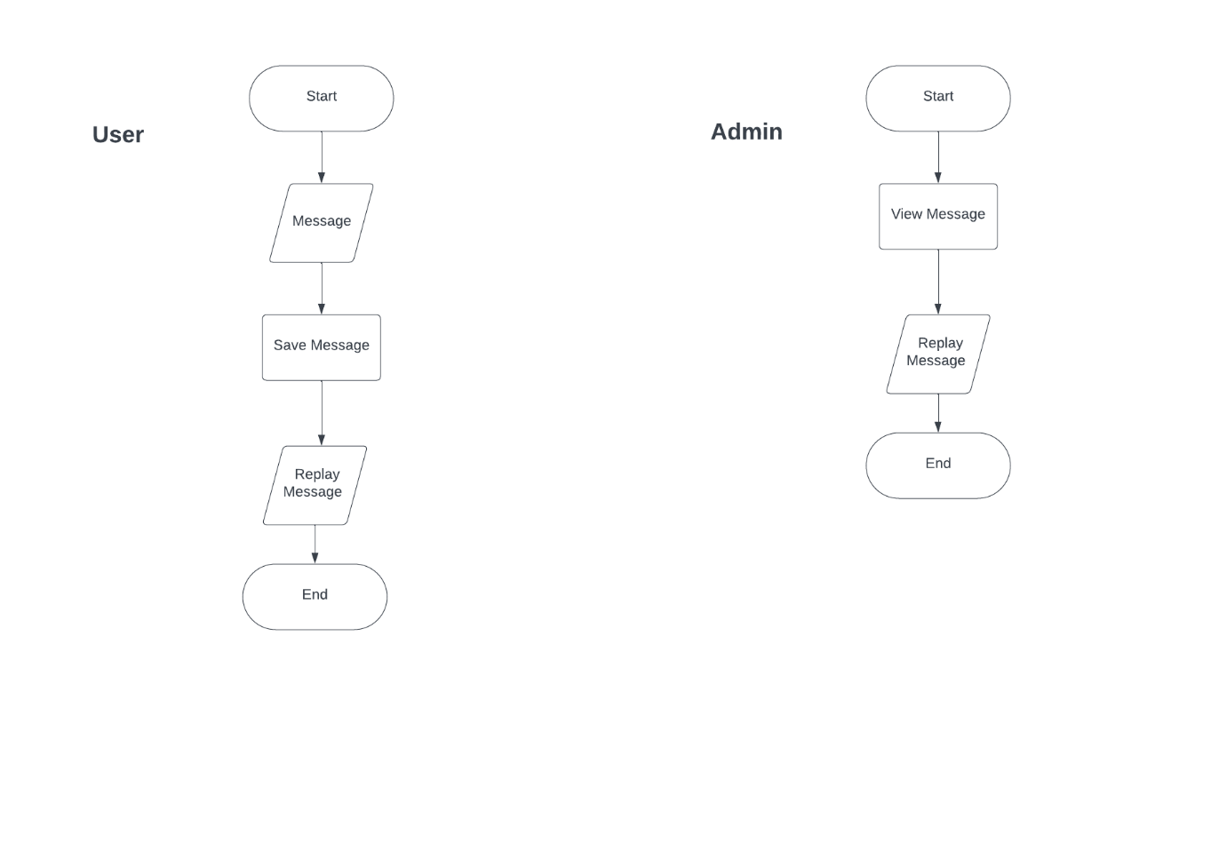

Figure 3.6

Figure describe dynamic aspects of Contact Us

**Add Illiterates Activity:**

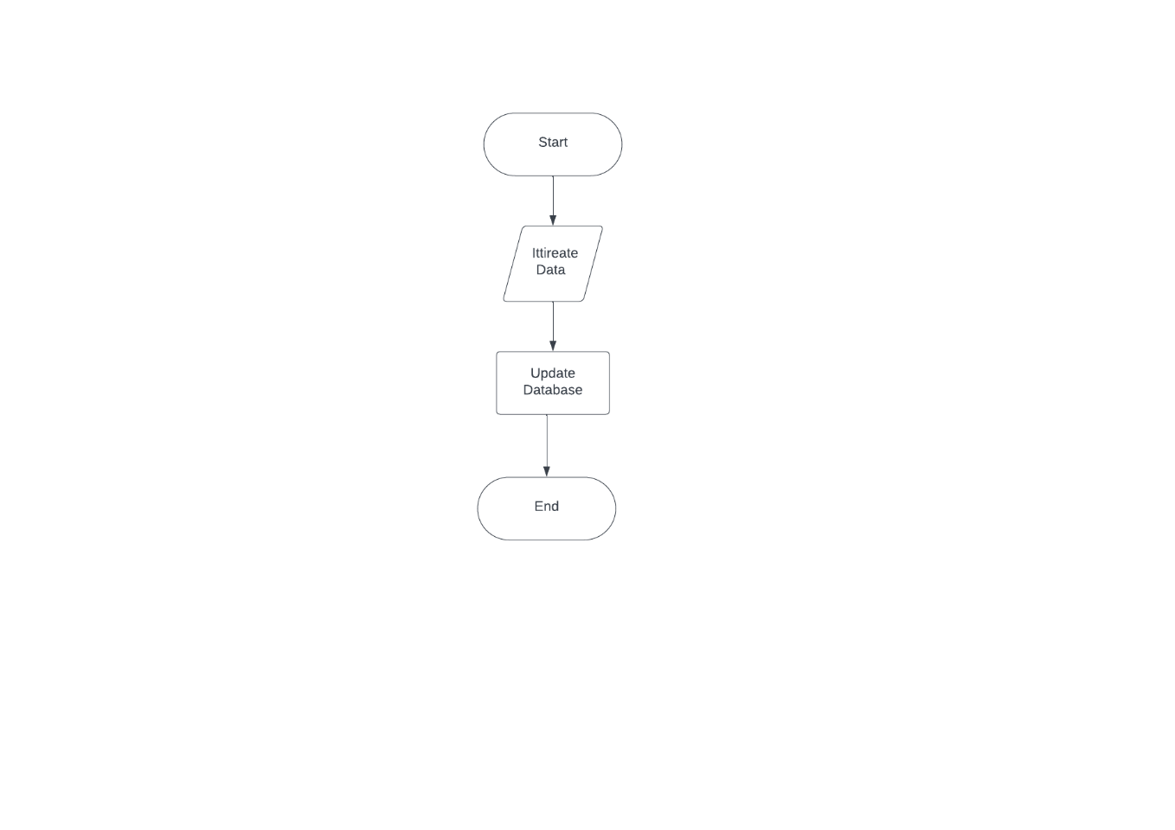

Figure 3.7

Figure describe dynamic aspects of Add Illiterates

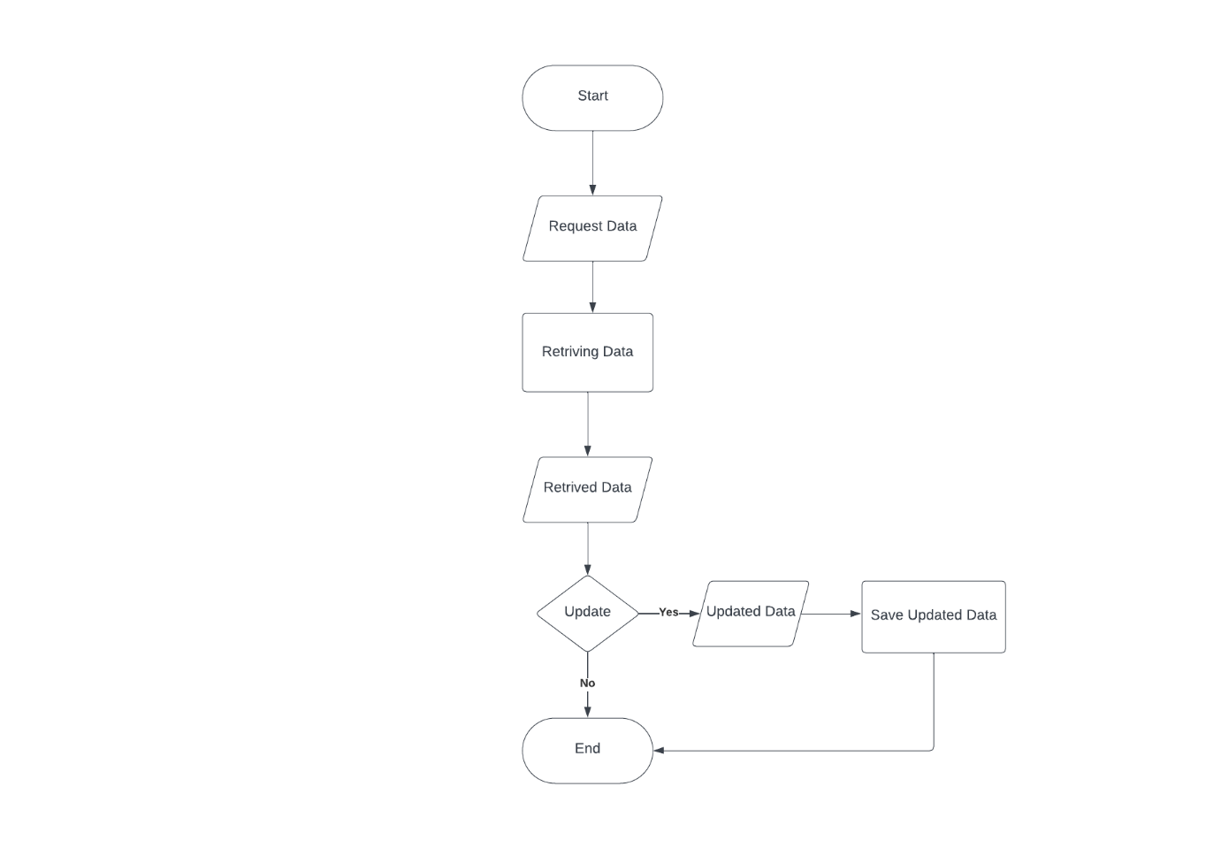**Database Activity:**

Figure 3.8

Figure describe dynamic aspects of Database

**ERD:**

Entity Relationship Diagram, also known as ERD, ER Diagram or ER model, is a type of structural diagram for use in database design. An ERD contains different symbols and connectors that visualize two important information: The major entities within the system scope, and the inter-relationships among these entities.

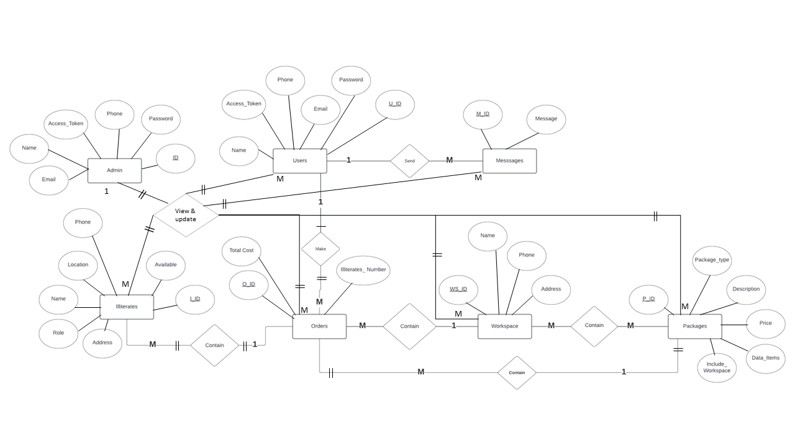

Figure 4

**Mapping:**

A database schema defines how data is organized within a relational database; this is inclusive of logical constraints such as, table names, fields, data types, and the relationships between these entities.

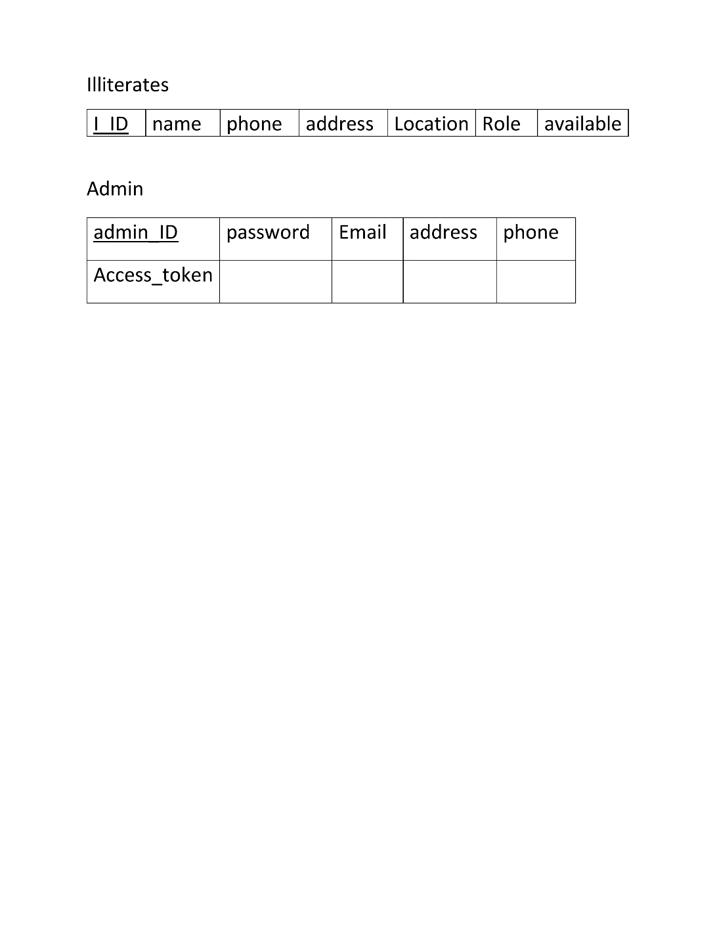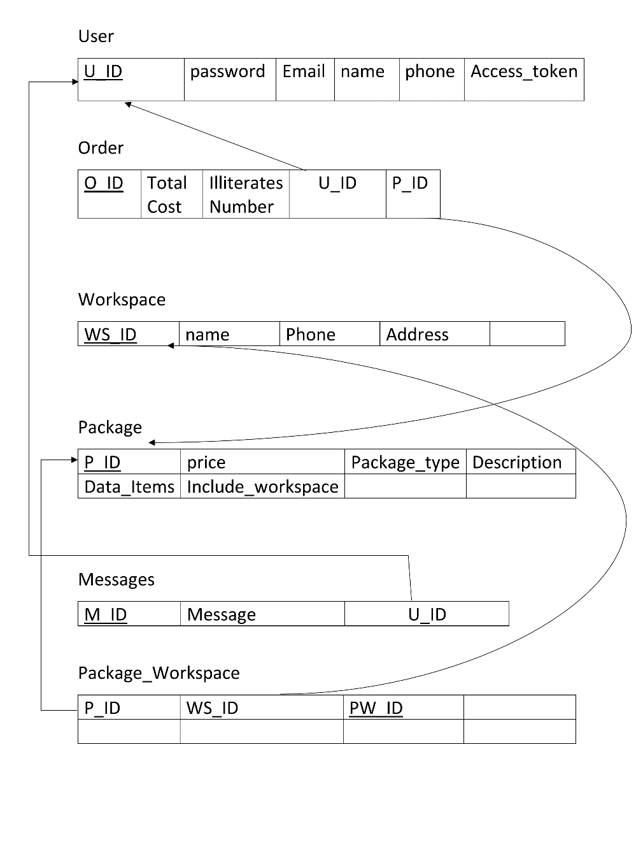

Figure 5

**Site Map:**

A site map is a model of a website’s content designed to help both users and search engines navigate the site

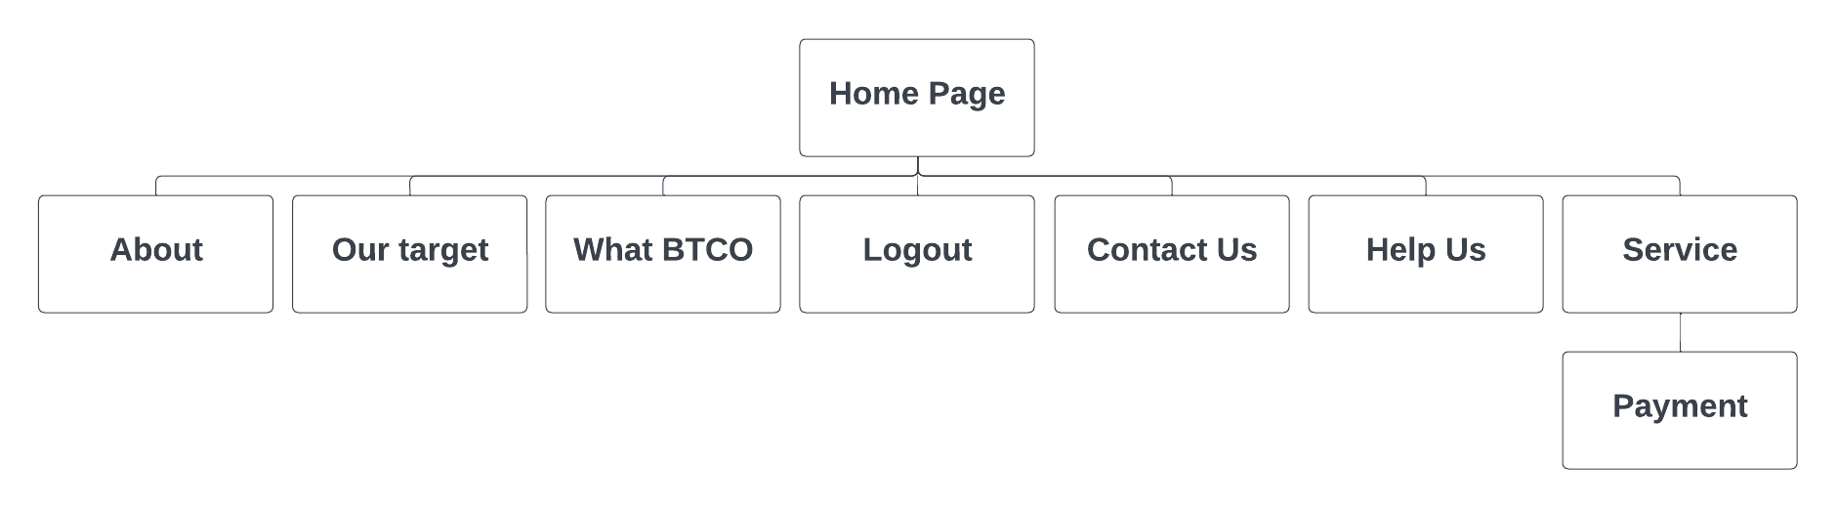

Figure 6

Chapter Five

# Implementation

**Admin Authentication:**

**Registration (The process of providing personal information & creating an account or profile on a website).**

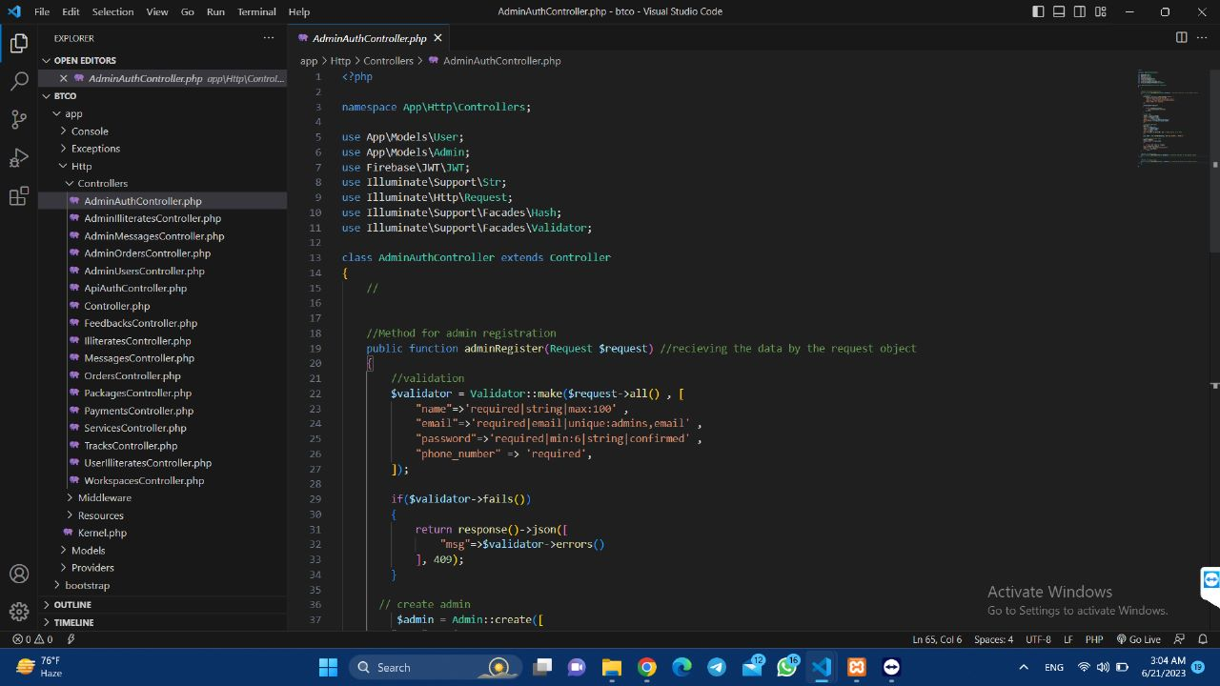

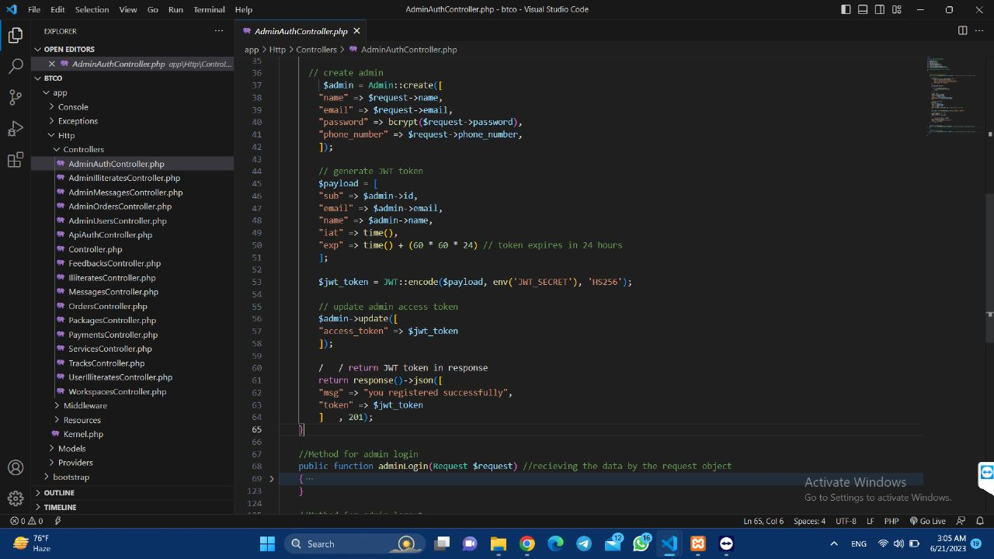

**Login (**The process of gaining access to the website by providing authentication credentials, such as username and password**).**

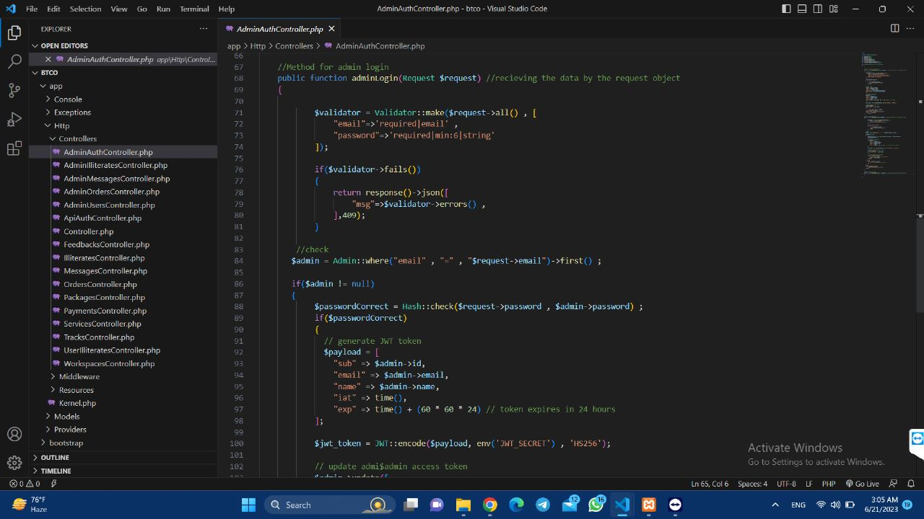

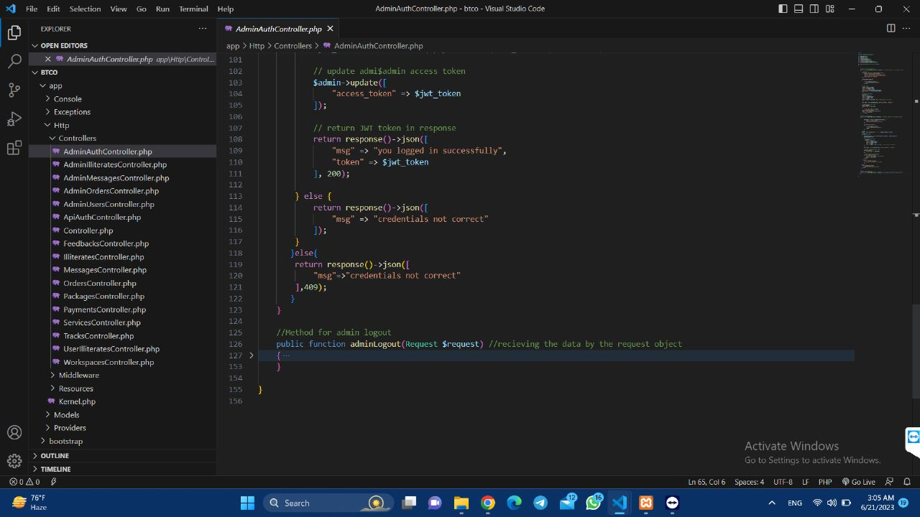

**Logout (**The process of terminating a user’s current session on a website**).**

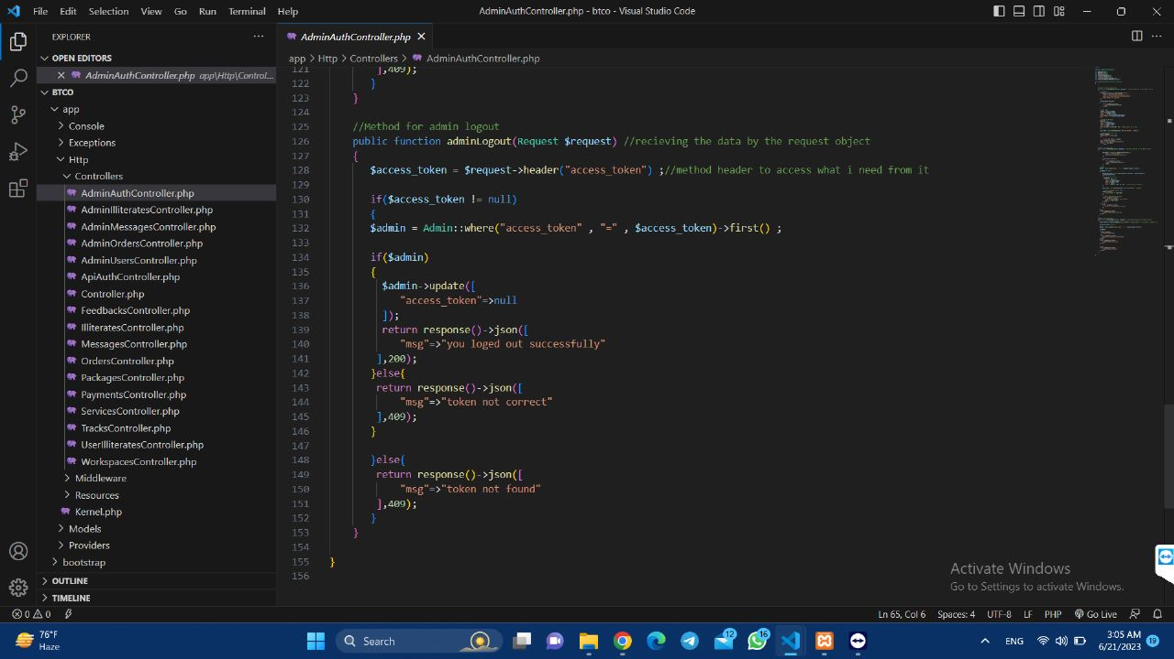

**Retrieving Illiterates (**Give the admin the access to retrieve the illiterates data**).**

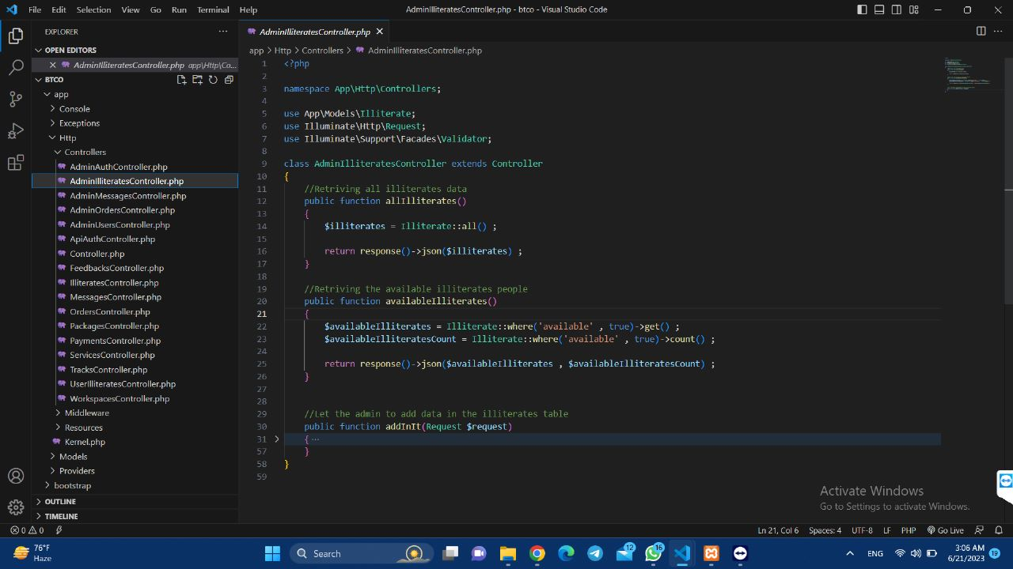

**Inserting illiterate’s data (**Illiterates data inserted by the admin in the database**).**

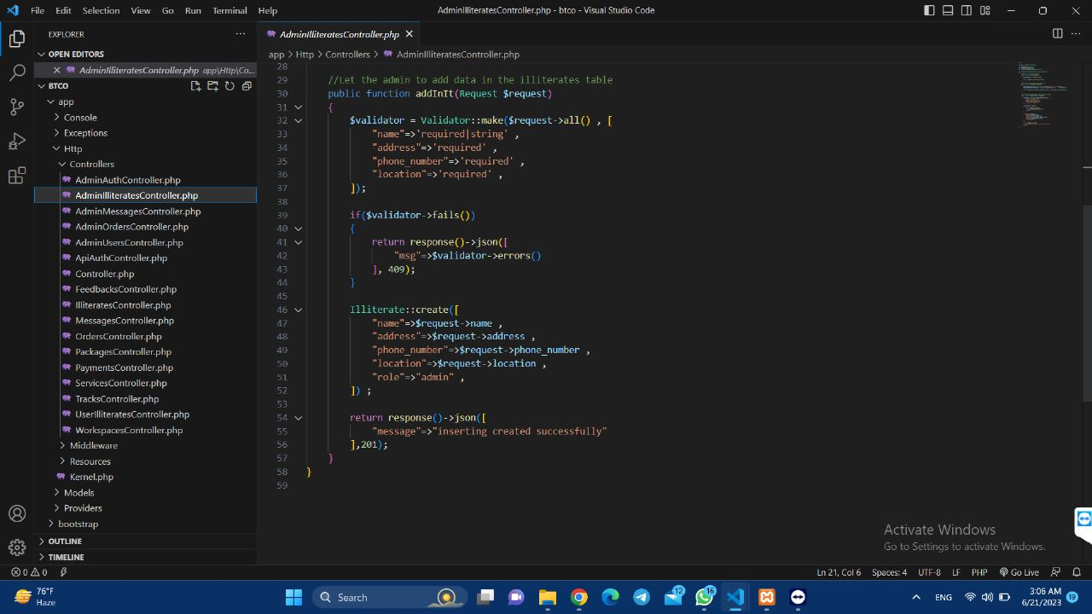

**Retrieving all user’s messages (**Give the admin the access to retrieve the user’s feedbacks**).**

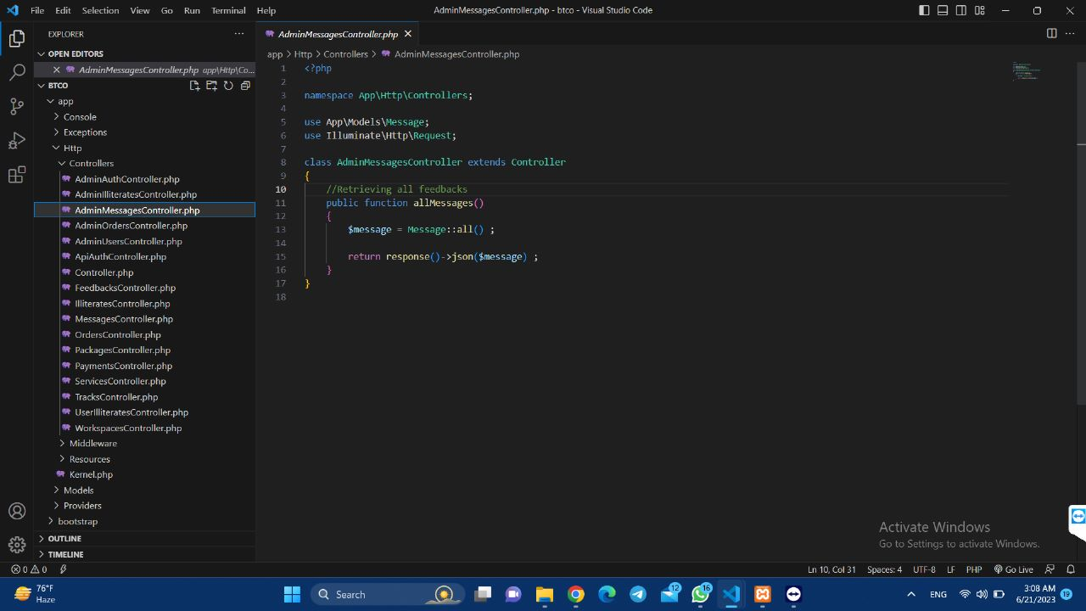

**Retrieving orders & specific orders (**Give the admin the access to retrieve the orders created by the user**).**

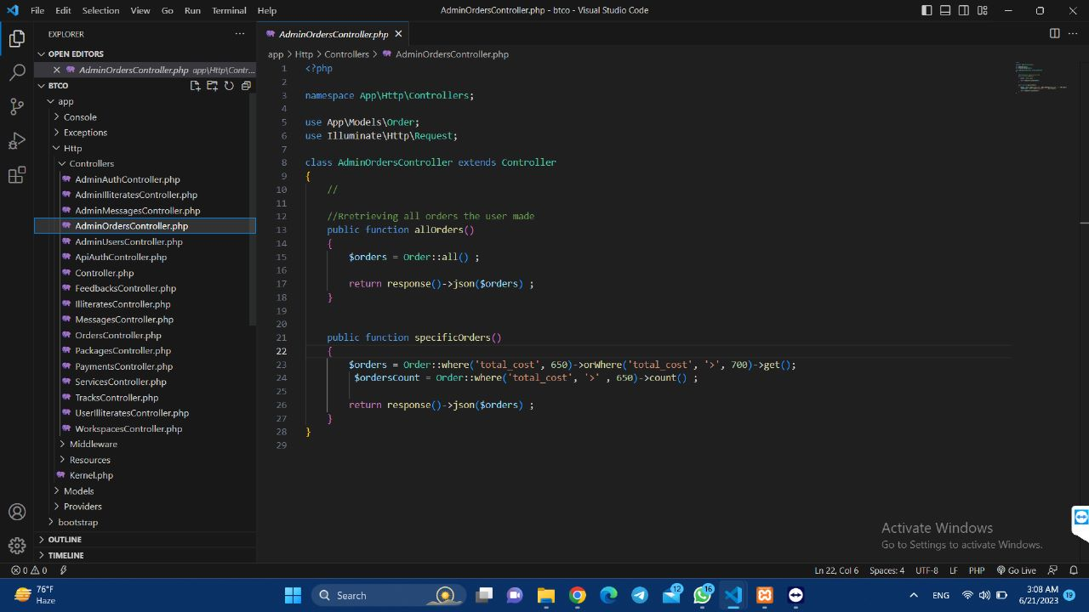

**Retrieving all users (**Give the admin the access to retrieve the user’s data**).**

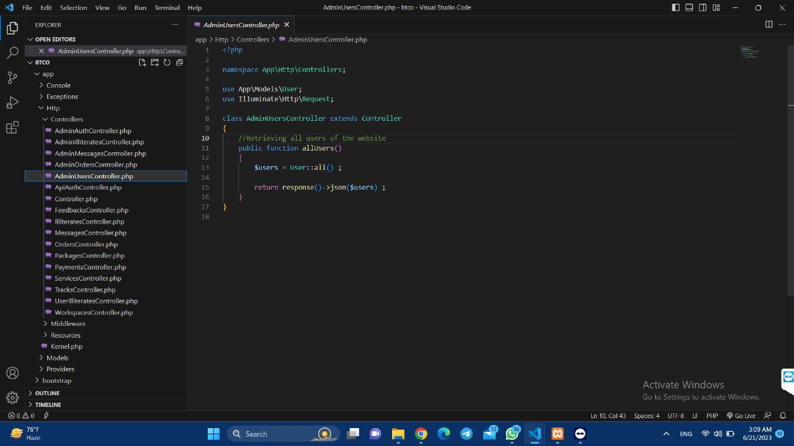

**User Authentication:**

**Registration**

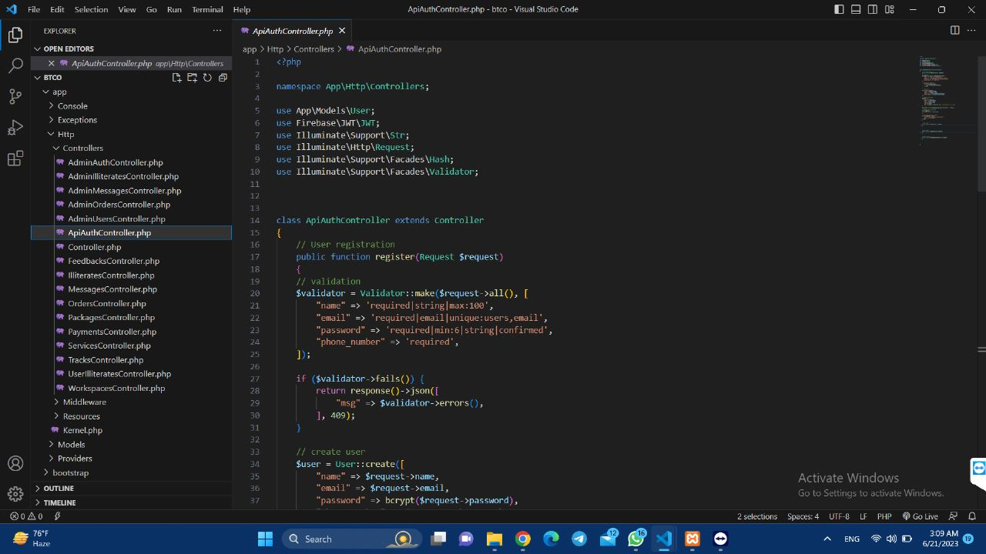

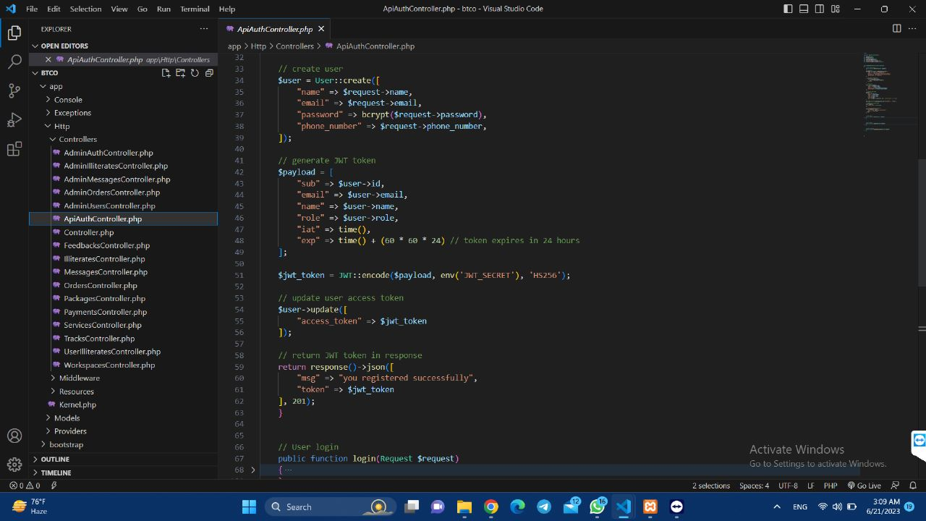

**Login**

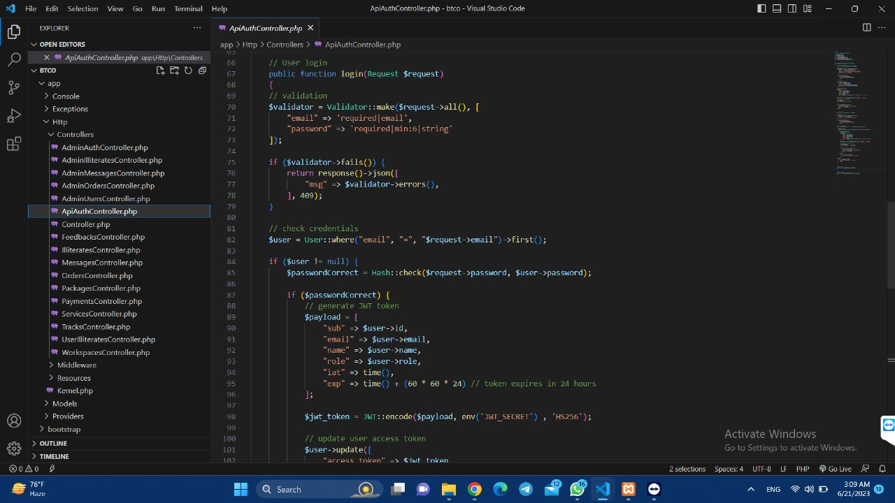

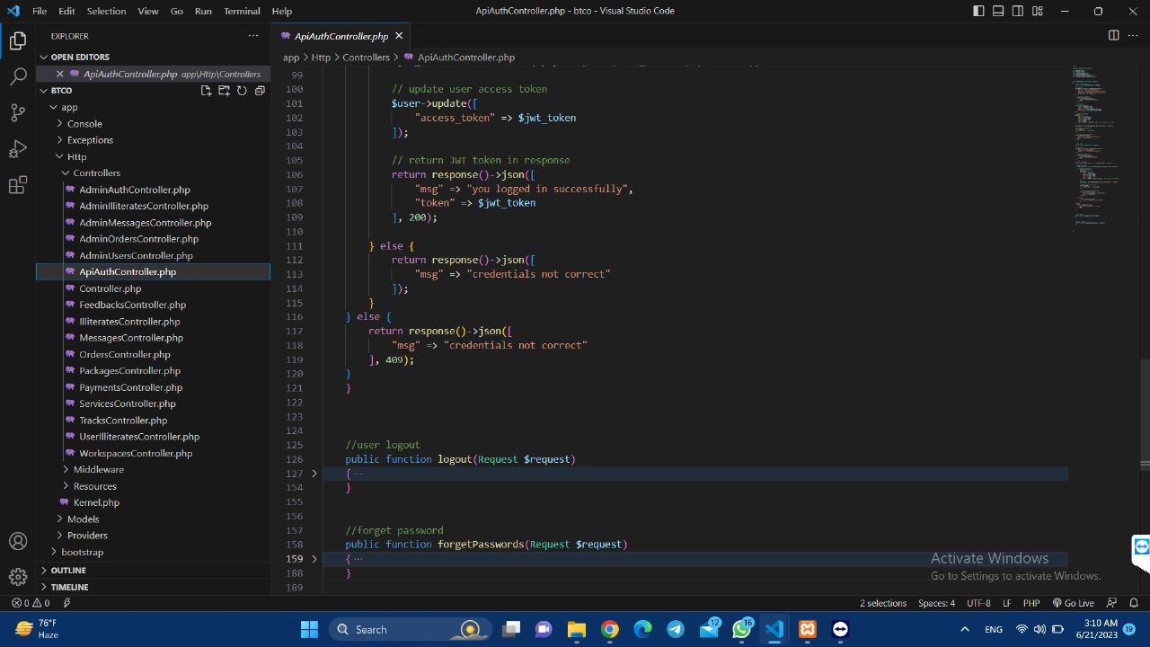

**Logout**

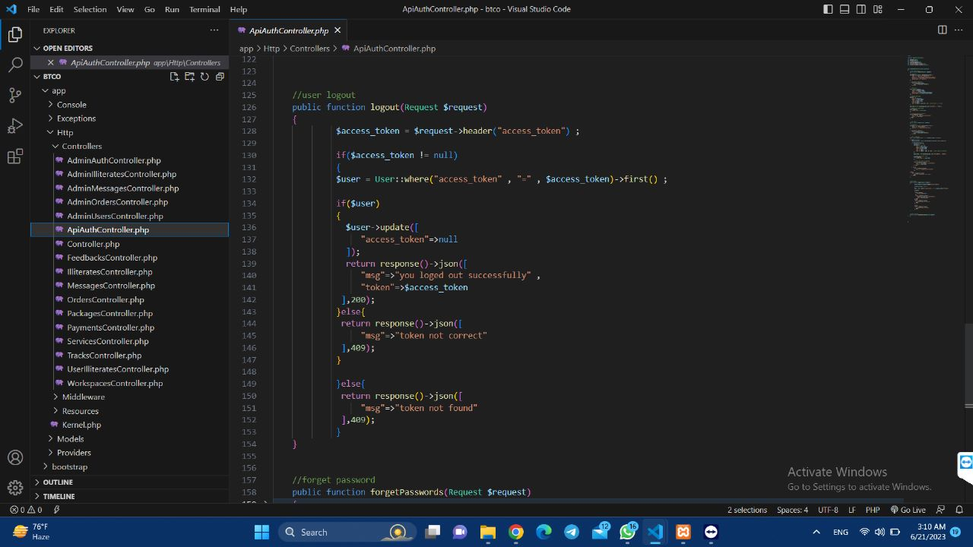

**Forget password (**It allows users who have forgotten their password to reset it and regain access to their account**).**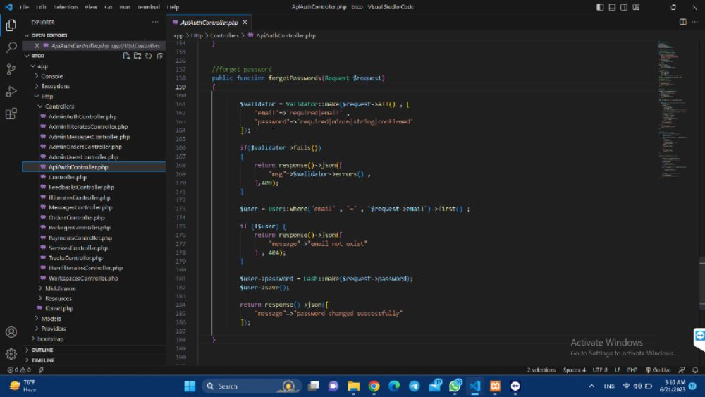

**User’s Feedbacks (Controller to handle the feedback process).**

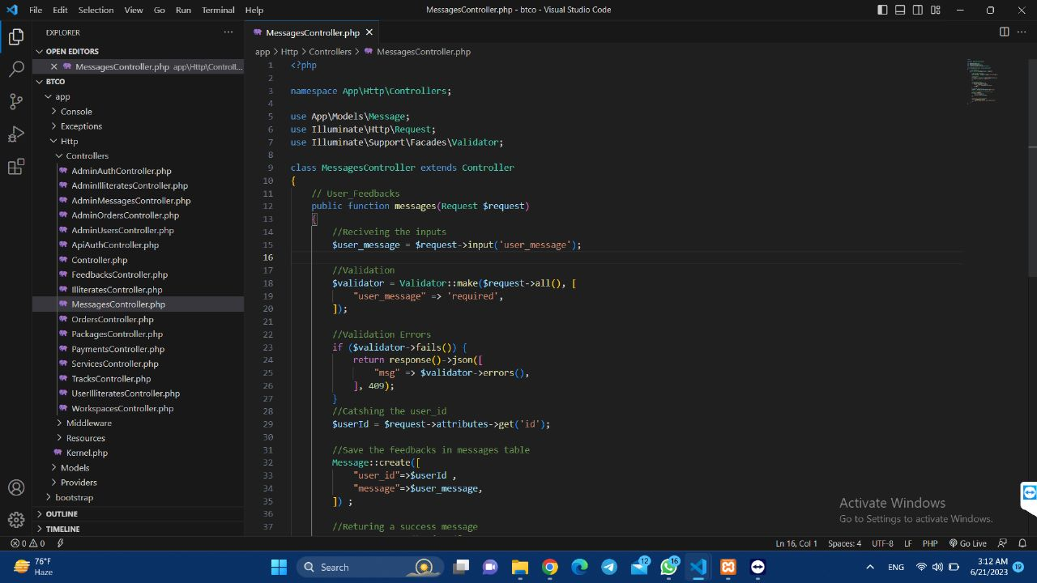

**All packages in the database (**All packages retrieved from the database in order to let the frontend designer to access them**).**

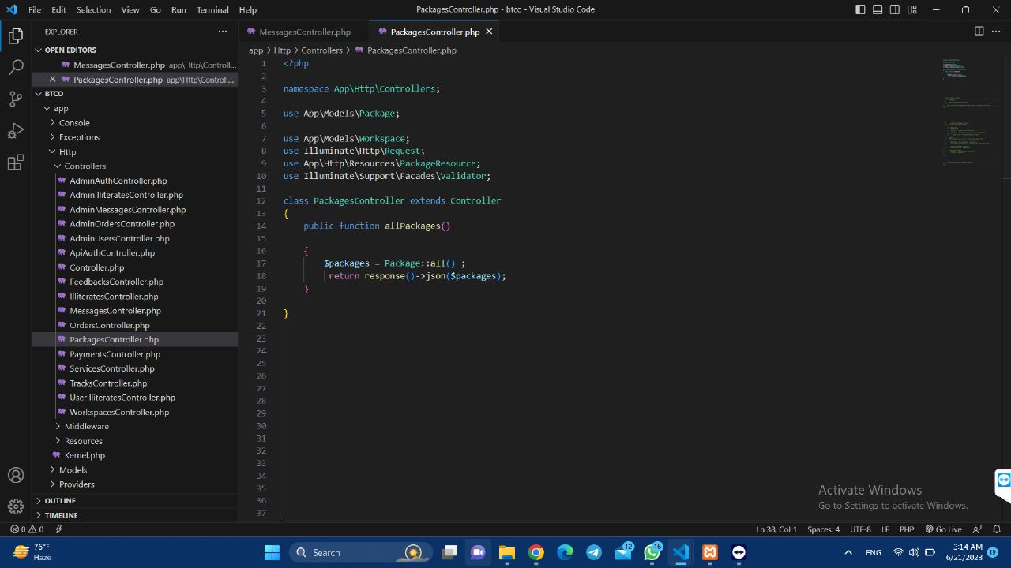

**Payment process (**Handling the payment form**).**

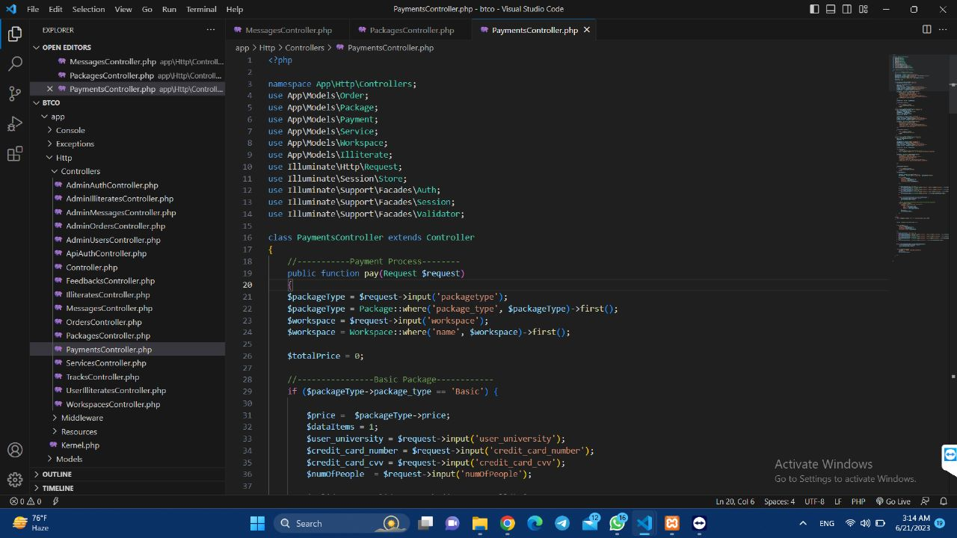

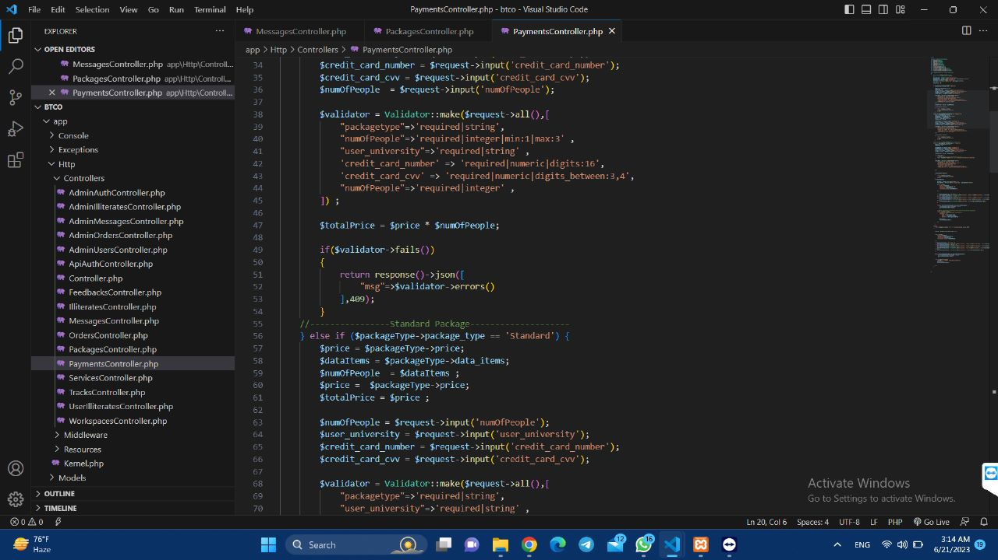

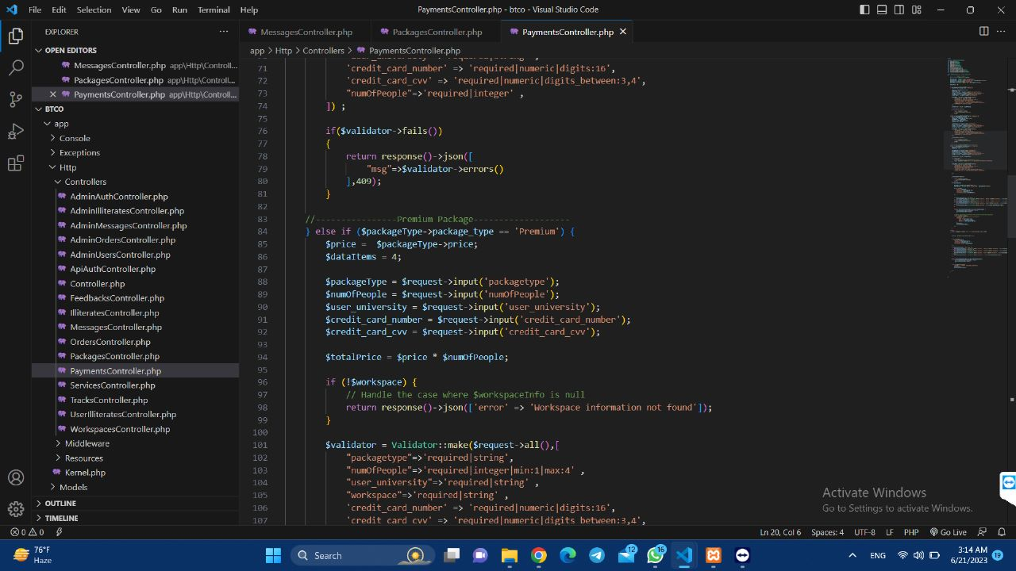

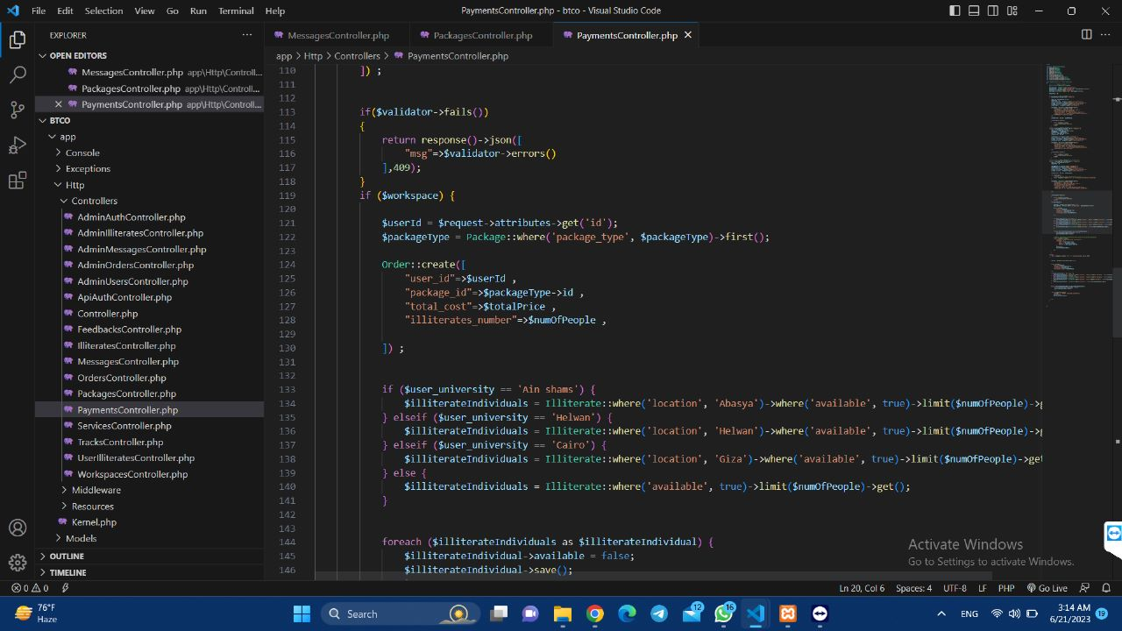

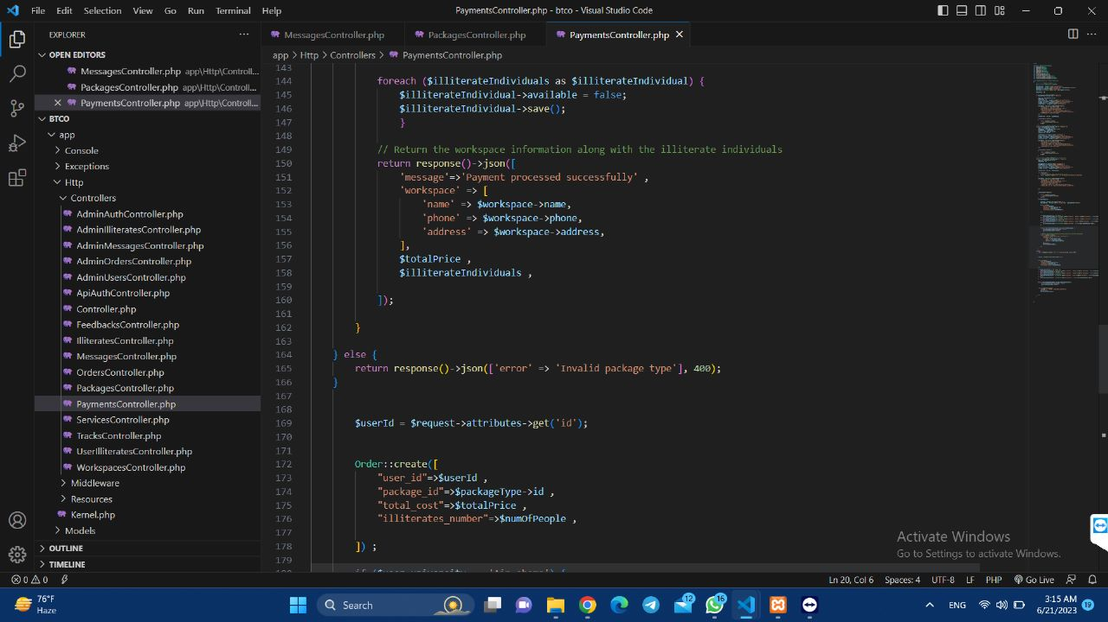

**All workspaces in the database (**All workspaces retrieved from the database in order to let the frontend designer to access them**).**

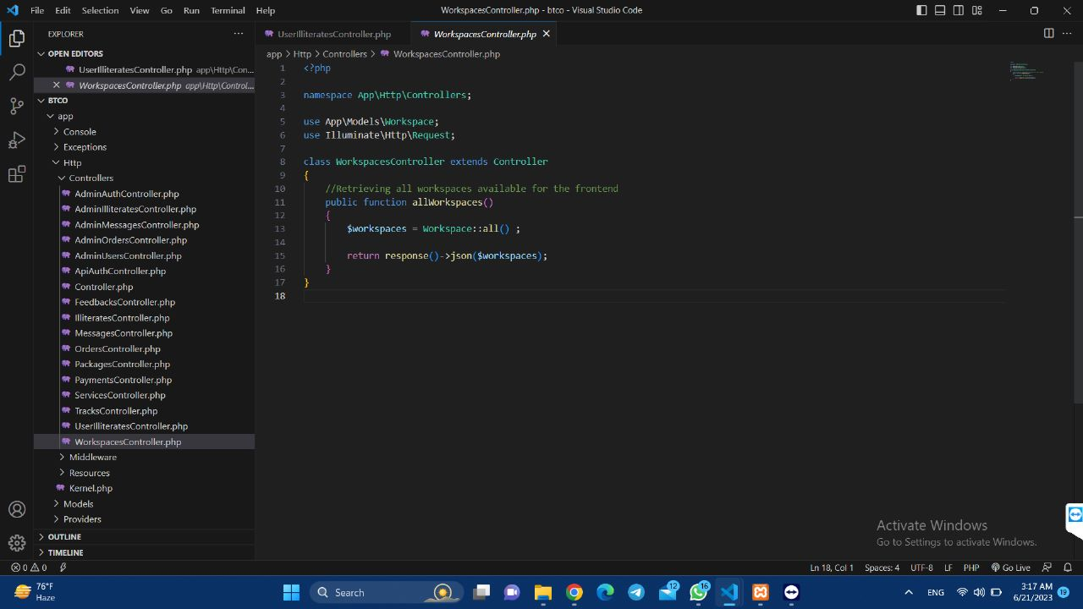

**Adding illiterates data by volunteers (**Illiterates data inserted by a volunteer in the database**).**

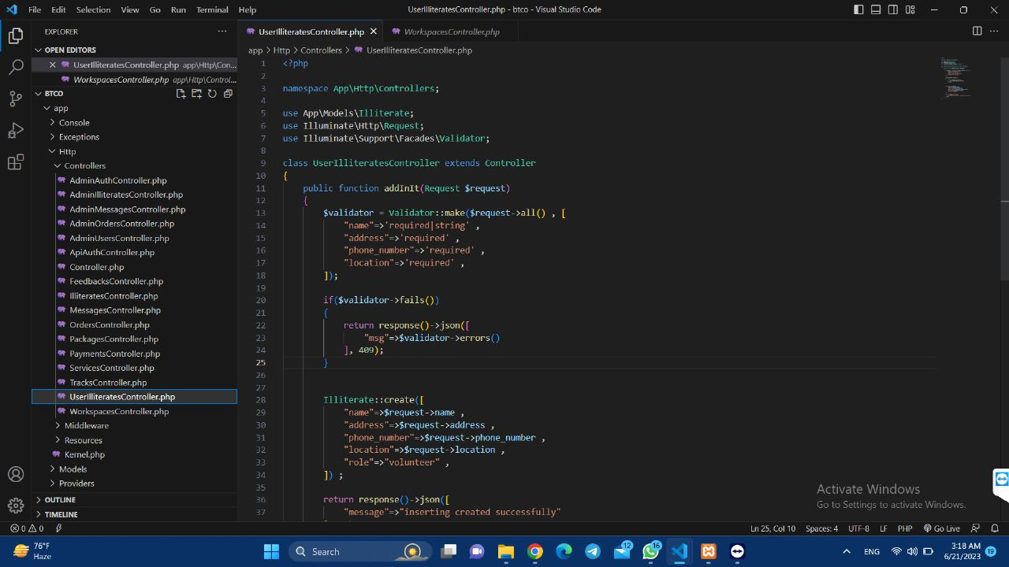

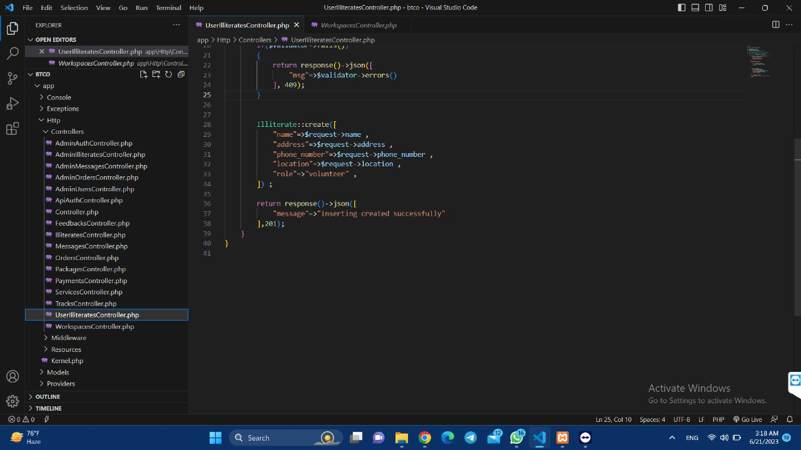

**Middleware for the admin to limit what to access**

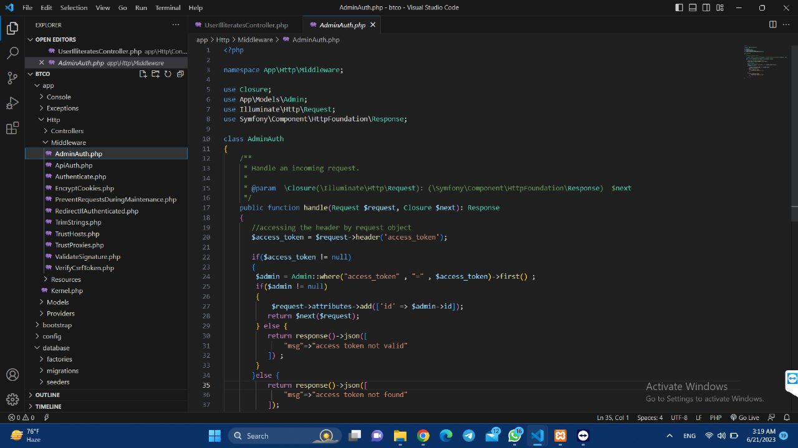

**Middleware for the user to limit what to access**

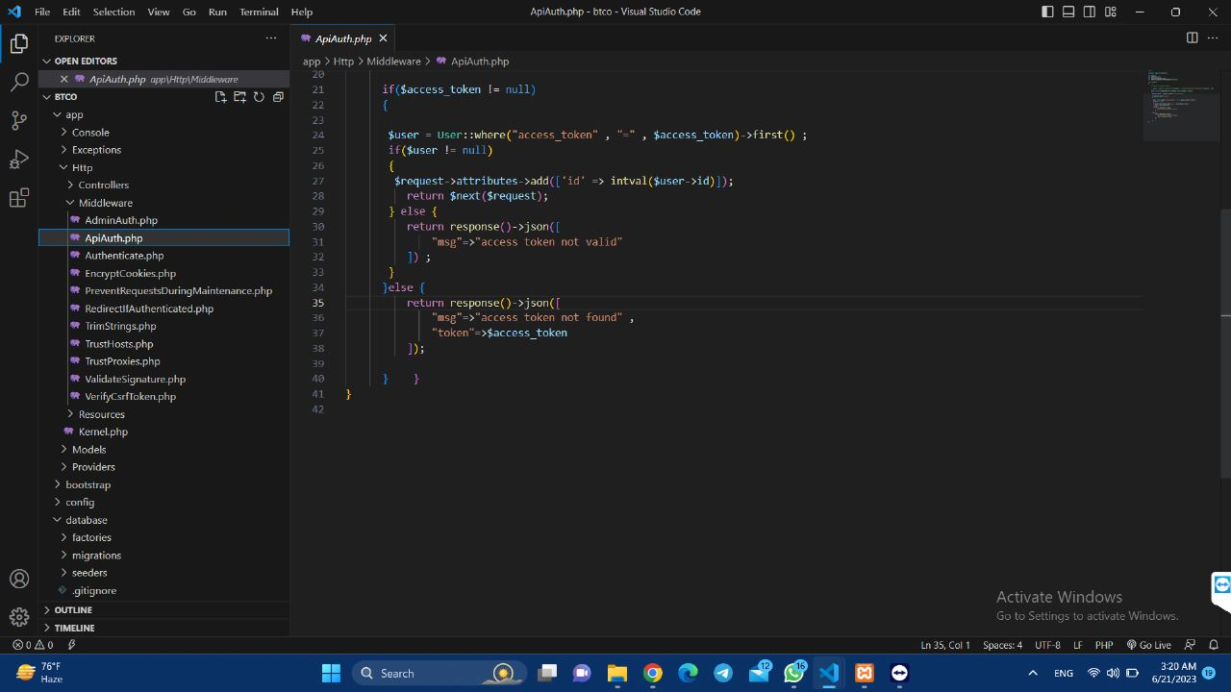

**Models (**Equal tables in database by laravel , which used to represent the data in the database**):**

**Admin model**

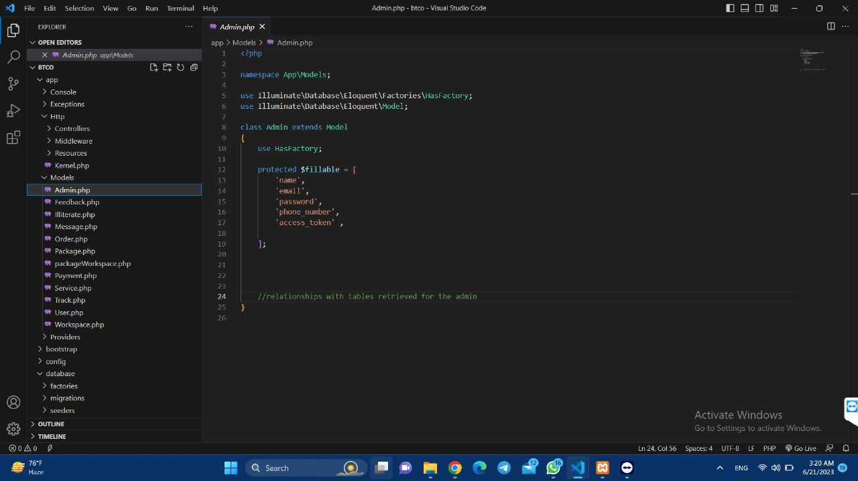

**Messages model** 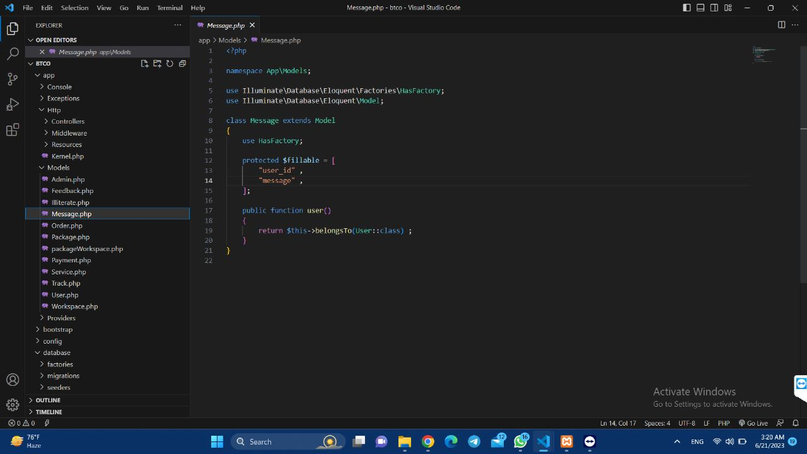

**Illiterates model**

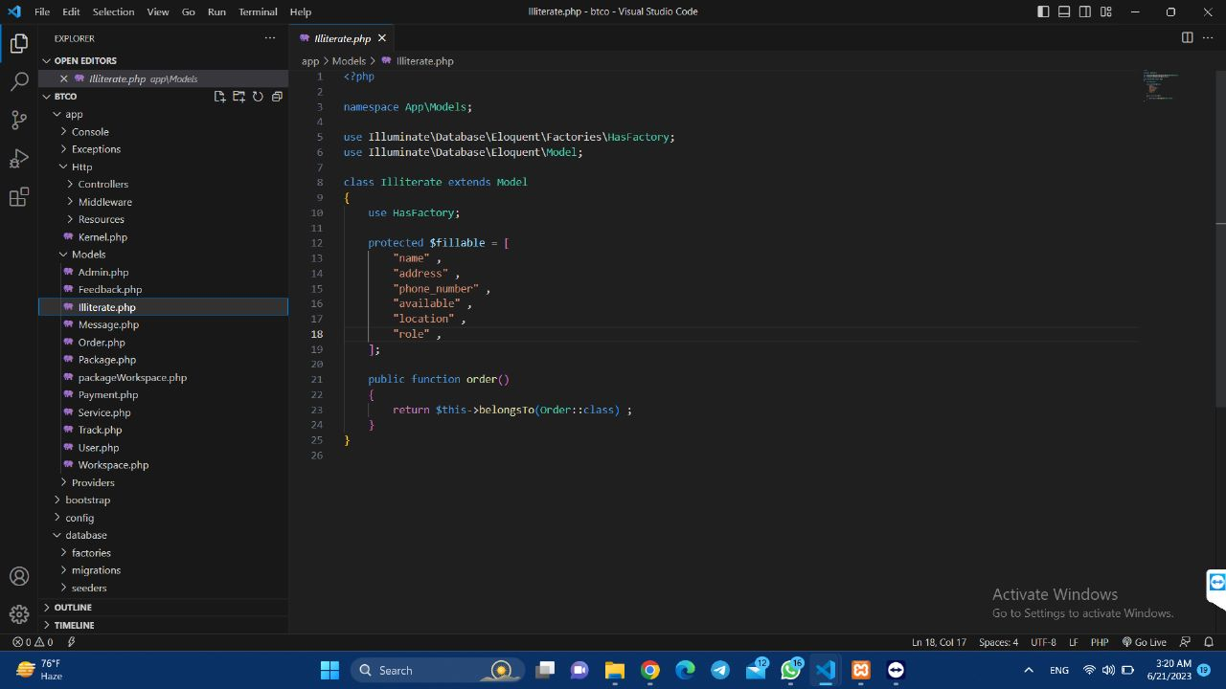

**Orders model**

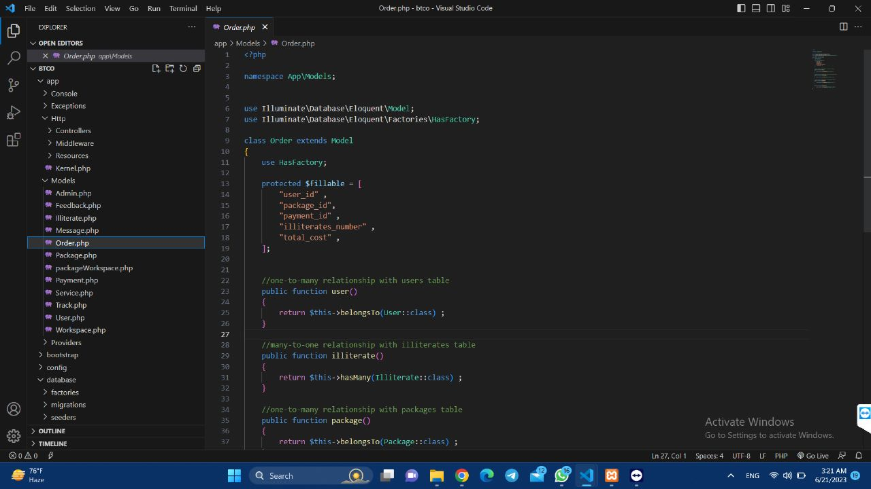

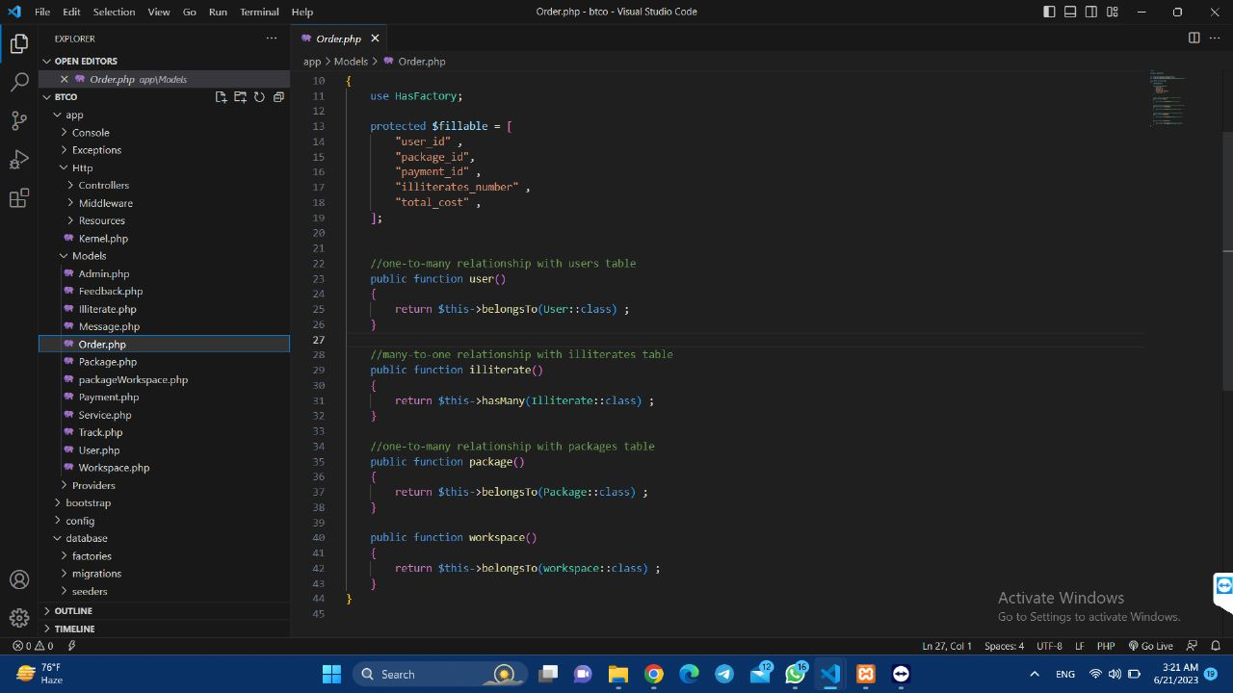

**Packages model**

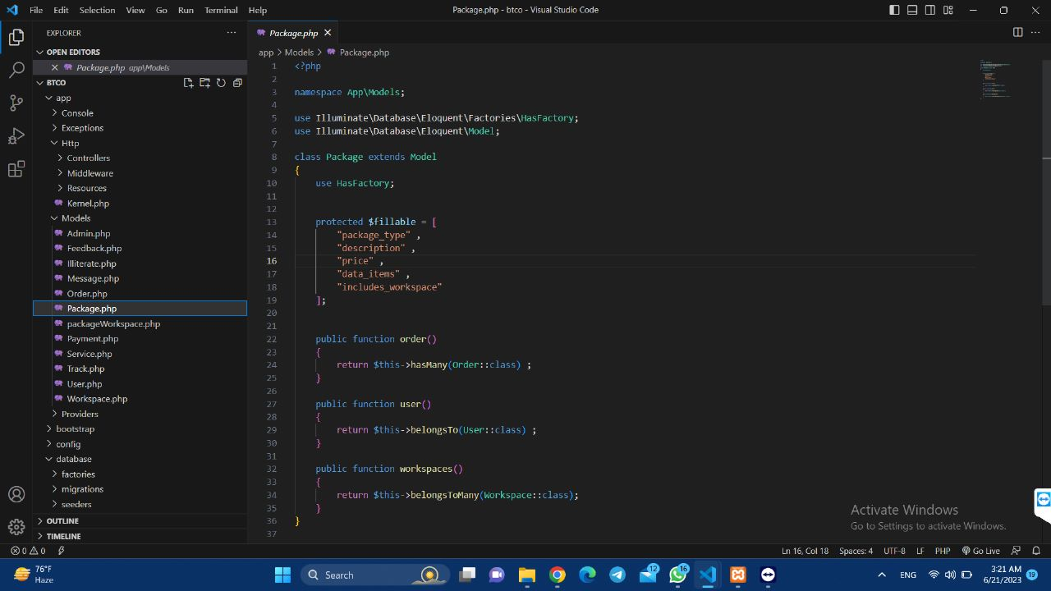

**Package_workspaces model**

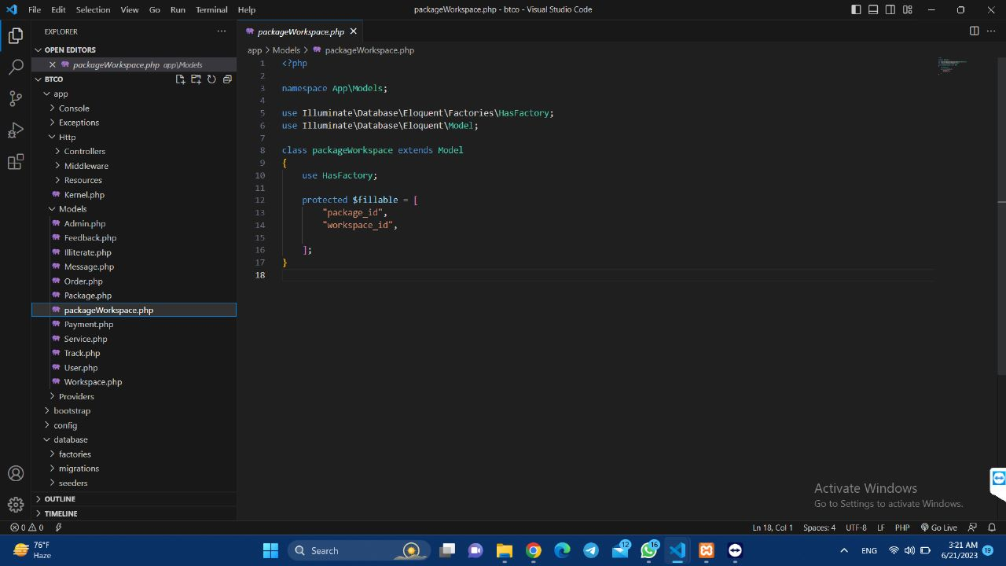

**Users model**

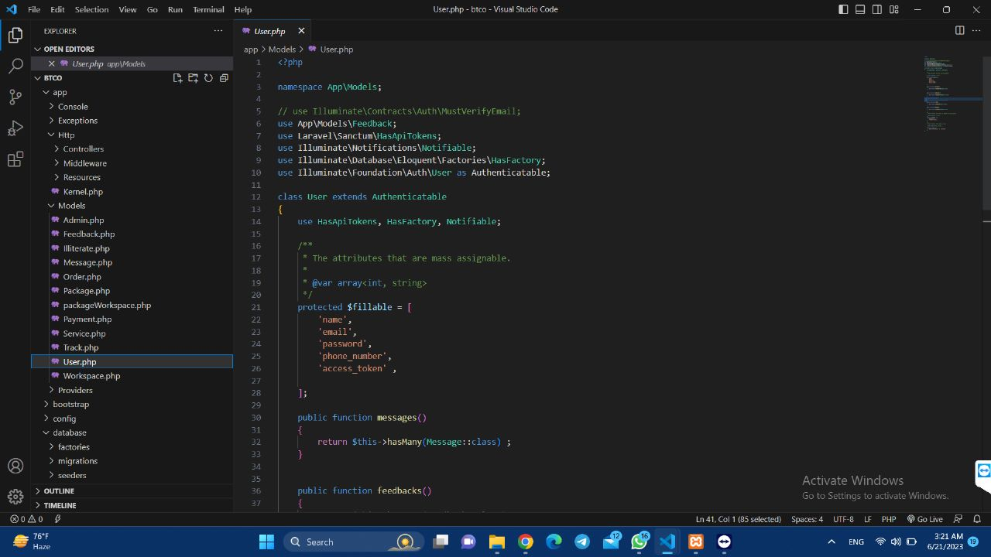

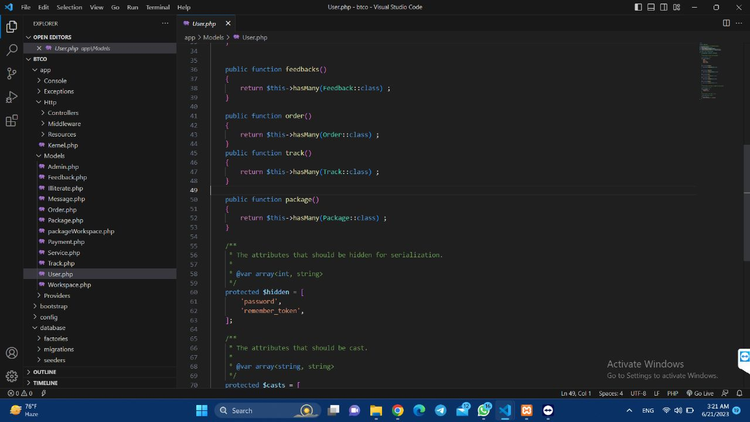

**Workspaces model**

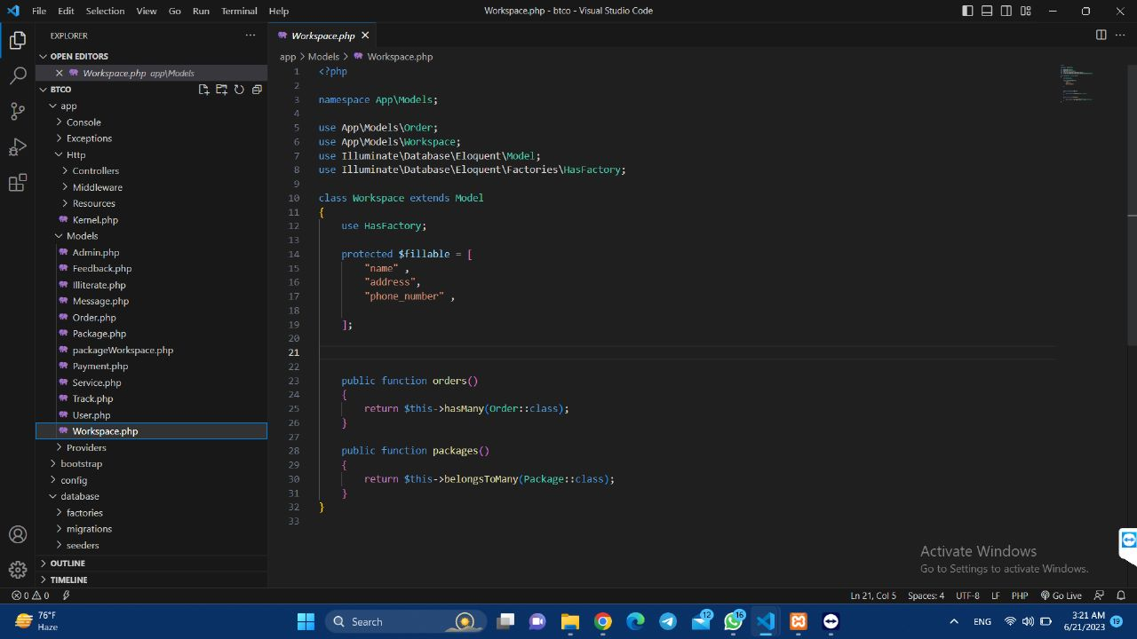

**Factories (**Used to generate fake data for testing and development purposes**):**

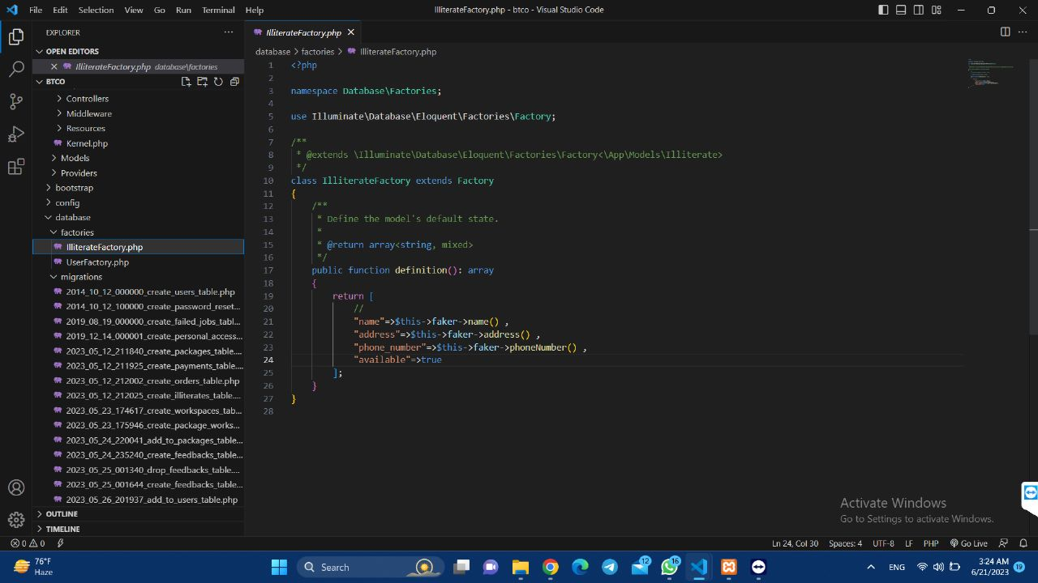

**Activating the factory**

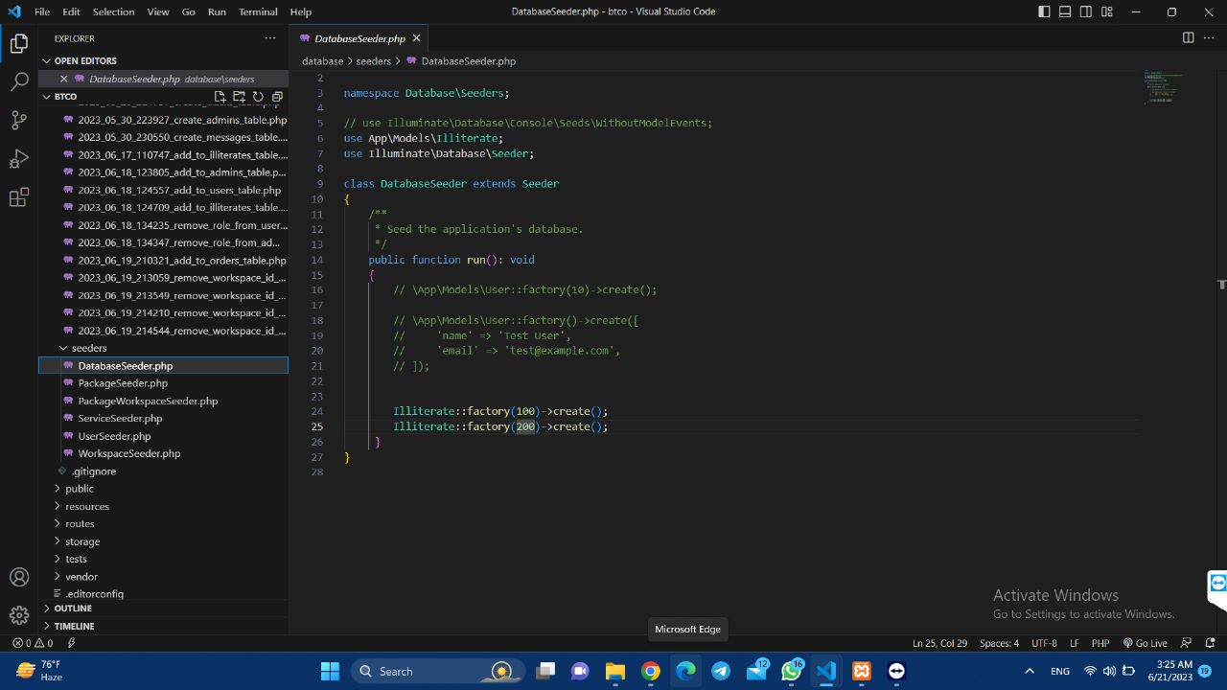

**Seeders to insert limited data (**Used to populate the database with initial data**):**

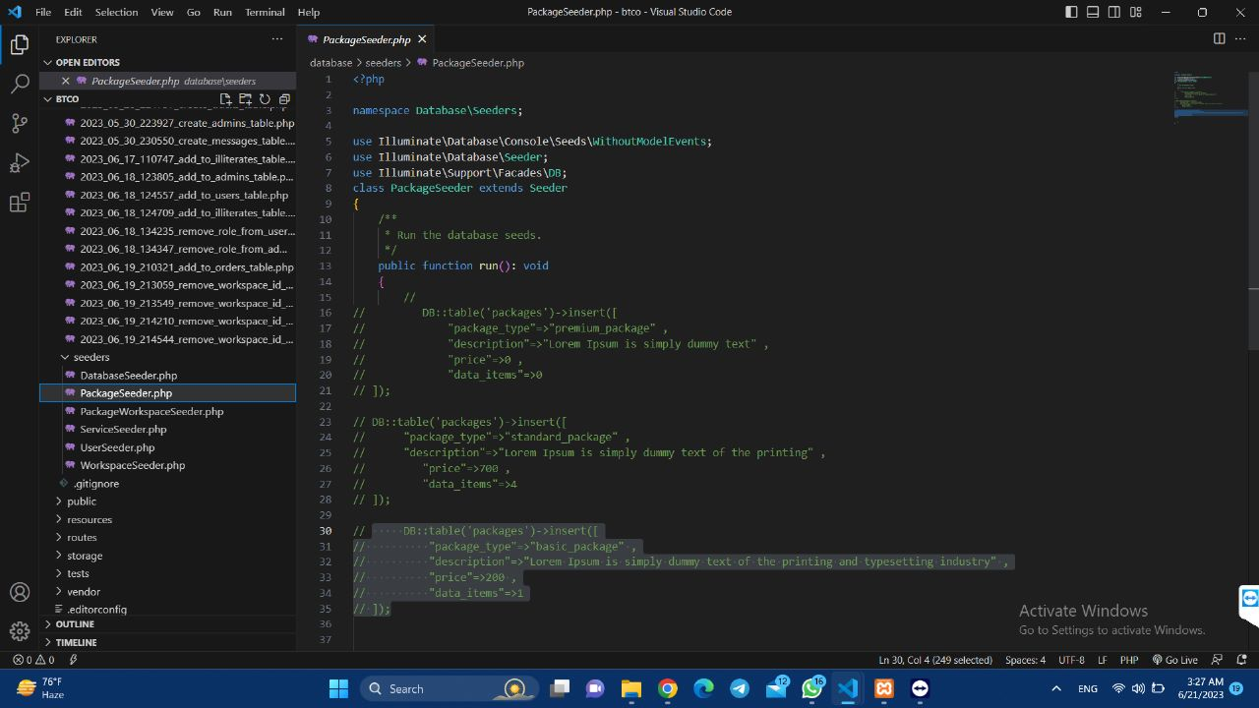

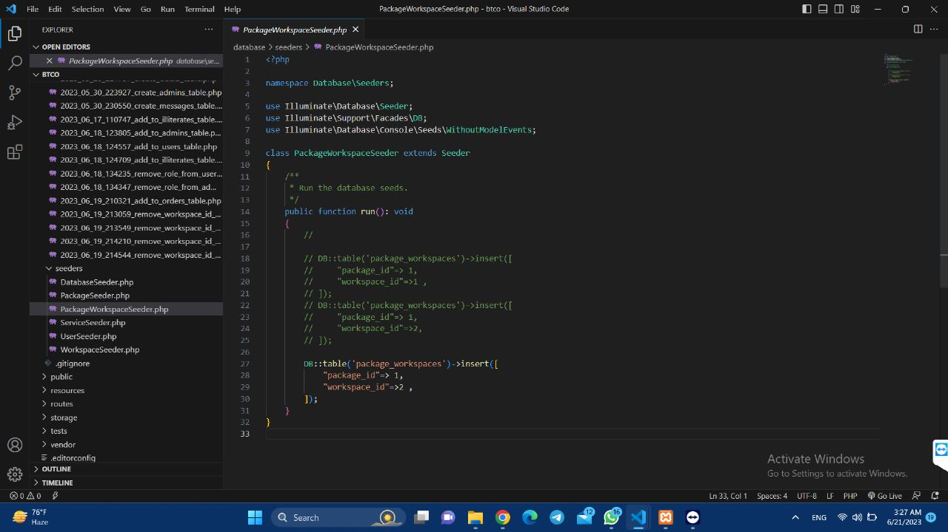

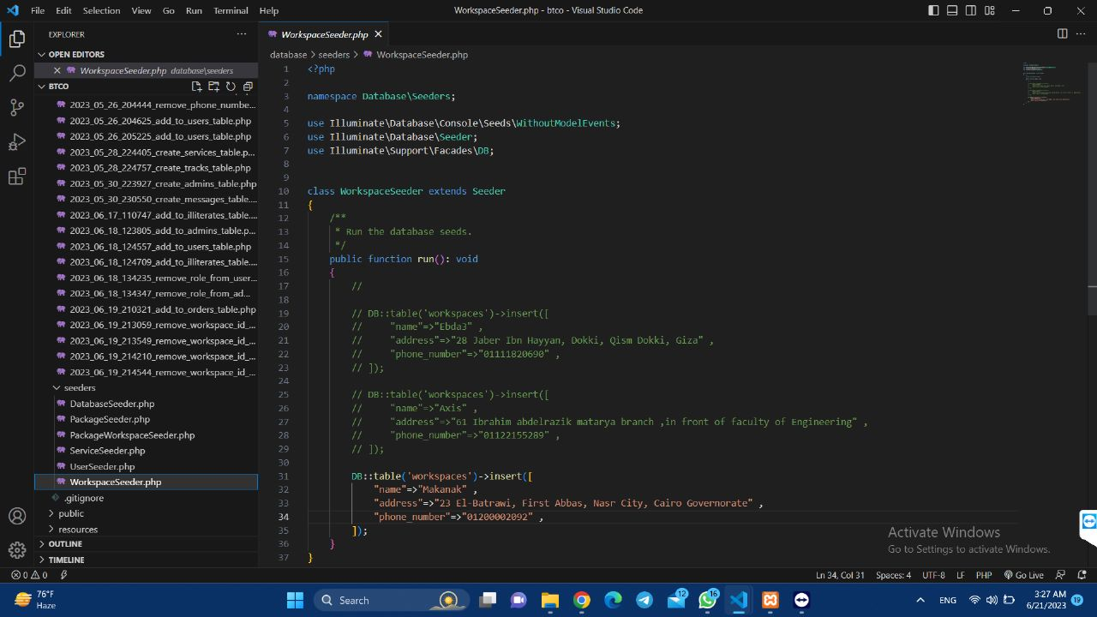

**Migrations (**Used to manage changes to the database schema over time , determines the datatype for each column**):**

**Users migration**

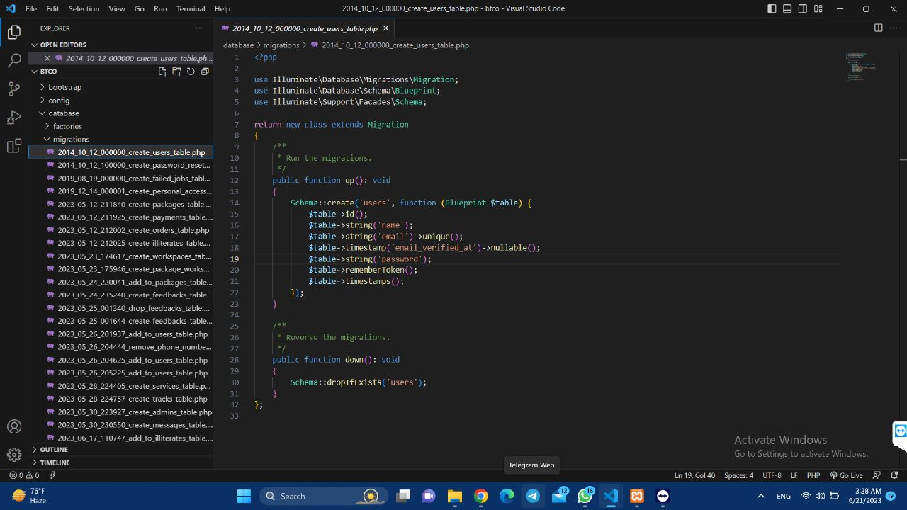

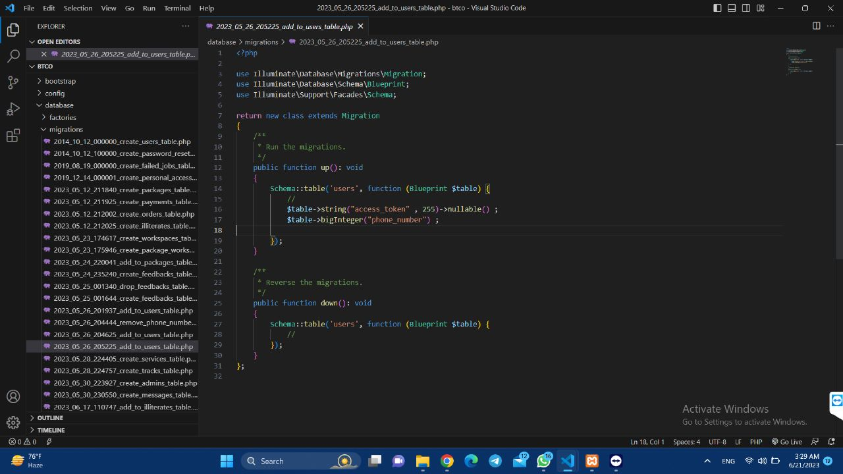

**Packages migration**

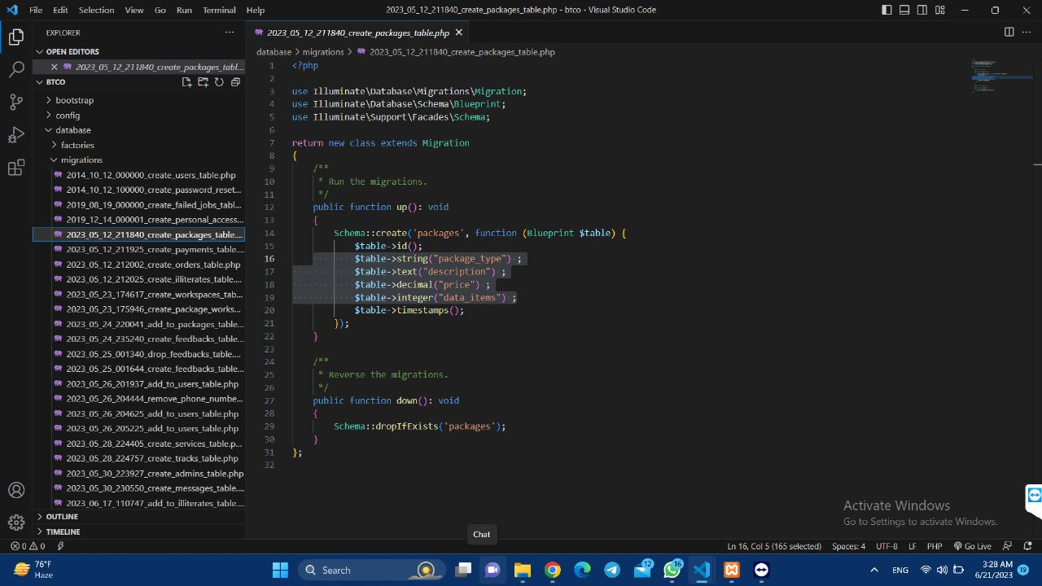

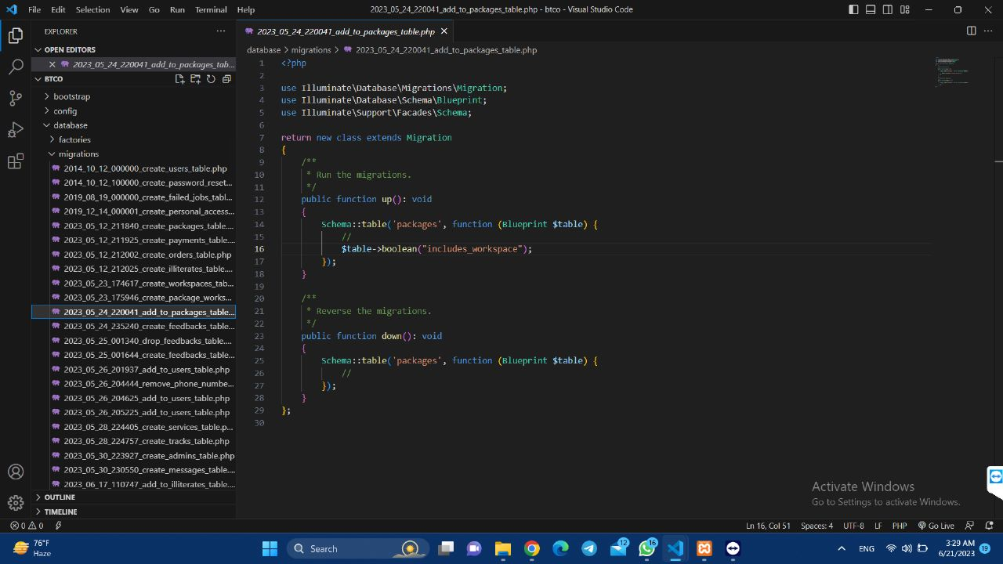

**Orders migration**

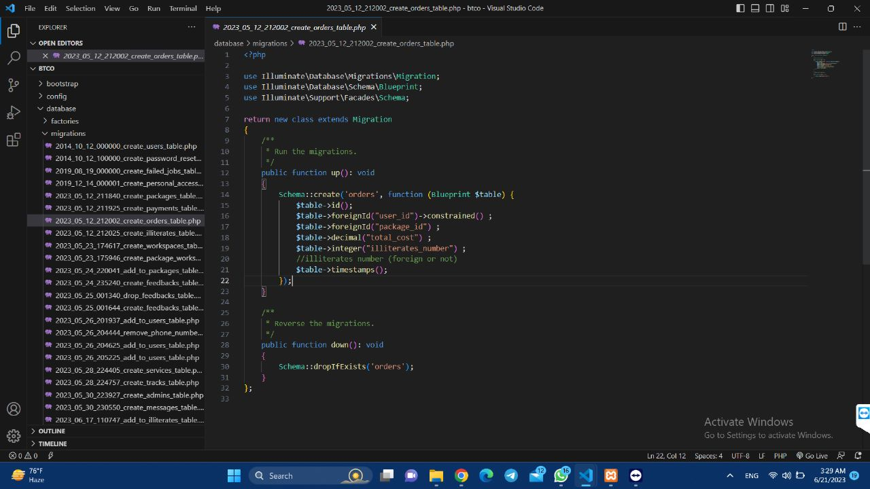

**Illiterates migration**

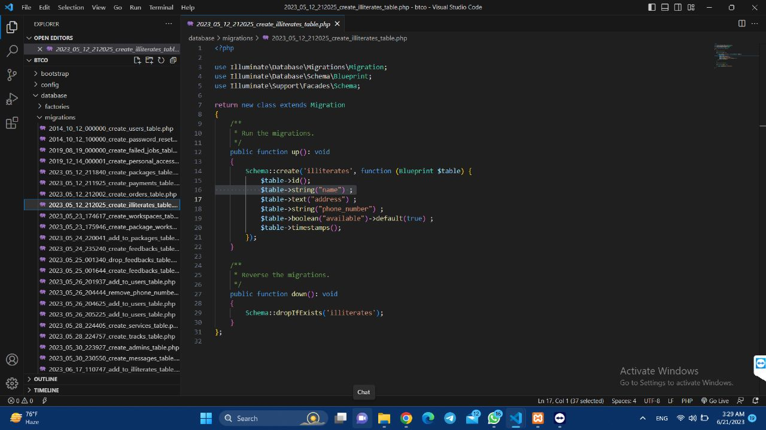

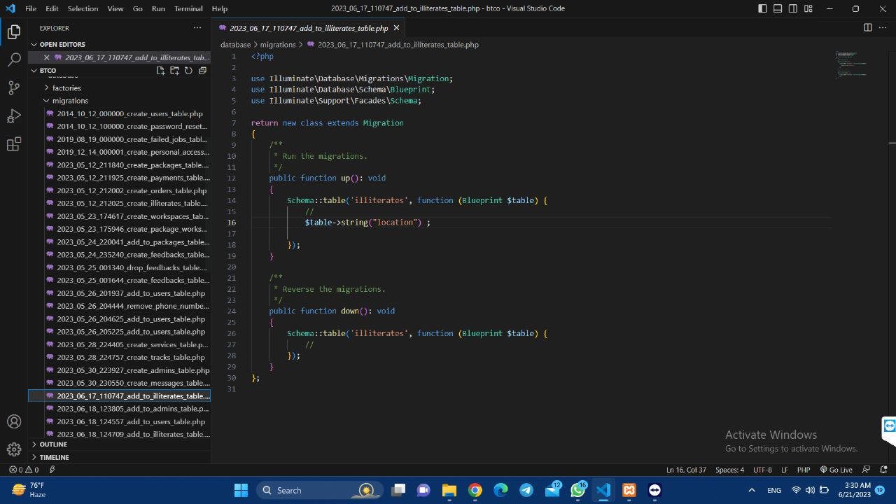

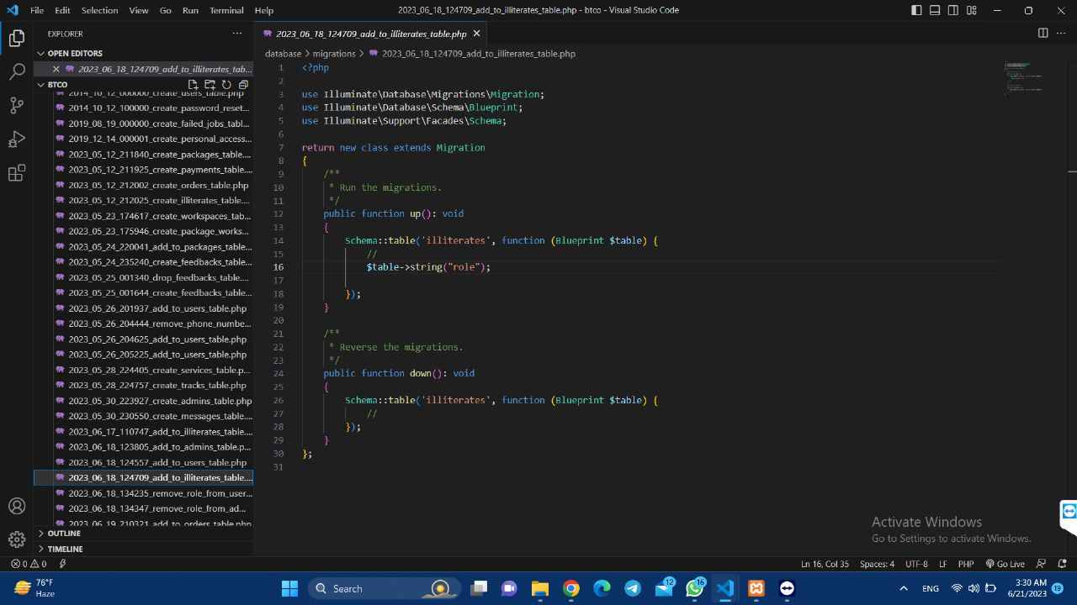

**Admins migration**

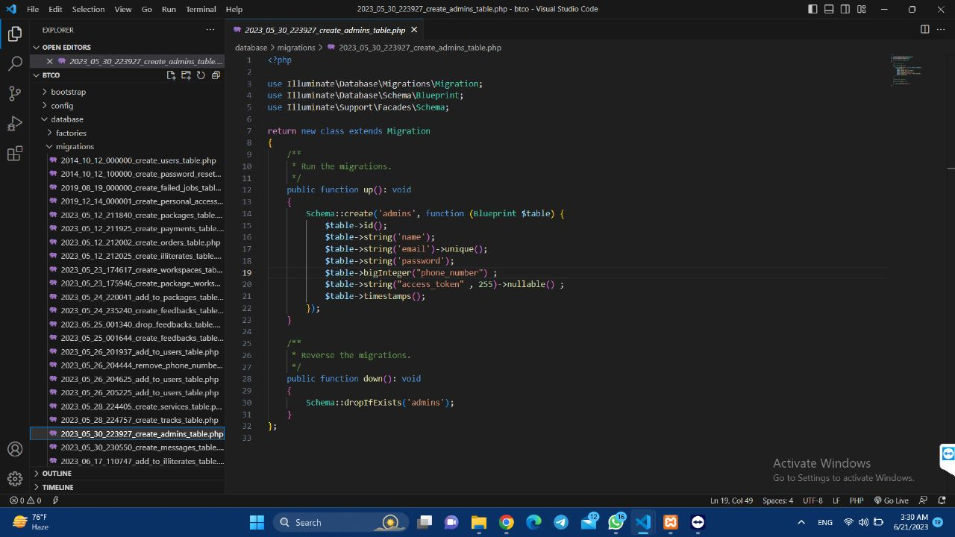

**Workspaces migration**

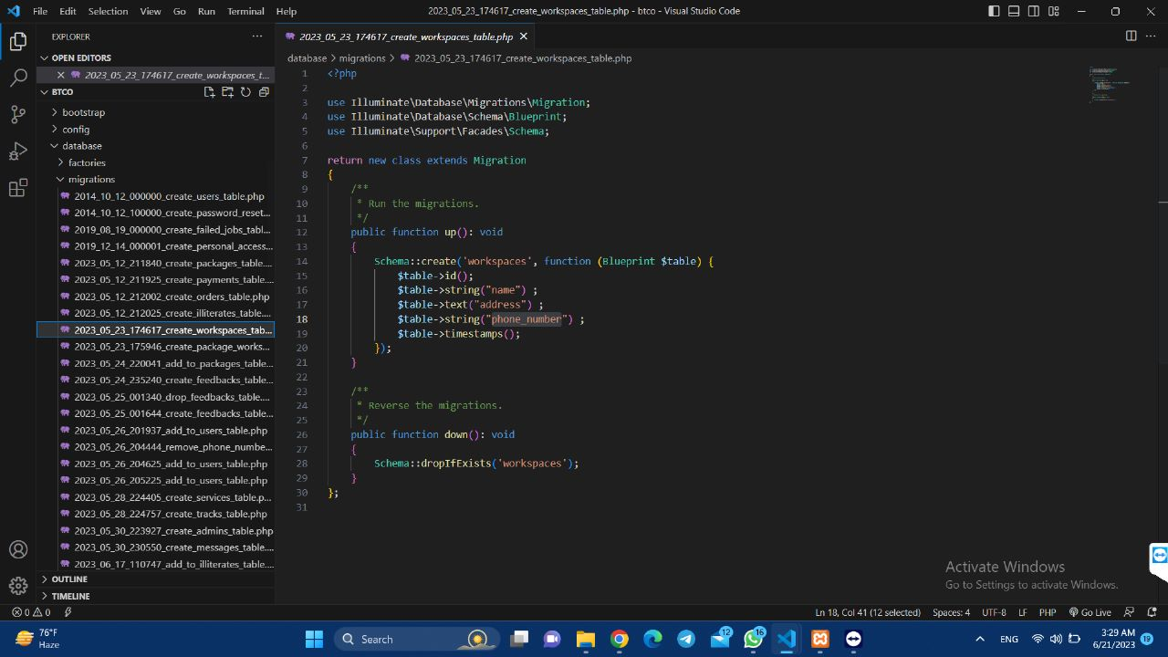

**Messages migration**

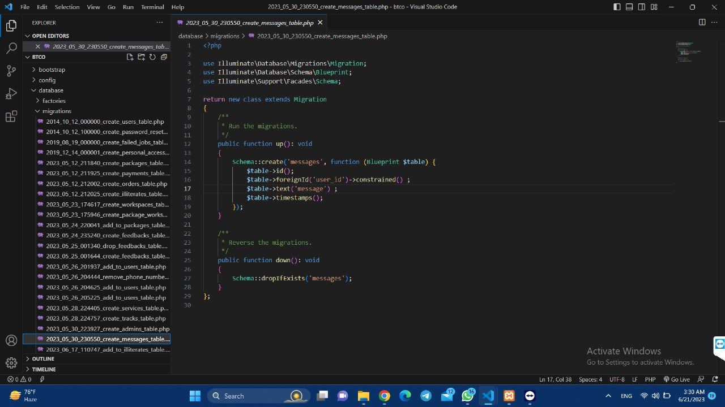

**Apis generated to be using by the Frontend (Stands for Application Programming Interface, is a crucial part of laravel API development):**

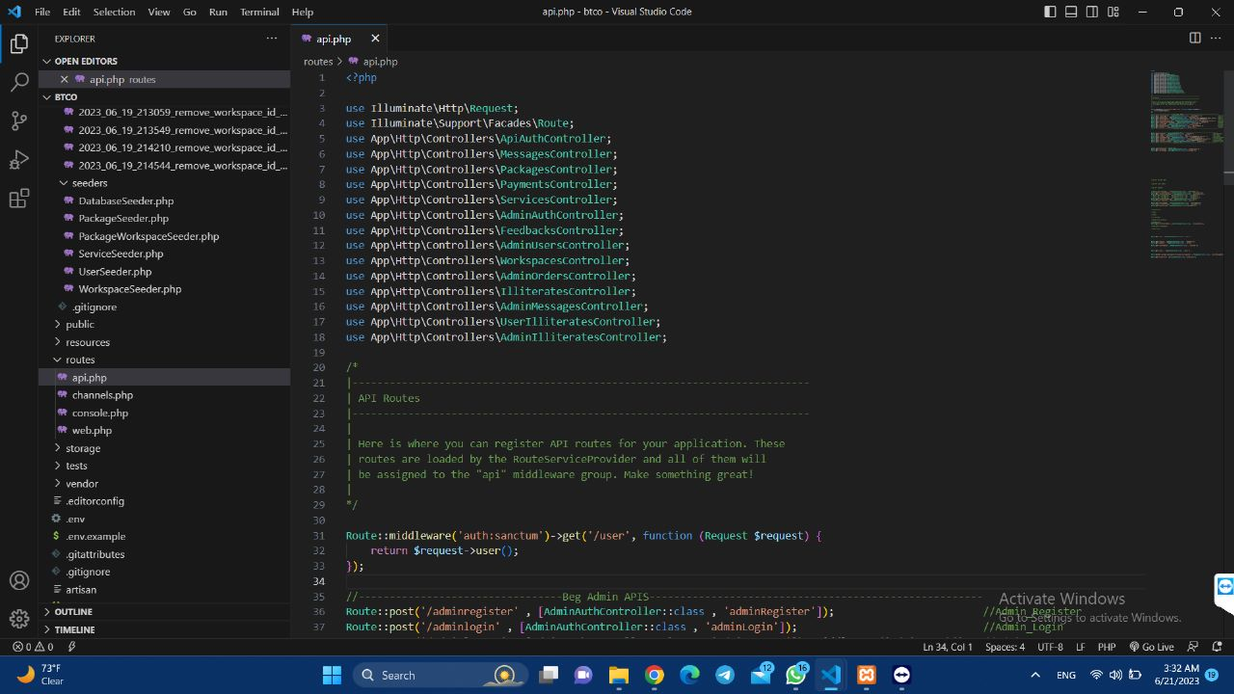

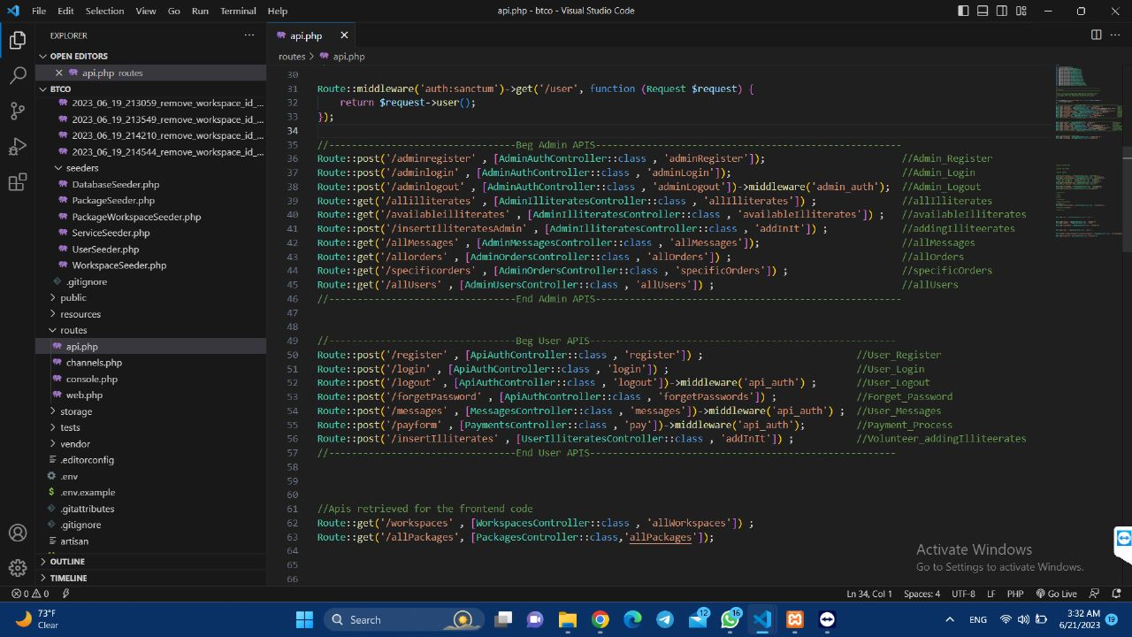

**.env file (which we determine the database name in it):**

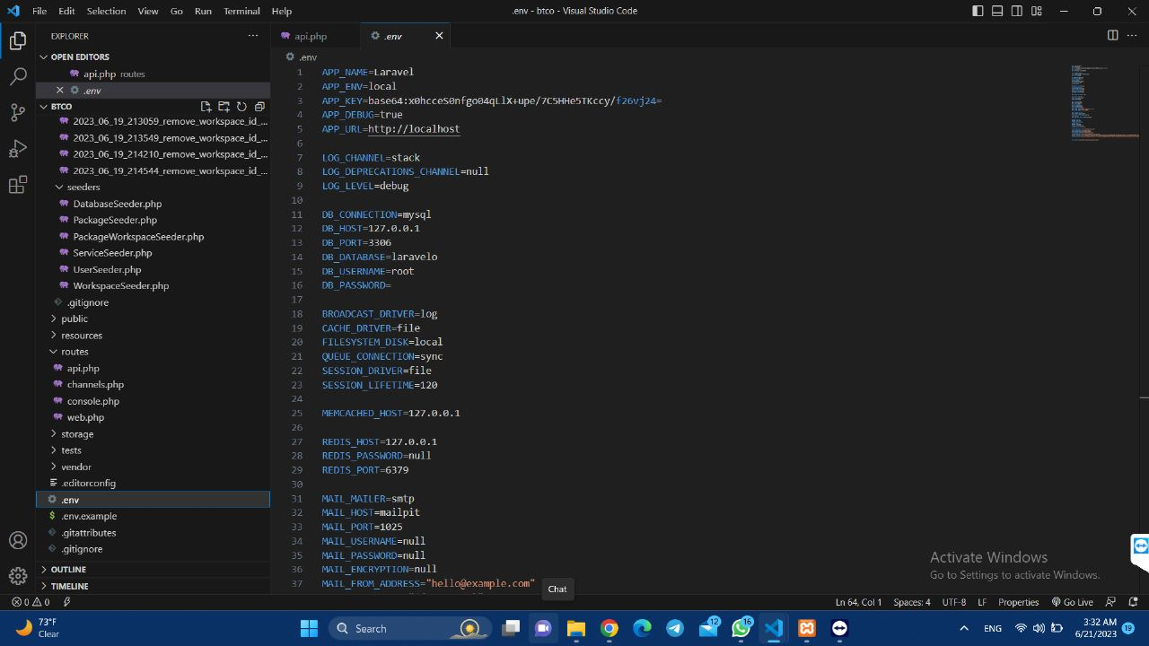

**Database Screenshots:-**

**Users table:-**

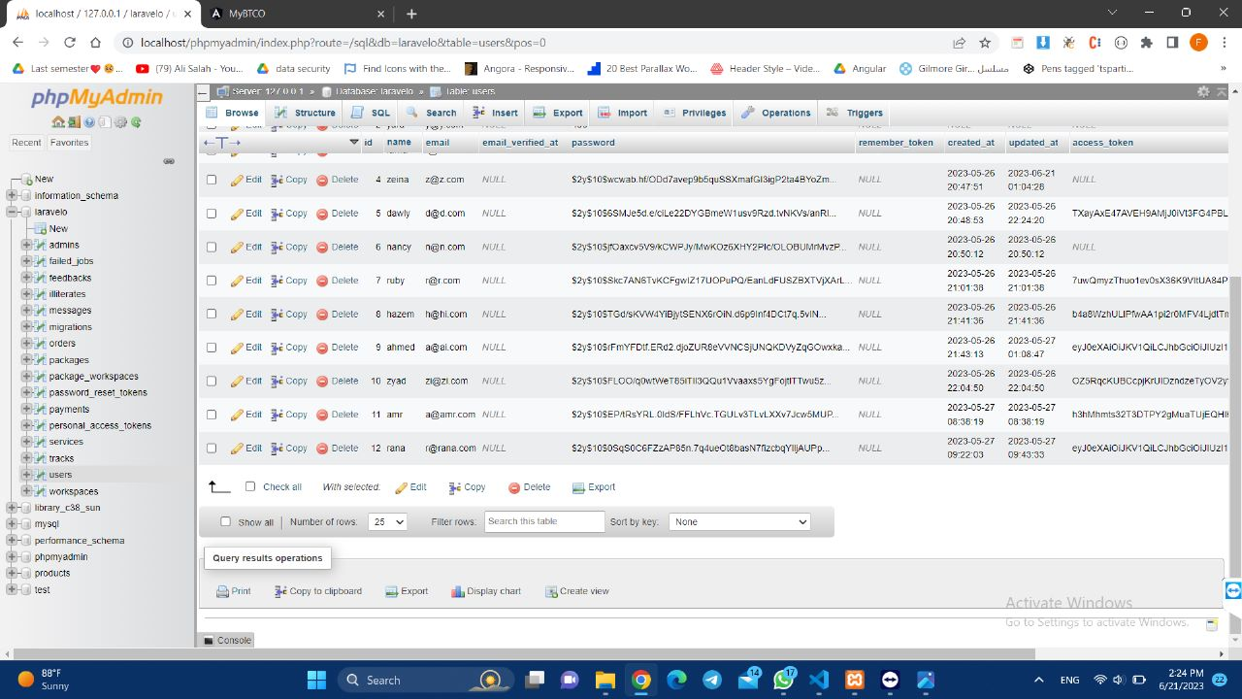

**Packages table:**

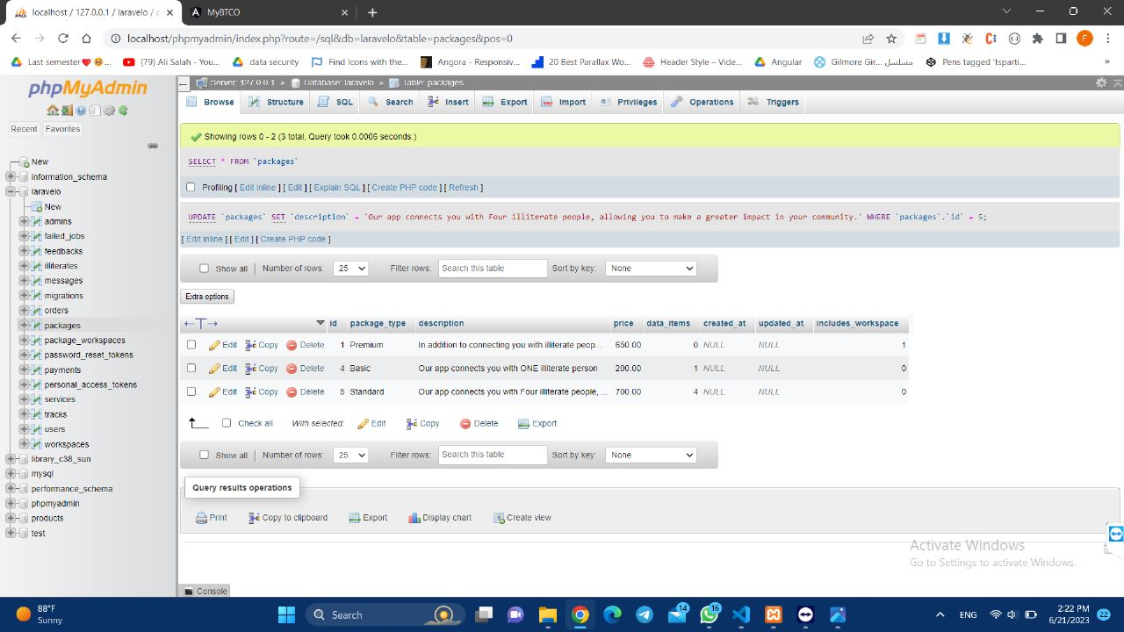

**Illiterates table:**

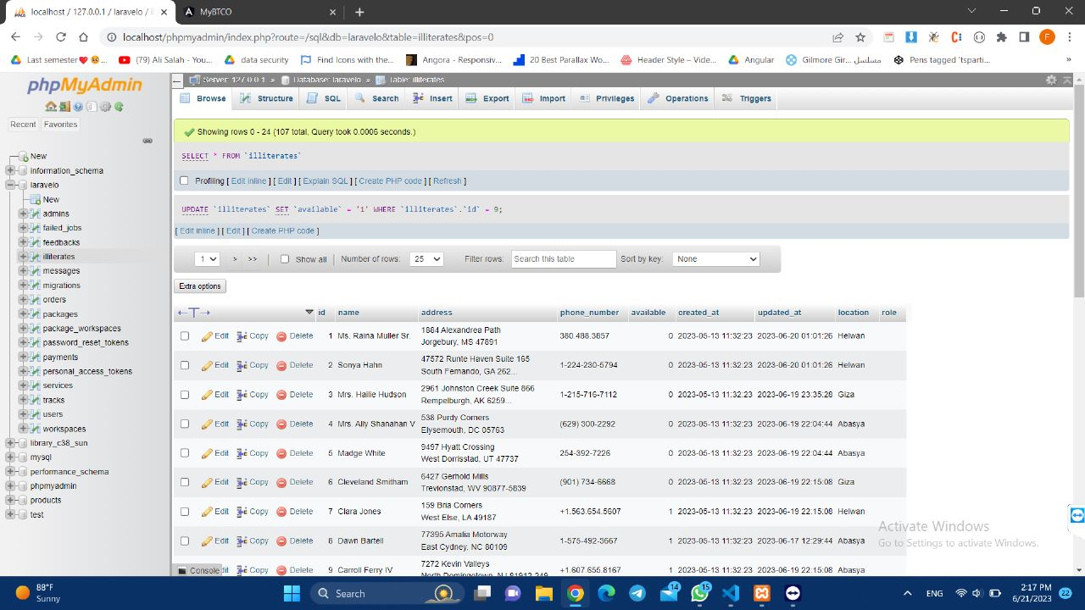

**Messages table:**

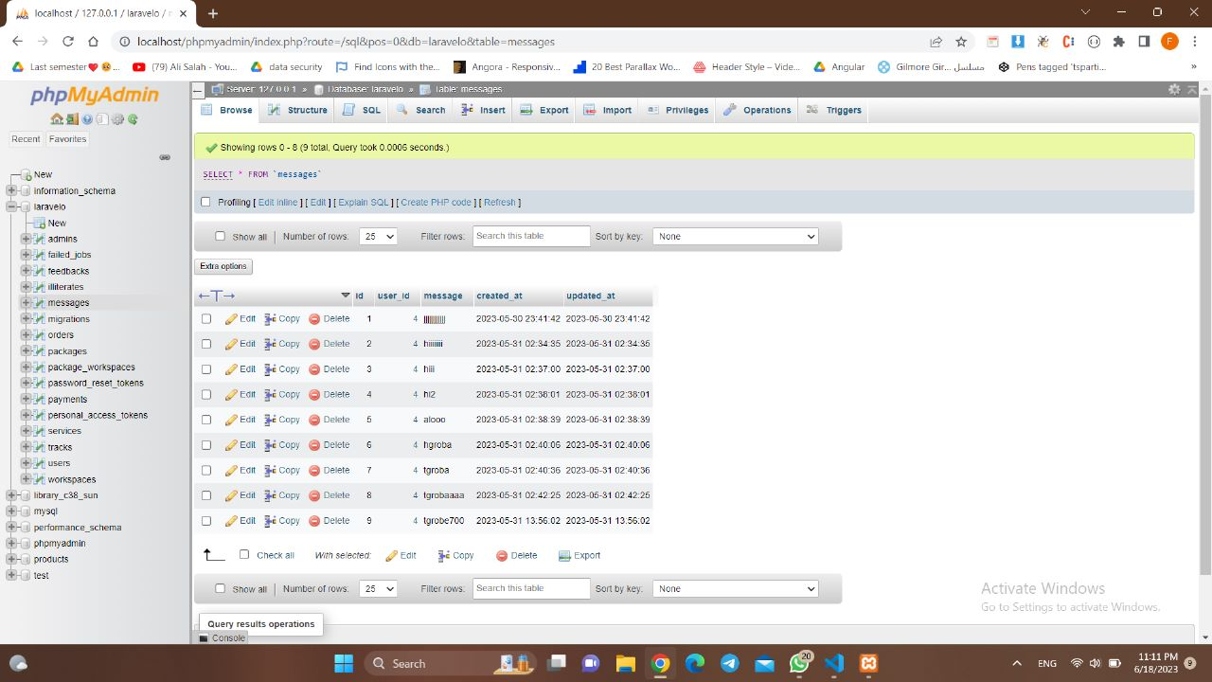

**Orders table:**

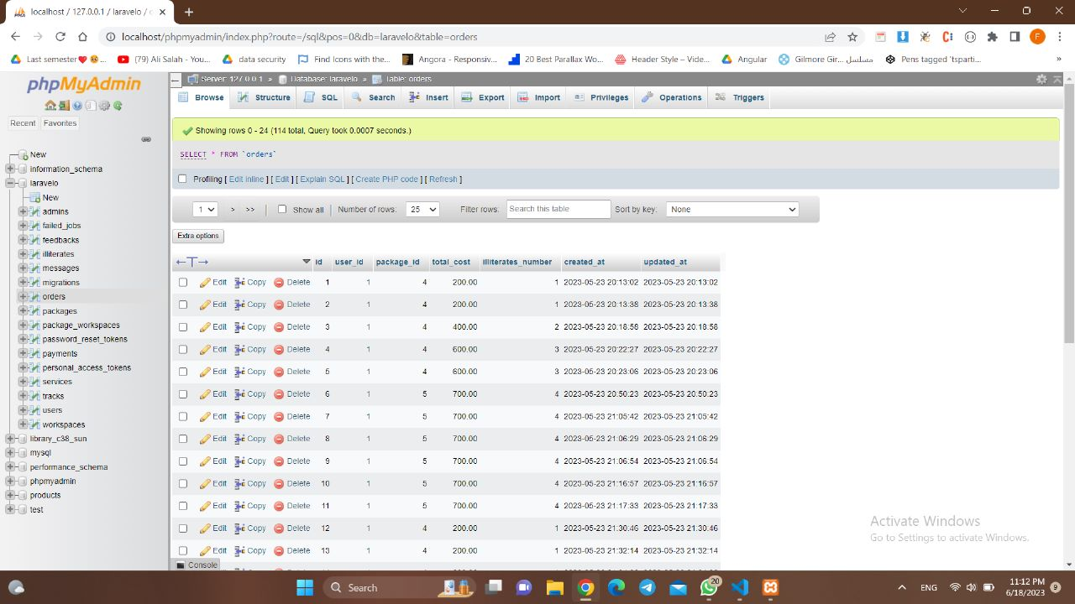

**Package_workspaces table:**

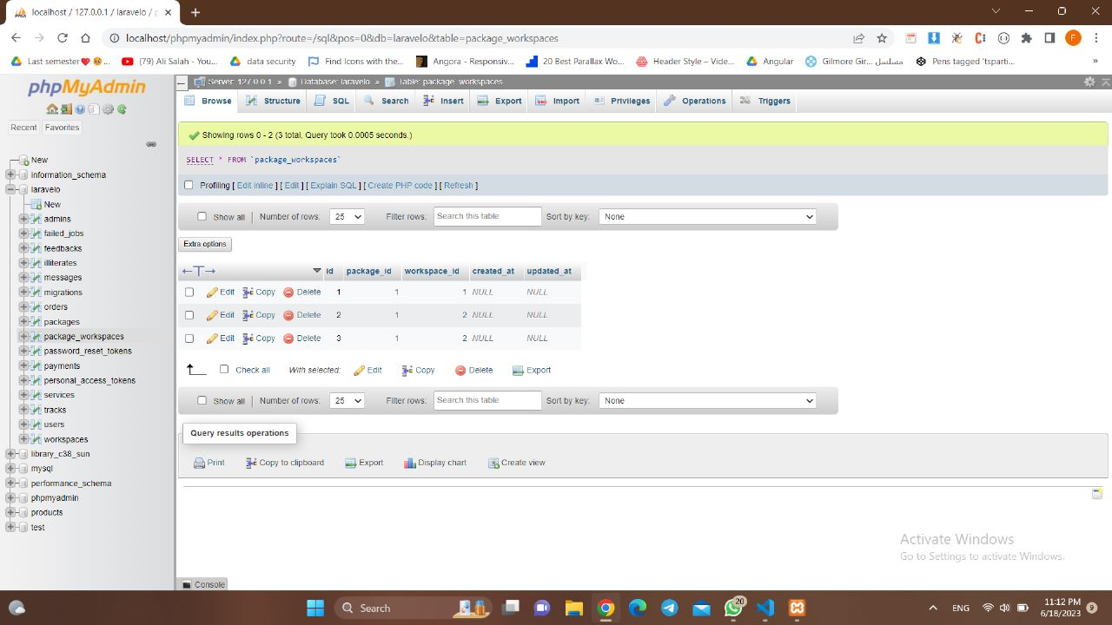

**Workspaces table:**

